  - NetApp AFX
General Test Plan
  - ONTAP 9.19.1

NetApp
July 2026
Abstract
<Provide a high-level summary of what is included in this document.>
Table of CONTENTS
Providing feedback 4
Support 4
Document version information 4
Overview 4
New ONTAP features to focus on 4
Documentation requirements 5
Licensing requirements 5
Recommended setup and prerequisites 5
Setup required 5
Datasets and workloads 7
Test plans 13
Basic functionality tests 13
Appendix 80
About EDA frontend, backend and blended terminology 80
NFS considerations 80
Client tuning considerations 82
REST API examples for testing. 88
Storage benchmark testing 91
Statistics counters 97
Scripts 101
Appendix B: Blank test template 102
Additional references 103
LIST OF TESTS
Test 1) Validate the cluster setup. 13
Test 2) Enable AutoSupport 17
Test 3) Create network interfaces. 18
Test 4) Data migration 19
Test 5) Volume management. 32
Test 6) API testing/seamless support for customer automation 35
Test 7) Customer workload testing – real workloads, real data 42
Test 8) Customer workload testing - benchmarks 43
Test 9) Performance monitoring 45
Test 10) Capacity management 49
Test 11) Node additions during live workloads 50
Test 12) Node failure behavior 55
Test 13) OPTIONAL: Use FlexCache between unified and NetApp AFX 58
Test 14) OPTIONAL: S3 in ONTAP 63
Test 15) OPTIONAL: Snapshots and SnapMirror during live workloads. 71
Test 16) OPTIONAL: Non-Disruptive ONTAP Upgrade 74
Test 17) Blank test template 102

LIST OF TABLES
Table 1) NFS features 8
Table 2) ONTAP limits and their potential impact on testing 9
Table 3) Alternate NFS mount options and their use cases 38
Table 4) Default readahead values – older Linux versions 87
Table 5) Default readahead values – newer releases 87
Table 6) Frontend EDA NFS operations – SPECSFS 2020 91
Table 7) Backend EDA NFS operations – SPECSFS 2020 92
Table 8) NFS operation types in SPEC SFS 2020 92
Table 9) NFS operations percent per model during runs 96
Table 10) Block size for READ operations 96
Table 11) NFS operation glossary 97

Providing feedback
We rely on our customers to provide detailed feedback throughout testing if at all possible. Product Management, Technical Marketing, and Engineering teams at NetApp will be actively involved in collecting and analyzing this feedback. Customers can leverage multiple communication channels to share your feedback and insights, including email or by scheduling meetings directly with the Product team. This feedback is incredibly important to us as it plays a critical role in refining and improving our products to meet and exceed customer expectations.

Support
Using the general NetApp support avenues is the preferred method of reporting and diagnosing issues. For general questions about the product, including implementation, best practices, or roadmap, reach out to your account team to get a meeting scheduled with the Product Management team.

Document version information
Version | Date | Summary
1.0 | July 2026 | Initial release

Overview
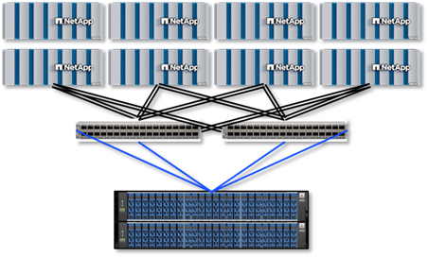 | NetApp AFX® is a new NAS and object-only platform that takes standard ONTAP software and replaces the multi-aggregate architecture for a single shared capacity pool, where all nodes in a cluster can utilize the same shelves.  This disaggregated architecture offers a way to present an asymmetric number of compute nodes or storage shelves for cost-effective performance and capacity while offering the same ONTAP experience found with unified ONTAP.

New ONTAP features to focus on
Each ONTAP release delivers new features to improve overall performance, stability, usability, etc. This test plan is intended to be ever-evolving and include new features to test and try out. You can find version-specific feature tests in the “ OPTIONAL: New feature tests” test plan.
New features in this release of ONTAP:
ONTAP 9.19.1GA feature | Full or limited support
FabricPool tiering | limited/dark content until 9.19.1P2
Larger Storage Availability Zone | Full
Aggressive readahead | Full
Global deduplication | Full
32 node support | limited
Dynamic storage efficiency | Full

Documentation requirements
NetApp documentation for NetApp AFX can be found here:
- NetApp AFX general documentation
- NetApp AFX technical reports

Licensing requirements
No special licenses are needed for NetApp AFX. It uses the same ONTAP licensing as unified ONTAP.

Recommended setup and prerequisites

Setup required
Hardware installation and initial configuration documentation links can be found in the “Documentation requirements” section. This test plan assumes that the initial setup and configuration has already been performed.
It is recommended that the AFX system starts no earlier than ONTAP version 9.19.1RC1. That release is the first release to support >16PB Storage Availability Zones and FabricPool. If starting on an earlier release, then a cluster reinitialization (data wipe) would be required when moving to ONTAP 9.19.1 to gain support for those features. A reinitialization script is available at: https://github.com/whyistheinternetbroken/AFX

Initial state of the test environment
The initial environment will depend on the number of nodes acquired for the test plan. The number of nodes available may also impact the number of tests available to the system (ie, node scaling, failover, etc).
NetApp AFX officially supports a minimum configuration of:
- Four storage nodes
  - Initial setup can be a two node HA-pair to provide scale/balancing testing
  - 2 more nodes added later as part of test plan steps (optional)
- Two Cisco switches (for cluster, HA & disk network)
  - RCF file to be provided
- Shelf minimums:
  - Fully populated shelves (24 drives each shelf)
  - 1 shelf of 15.3 TB SSDs
  - 2 shelves of 7.6 TB, 30.1 TB, or 60.1 TB SSDs
  - No drive mixing support yet
- Recommended ONTAP version of 9.19.1 or later
- Pre-configured cluster, SVM, NFS server, protocol licenses
- Node and cluster management interfaces for access to the CLI and GUI

Clients
For the best results, provide at least four modern NFS clients to run storage benchmarks. Client OS is not important, provided it adheres to RFC standards and are within a few minor releases of the newest versions available. All clients should have high performance specs including CPU, memory & networking, ideally 100GB+. All clients should be routable to all data interfaces in the NetApp AFX cluster – especially if features such as pNFS and NFSv4.1 session trunking are used.
This test plan mainly focuses on NFS, but many of the concepts can also be applied to SMB operations. Future versions of this test plan may include SMB, multiprotocol NAS, etc.
Our internal benchmark results were generated with the following client configurations:
Ubuntu 24.04.1 LTS
6.8.0-51-generic
Doca-all 3.4.0 3.4.0-085000 with rpcrdma module

Client network & NIC tuning
Dual NICs bonded for RoCE (LACP)
RX/TX ring buffers set to 8192
PFC and DSCP configured per NIC
RoCE traffic class set using cma_roce_tos

Client OS tuning
sunrpc.rdma_slot_table_entries set to 200
vm.dirty_background_bytes = 2147483648 (2GB)
vm.dirty_bytes = 5368709120 (5GB)
vm.dirty_background_ratio = 0
vm.dirty_ratio = 0
vm.dirty_expire_centisecs = 300
vm.dirty_writeback_centisecs = 100

Networking requirements
All data network interfaces in and ONTAP SVM should be routable to all clients for best results in this test plan. The IP address count needed are as follows:
- Four (4) intercluster interface IP addresses
- one per node required; to be used for SnapMirror® and FlexCache operations (unless not testing these features)
- At least eight (8) data interface IP addresses (two per node)
- pNFS supports up to sixteen (16) data IP interfaces per node
- Can be TCP or RDMA capable
- One (1) cluster management interface IP address for administrative interaction
- Four (4) node management interface IP address (one per node)
- Four (4) service processor/BMC IP address (one per node)
- Client IP addresses
- NICs can be bonded, trunked, etc. No set requirements there unless using RDMA, which may have support limitations for NICs.

NFS server configuration
The following shows the NFS server options that should be configured for this test plan. Other NFS server options can be enabled as well (for instance, NFSv4 ACL support), but they are outside of the scope of this NetApp AFX-focused test plan.
v4.1 | Enabled
v4-id-domain | [domain name]*
v4.1-pnfs | Enabled
v4.1-trunking | Enabled
tcp-max-transfer-size | 262144
v3-64bit-identifiers | Enabled
v4-64bit-identifiers | Enabled
v3 | Enabled
v4.1-read-delegation | Disabled
v4.1-write-delegation | Disabled
rdma | Enabled (optional)
v4.0 | Disabled
v3-hide-snapshot | Enabled
mount-rootonly | Disabled
nfs-rootonly | Disabled
*The NFSv4 ID domain can be any value, provided it matches what is set on the NFS clients.
To verify the NFSv4 ID domain on the client:
# nfsidmap -d
user-domain.company.com
# cat /etc/idmapd.conf | grep Domain
Domain = user-domain.company.com
If those commands do not work, you likely have not installed the proper NFS packages to leverage NFSv4.x. Ie, nfs-common for RedHat-based kernels.

Datasets and workloads
NetApp AFX is intended for high performance NAS and object workloads that require massive amounts of throughput and IOPS with the ability to independently scale storage nodes and capacity. Because it runs NetApp ONTAP, NetApp AFX is versatile enough to handle a variety of workload types at the same time on the same datasets with minimal configuration changes to optimize. Some of the largest companies in the world run their workloads on ONTAP, across multiple industries.
These include, but are not limited to:
- Media and entertainment (movies, television, streaming, music, gaming)
- Electronic Design Automation/EDA (semiconductor and chip development)
- Oil, gas & seismic
- Financials (high volume trading, prediction, AI/ML)
- Healthcare (medical imaging, AI/ML, LLM)
- Software development

Workload use cases
Datasets and testing of workloads will be dependent on the overall goal of the test plan, but there are three main scenarios in play here.

Workload types
NetApp AFX, while initially designed for AI/ML training and inference use cases, is capable of hosting a variety of different workloads including:
- High throughput read/write (random or sequential)
- High IOP workloads (small, random IO/high metadata)
From an application/solution perspective that means workloads such as AI/ML training, software development, HPC, virtualization, media and entertainment, etc. are all pertinent to what NetApp AFX can offer.

Are you currently using ONTAP?
If ONTAP is currently running your production workloads, this test plan will use SnapMirror to efficiently and quickly replicate volumes to NetApp AFX.
Some considerations:
- SnapMirror from unified ONTAP to NetApp AFX can be performed with any unified ONTAP version within 2 major releases (ie, ONTAP 9.16.1 -> 9.18.1).
- SnapMirror to unified ONTAP from NetApp AFX is only supported on unified ONTAP running ONTAP 9.16.1 when replicating FlexGroup volumes. FlexVol volumes can still use the 2 version compatibility rule.
- Alternatively, it is also possible to copy subsets of data using NAS protocol-based tools such as XCP, robocopy, etc. Those methods will not be covered in the scope of this document.

If you are not currently using ONTAP
If ONTAP is not currently being used within your environment, then a NAS protocol-level copy of datasets to NetApp AFX or initial data generation (ie, via storage benchmarking tools) will be needed to run portions of this test plan. Those methods will not be covered in the scope of this document.
An alternative method of leveraging industry standard benchmarks for the workload are provided as an optional test plan in this document.

Supported data protocols
NetApp AFX is compatible with the following data protocols:
- NFSv3, NFSv4.0, NFSv4.1 / NFSv4.2 (with pNFS)
- SMB2.x, SMB3.x
- Dual protocol NAS (SMB and NFS)
- S3
- NFS over RDMA
- File / object multiprotocol (Present an existing NAS volume as an S3 bucket)
As mentioned previously, this test plan currently focuses mainly on NFS and object workloads. Future versions of this test plan may include SMB, dual protocol, etc.

Recommended NAS protocol features
Most modern clients have support for specific NFS features that workloads running on NetApp AFX systems can leverage and benefit from.
When using NFSv4.x, use only NFSv4.1 and later.
Table 1) NFS features
Feature | Purpose | NFSv3 | NFSv4.1+
Nconnect | Multiple TCP connections per single mount point for increased performance and scale.  Nconnect + pNFS = OK  Nconnect + session trunking = OK  Nconnect + session trunking + pNFS = not recommended | Yes | Yes
Trunking | Combines multiple interfaces into one connection to provide increased throughput and resiliency. (Not to be used with nconnect) | No | Yes
pNFS | Data locality for improved latency and parallel access to single file portions of large files for better performance when using FlexGroup volumes. | No | Yes

Volume type recommendation
It is highly recommended to leverage FlexGroup volumes in this test plan due to their ability to spread a working dataset across multiple nodes and CPU threads for higher performance.
To create a FlexGroup volume in the AFX command line:
::> volume create -volume flexgroup -size 500t -vserver svm1 -auto-provision-as flexgroup
To create a FlexGroup volume in System Manager:
- Navigate to Storage -> Volumes
- Click +Add
- Select “High throughput” to create a FlexGroup
To leverage REST API, see:
https://docs.netapp.com/us-en/ontap-afx/rest/api-reference.html

S3 specific features
ONTAP S3 supports a limited number of S3 features and functionality. Support for these features spans both NetApp AFX and Unified ONTAP.
For details and recommendations, see: Learn about S3 configuration

ONTAP limits considerations
NetApp AFX runs ONTAP, and because of that, you need to be aware of what file system limits are present in ONTAP, since testing/benchmarking can run into errors if these limits are reached.
The following table spells out specific limits and what their impact may be on testing. The test plans attempt to build most of these into the tests to avoid unforeseen issues. For more information, see the Performance testing configuration section.
Table 2) ONTAP limits and their potential impact on testing
Limit | Value | Potential impact
Maximum volume size | 100TB  (-is-large-size-enabled false)  300TB  (-is-large-size-enabled true)  ONTAP sets this option to false by default. This option also impacts the maximum FlexGroup size (20PB vs. 60PB) | If a volume size reaches its maximum allowed size and then fills to 100%, then there is no way to expand it beyond that. Testing would fail due to lack of space.  Remediation  - Set -is-large-size-enabled to true at volume creation  - Configure volume autosize  - Configure monitoring and alerts for volumes approaching 90% capacity used  - Delete snapshots or data if the limit is reached
Maximum file size | 16TB  (-is-large-size-enabled false)  127TB  (-is-large-size-enabled true)  ONTAP sets this option to false by default. | Reaching the maximum file size limit will show an “out of space” error and the file will no longer be writeable. In some cases, if the space error occurs during an in-flight write, that write may be corrupted.  Remediation  - Set -is-large-size-enabled to true at volume creation  - Avoid creating files larger than the allowed maximum size.
Maximum files/inodes | 2 billion (FlexVol)  200 billion (FlexGroup)  The maximum files/inodes allowed in a single volume is determined by the -files volume option. | If a test attempts to exceed the maximum files allowed, then the test will fail due to an “out of space” error. (callhome.no.inodes in ONTAP)  This error is a common root cause for test failures, as the max file value is variable based on volume size and the absolute maximums are only reached when the volume size (FlexVol or constituent FlexGroup volume) is ~7.8TB. Because it manifests on the client as a “out of space” error, it can be hard to track down.  By default, the maximum files value is determined by the volume size (one inode per 4K of space) and does *not* allow the absolute maximum number of files. For instance, if a volume size is 100GB, then the default value is 3,112,959, but the maximum allowed would be 24,903,679.  Remediation/prevention  - Create volumes at a large enough size to support the maximum files allowed. (>7.8TB for FlexVol, 7.8 * 10 * nodes for FlexGroup)  - Set -files-set-maximum to true at volume creation  - Monitor for inode allocation for the volume  - Consider setting quotas on the volume to alert when an inode allocation value has been reached  - Delete files if the limit is reached
Maximum files per directory (maxdirsize) | 320MB (default)  The number of files is variable depending on several factors (see right column), but is generally in the ~2-4 million range for FlexVol volumes and ~1-2.5 million for FlexGroup volumes. | If a directory reaches its maximum directory size allowed in ONTAP, clients will see an “out of space” error. ONTAP will show a wafl.dir.size.max or wafl.dir.size.max.warning message in EMS (event log show in CLI).  It is a best practice to keep the file counts in single directories lower than the maximums allowed by default.  320MB is the size allocated to memory for a directory’s index file size. Each time a file is added to a directory, the index file increases in size. This size is impacted by file count, file name length, hardlinks, and character types. The exact number of files can be varied depending on those factors. It is generally not recommended to increase the maxdirsize value, as it can impact overall system performance for all workloads when approaching the higher end of the limits. However, in benchmark tests, this limit can be modified to verify the impacts seen.  Remediation/prevention  - Avoid creating millions of files in a single directory when possible.  - Monitor for maxdirsize usage via the EMS message wafl.dir.size.warning and wafl.dir.size.max.warning  - Increase the -maxdirsize value to no more than 4GB if testing includes creating >2 million files in a single directory
TCP connections | 100,000 per node | If a TCP connection maximum is exceeded on a node, then new mounts will be disallowed until connections are freed up. This scenario is an uncommon occurrence due to the high number of connections allowed, but in Kubernetes/container environments where NFS is used, this can happen on occasion – particularly when initial mounts are occurring across many clients, TCP is not specified in the mount options, and nconnect is in use. This mainly impacts NFSv3.  Remediation/prevention  - Use the “tcp” mount option value to avoid UDP mount requests for NFSv3  - If using nconnect, remember your total mount connections allowed will be 100,000/nconnect value  - Leverage DNS load balancing or some other round robin mechanism to balance mounts across nodes in the cluster
NFSv4.x session slots | 2000 (180 default) | Too high or low of a value here can negatively impact performance in ways that are hard to track down. Generally speaking, too low will create a sort of NFS flow control of incoming connections, while too high may impact CPU utilization. For details, see:  https://learn.microsoft.com/en-us/azure/azure-netapp-files/performance-linux-concurrency-session-slots  Session slots are the number of supported in-flight requests in a single NFSv4.x session. By default, ONTAP supports 180 session slots, but in-house performance testing has shown that lowering this value to 64 is optimal.  Remediation/prevention  - Limit the session slots (-v4.x-session-num-slots) to 64 when using NFSv4.x
RPC slot tables | 128 per TCP connection | NFS slot tables help control the concurrency of operations for NFS mounts. If they are exceeded in ONTAP, then the NFS server will create a wait queue for incoming operations, which will then impact performance. One of the main signs of this is the EMS message nblade.execsOverLimit. This event is triggered when a delta of incoming requests exceeds the monitored value in ONTAP. In some cases, this event may fire as a false positive where performance isn’t being negatively impacted, but if you are seeing these messages, you are generally exceeding the 128 limit.  By default, modern NFS clients allow dynamic control of NFS slot tables by way of communication between the client and NFS server. ONTAP’s NFS server has no configurable or advertised value for this, so the NFS client has no way of knowing how many slot tables the server supports. As a result, the client will send up to the maximum of 65536 slot table entries to the NFS mount’s IP address, which greatly exceeds ONTAP’s 128 maximum.  This can impact both NFSv3 and NFSv4.x.  Remediation/prevention  - Modify your sunrpc slot tables value on your NFS clients to no more than 128 (preferably 64) for NFSv3 (see NetApp ONTAP NFS Best Practices for more information on page 122)  - Modify the session slot value for NFSv4.x on the ONTAP NFS server  - Monitor for nblade.execsOverLimit

Test plans
The following sections outline the testing NetApp encourages customers complete as part of this test plan. A notes section is included for your own use, but it would be invaluable to NetApp if following these tests, those notes were passed on as feedback about NetApp AFX or the test plan itself. To submit feedback, email ng-afx-testplan@netapp.com.
Test scenarios that are executed outside of these guidelines are fine and it is still of high value to provide the results of such tests. As such, in the document we have provided a blank test plan template in Appendix B which should be filled in for such tests containing all steps that were executed, results that were expected and that were achieved as well as collected data.
All tests have a ‘Comments’ section. It is appreciated if any comments – even those not directly related to the executed tests – are provided as either part of the tests or separately.
Images in these test plans may differ from your actual lab environment. For questions, please reach out to your account team.

Basic functionality tests
The goals of these tests are to illustrate the basic administrative and functionality of NetApp AFX in contrast to other storage platforms you may be used to (or to unified ONTAP itself). These tests build as they proceed, so it is important not to skip these tests to ensure later tests work as expected.
- Validate the cluster setup
The first test plan here is to validate the cluster heath, configuration, etc.
Test 1) Validate the cluster setup.
Section | Details
Test 1 | Tester: |  | Date:
Test requirements: | No specific requirements
Test procedure – GUI:
- Log into the System Manager GUI via https://[clus_mgmt_IP]
- The system dashboard will show errors, warnings, capacity information, and a high-level overview of the storage hardware.
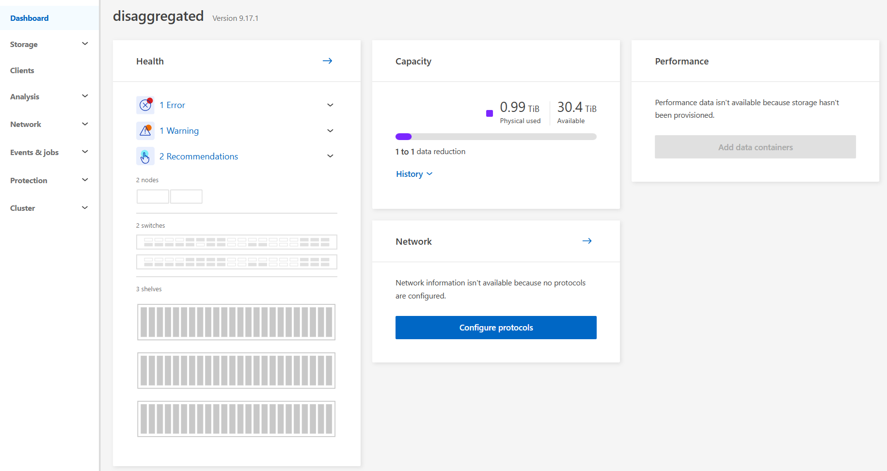
- Click on “Errors” to view any issues the cluster may be having. This will take you to Events & Jobs -> Events.
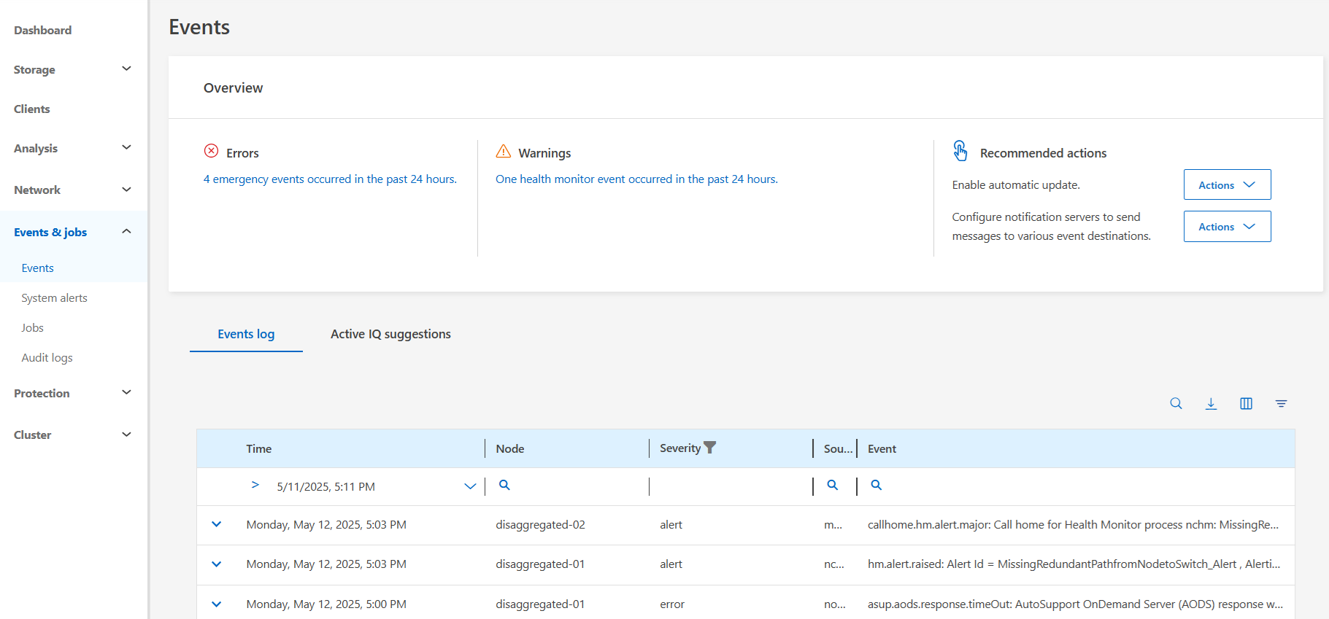
- Click on System Alerts to see specific alerts.
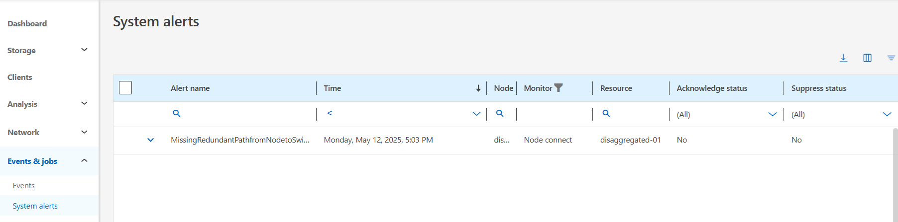
- Under Cluster -> Overview, you can see the following via the tabs on the page:
- Node health and information
- Shelves
- Shelf IO modules
- Disks
- Switches
- Cabling
Scroll through each of these and take note of the different components in the NetApp AFX architecture.

Note: You can toggle between list view and graphical view on each tab.

The cabling diagram provides a clean view of the clusters physical layout.
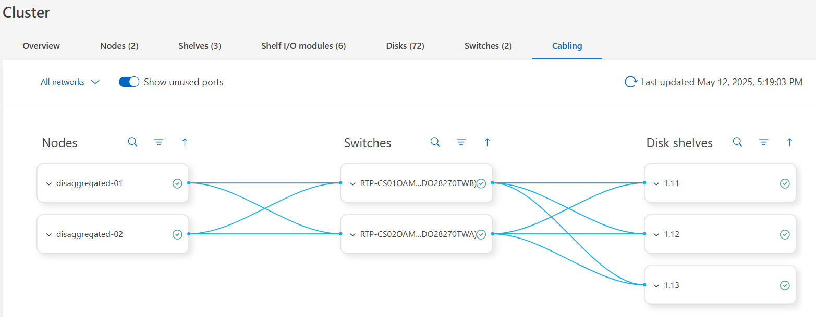
Use the down arrows  in each of the Nodes, Switches and Disk Shelves to see their associated ports. Some ports will be unused. To see a consolidate cabling diagram with only the used ports, uncheck “Show unused ports.”
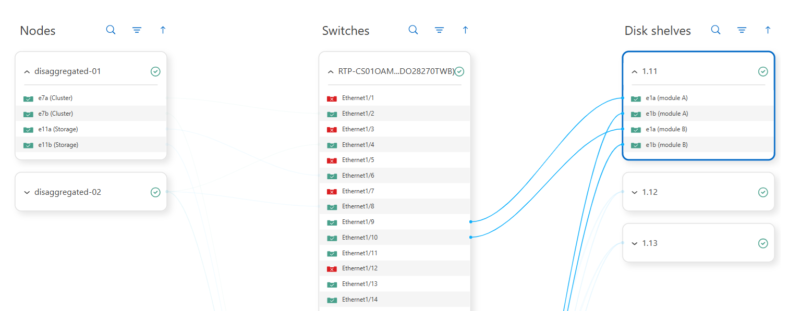
Test procedure – CLI:
- Log in to the NetApp AFX CLI
- Verify cluster health.
AFX::*> set advanced
AFX::*> cluster show
AFX::*> system health status show
AFX::*> system health subsystem show
AFX::*> health alert show

- Ping cluster interfaces to ensure health and connectivity.
AFX::*> cluster ping-cluster -node AFX-01
Host is AFX-01
Getting addresses from network interface table...
Cluster AFX-01_clus1 192.168.76.221 AFX-01 e7a
Cluster AFX-01_clus2 192.168.76.228 AFX-01 e7b
Cluster AFX-02_clus1 192.168.76.224 AFX-02 e7a
Cluster AFX-02_clus2 192.168.76.231 AFX-02 e7b
Local = 192.168.76.221 192.168.76.228
Remote = 192.168.76.224 192.168.76.231
Cluster Vserver Id = 4294967293
Ping status:
....
Basic connectivity succeeds on 4 path(s)
Basic connectivity fails on 0 path(s)
................
Detected 9000 byte MTU on 4 path(s):
Local 192.168.76.221 to Remote 192.168.76.224
Local 192.168.76.221 to Remote 192.168.76.231
Local 192.168.76.228 to Remote 192.168.76.224
Local 192.168.76.228 to Remote 192.168.76.231
Larger than PMTU communication succeeds on 4 path(s)
RPC status:
2 paths up, 0 paths down (tcp check)
2 paths up, 0 paths down (udp check)

- Show that disk shelves are connected and available.
AFX::*> storage shelf show
AFX::*> storage shelf port show

- Verify the system HA status.
AFX::*> system ha interconnect status show
AFX::*> system ha interconnect port show
AFX::*> storage failover show

- Verify the storage switches are connected and available.
AFX::*> system switch ethernet show

- Show network interfaces.
AFX::*> network interface show

- Show the storage availability zone.
AFX::*> storage availability-zone show

- Show system processor interfaces.
AFX::*> service-processor show

- Show available cluster space.
AFX::*> cluster space show

- Verify the NFS server is configured properly.
AFX::*> nfs show -fields v4.1,v4-id-domain,v4.1-pnfs,v4.1-trunking,tcp-max-xfer-size,v3,v3-64bit-identifiers,v4-64bit-identifiers,v3,v4.1-read-delegation,v4.1-write-delegation,rdma

The NFS server output should show:
v4.1 | Enabled
v4-id-domain | [domain name]
v4.1-pnfs | Enabled
v4.1-trunking | Enabled
tcp-max-transfer-size | 262144
v3-64bit-identifiers | Enabled
v4-64bit-identifiers | Enabled
v3 | Enabled
v4.1-read-delegation | Disabled
v4.1-write-delegation | Disabled
rdma | Enabled

Expected outcome(s):
- The cluster is healthy and available.
- The shelves are cabled properly.
- The network interfaces are present for management Ips.
- Storage availability zone concepts are reviewed.
- Cabling diagrams are viewed.
- Error states are not present. If errors are present, resolve with support before moving on to the next sections.
Test results:
Test summary:
Comments:
- Enable AutoSupport (optional)
AutoSupport is enabled for these environments to ensure the following:
- Proper call home / case creation when needed.
- Data collection for the AFX clusters, including detailed log files.
- Troubleshooting/support
AutoSupport requires the ONTAP system to be able to access the internet to send its payload to NetApp. For environments that do not allow external access please follow this procedure to manually upload an AutoSupport. https://kb.netapp.com/on-prem/ontap/Ontap_OS/OS-KBs/How_to_manually_upload_AutoSupport_messages_to_NetApp_in_ONTAP_9
For more information on what AutoSupport is, the information that AutoSupport contains, or how to configure AutoSupport, please consult TR-4444.
Test 2) Enable AutoSupport
Section | Details
Test 2 | Tester: |  | Date:
Test requirements: | No specific requirements
Test procedure:
Log into the System Manager GUI via https://[clus_mgmt_IP]
- Navigate to Cluster -> Settings.
- Under AutoSupport, if not already enabled, click the menu and select enable.
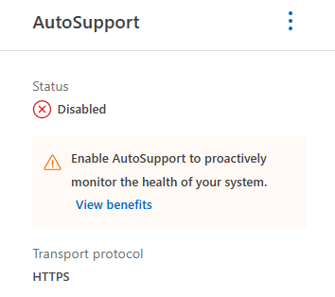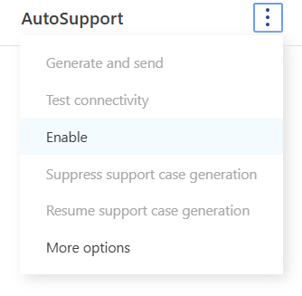
- Test AutoSupport connectivity
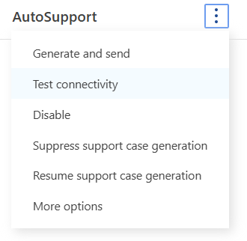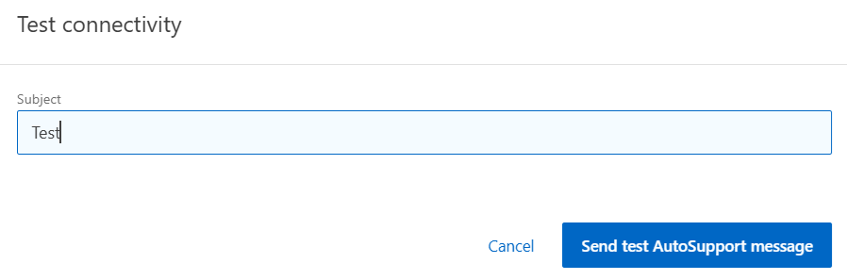
Expected outcome(s):
- AutoSupport is enabled.
- A test ASUP succeeds.
Test results:
Test summary:
Comments:
- Create network interfaces
ONTAP can be configured with multiple network interfaces for management, data access and inter-cluster connectivity.
Test 3) Create network interfaces.
Section | Details
Test 3 | Tester: |  | Date:
Test requirements: | No specific requirements
Test procedure:
- Log into the System Manager GUI via https://[clus_mgmt_IP]
- Navigate to Network -> Overview.
- Click the “+ Add” button under Network interfaces.
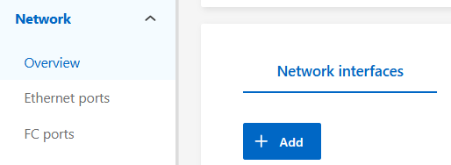
- Select “data” for the interface type and select the desired options, specify a name, home node, etc.
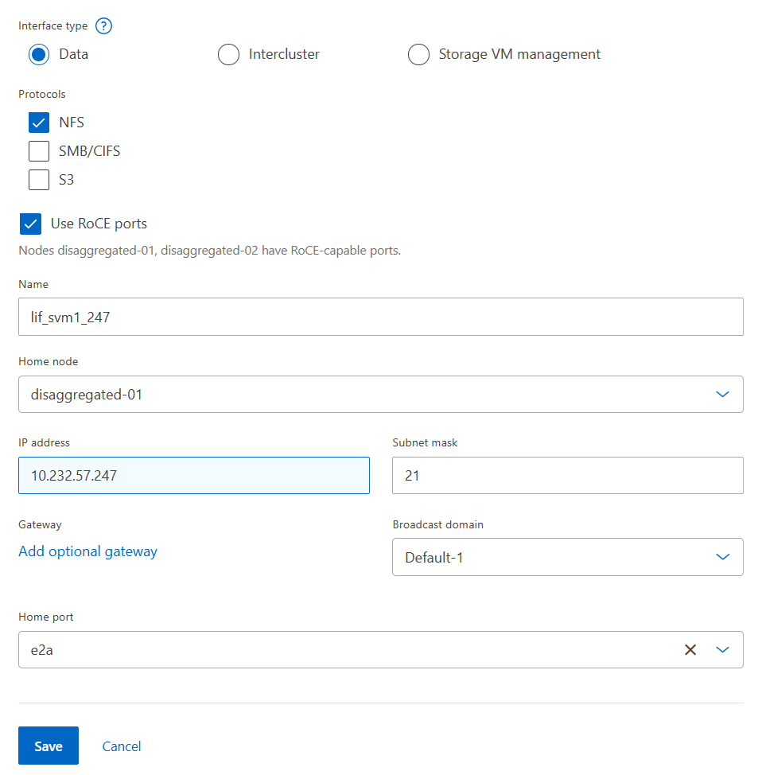
- Repeat the above step for each node. Create at least 2 data interfaces per node to provide paths for NFS session trunking.
Alternately, use the LIF creation script found in the Appendix of this document.
Expected outcome(s):
- Two or more data interfaces are created per node.
Test results:
Test summary:
Comments:
- Data migration (optional)
The goal for this test is to provide a mechanism to display the ease and speed of migration of data from unified ONTAP to NetApp AFX using NetApp SnapMirror technology. This test is optional if you plan on generating your own datasets on the cluster.
Additionally, we can also show how NetApp AFX can replicate to a unified ONTAP system to provide a cost-effective way to provide disaster recovery, provided the SnapMirror version requirements are met.
Test 4) Data migration
Section | Details
Test 4 | Tester: |  | Date:
Test requirements: | Intercluster LIFs on each node  ONTAP versions within 2 releases (ie 9.16.1 -> 9.18.1)  A secondary cluster running ONTAP (or replicate to the same cluster to a different volume)  *Unified ONTAP cluster must be at 9.16.1 if replicating FlexGroup volumes from NetApp AFX source to unified ONTAP destination
Test procedure:
- Ensure intercluster interfaces exist.
Click Network -> Overview.
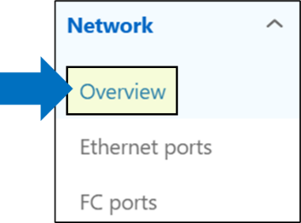
Click the magnifying glass to search for interfaces with the type of “intercluster.”

Type “intercluster” in the search field to find any intercluster interfaces.
If there are none, move on to the next step to create intercluster interfaces. If they do exist, move to the following step to set up the cluster peer.

- Create intercluster interfaces (if they do not already exist)
Each node in both clusters should have at least one intercluster interface.

Navigate to Protection -> Overview and click “Add network interfaces”.
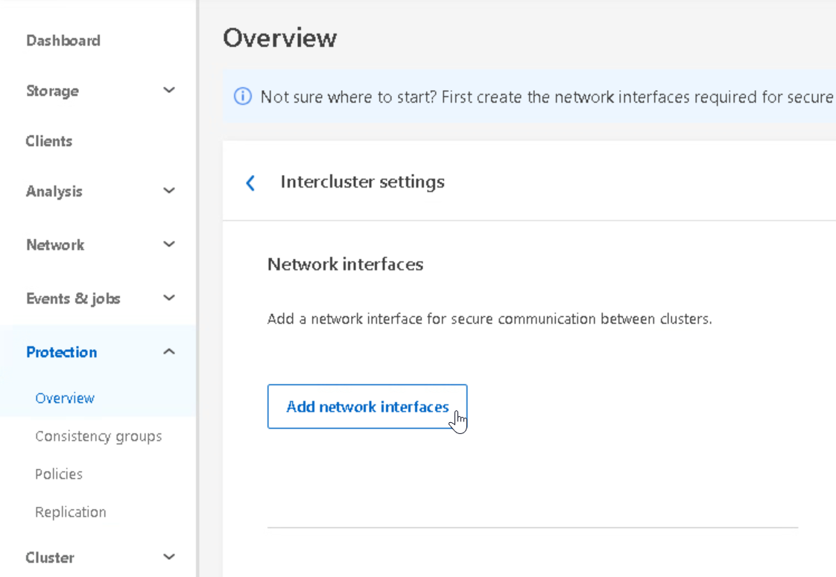

Configure the interfaces for each node, as shown below
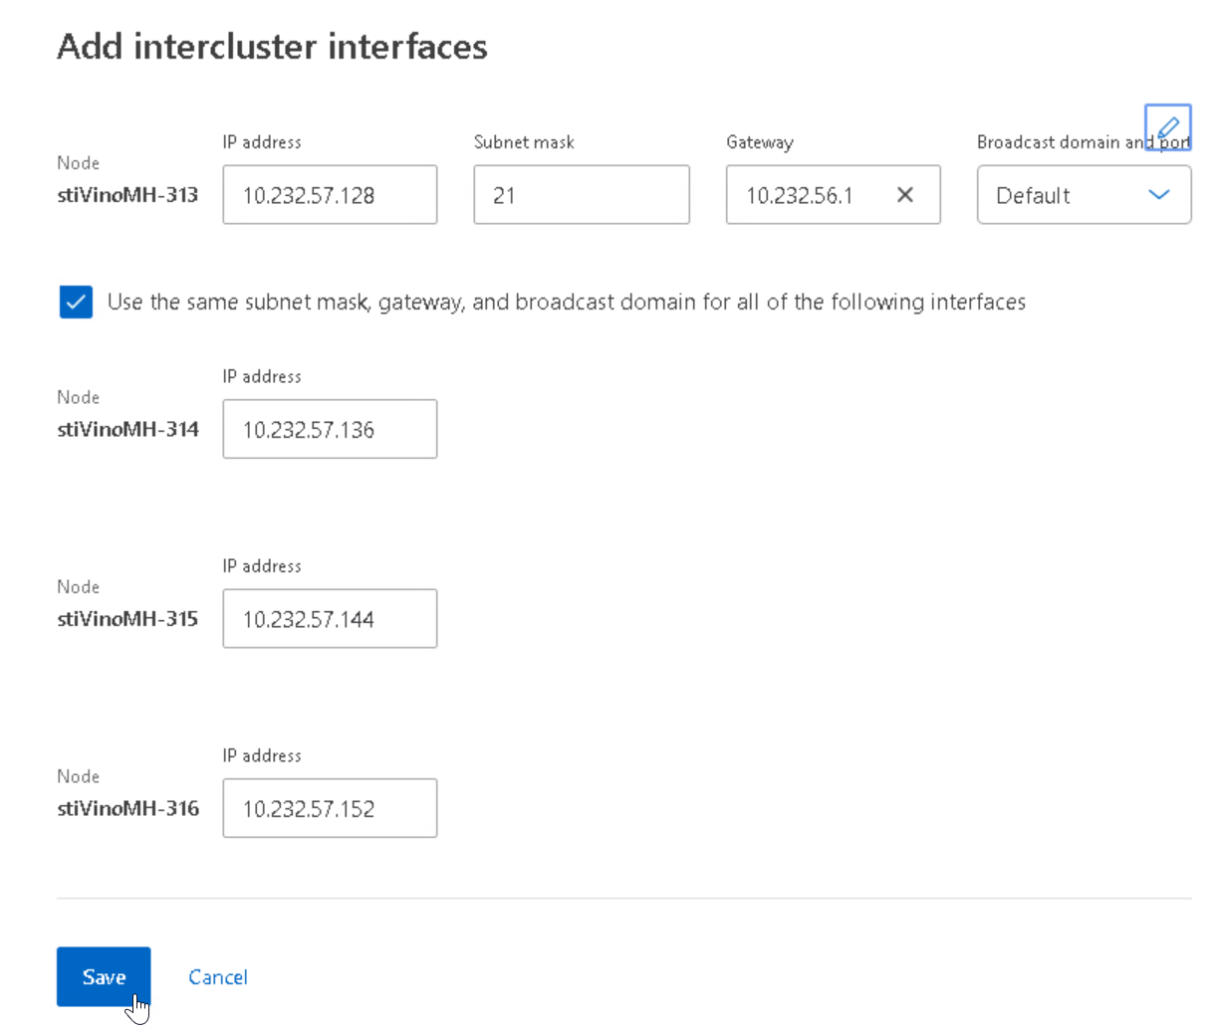

Click save and confirm the interfaces.
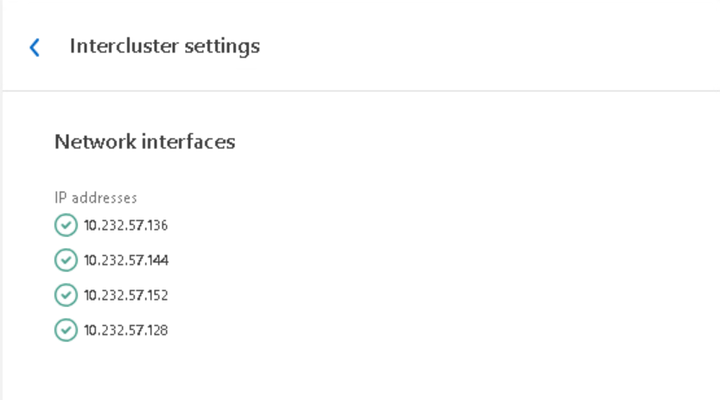

Verify the interfaces have been created from the “Network interfaces overview.”
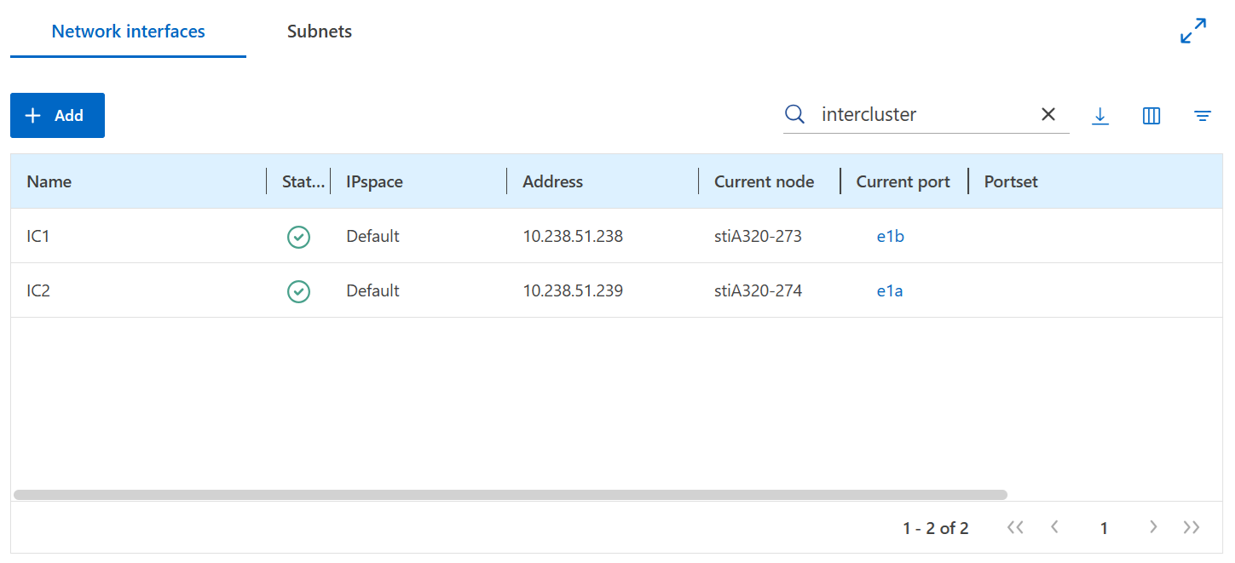
Note: If necessary, make any edits to interfaces here.

- Add a cluster peer via System Manager on the source ONTAP cluster.
Navigate to (Protection -> Overview)
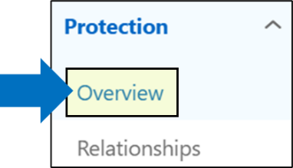
Click the next to “Cluster peers” and click “Add cluster peers” or click the “Add a cluster peer” button
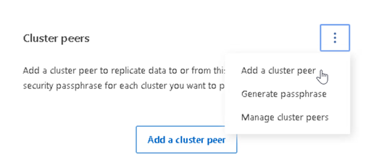
To peer to a remote cluster, a passphrase will be needed.
Click “Launch remote cluster.”
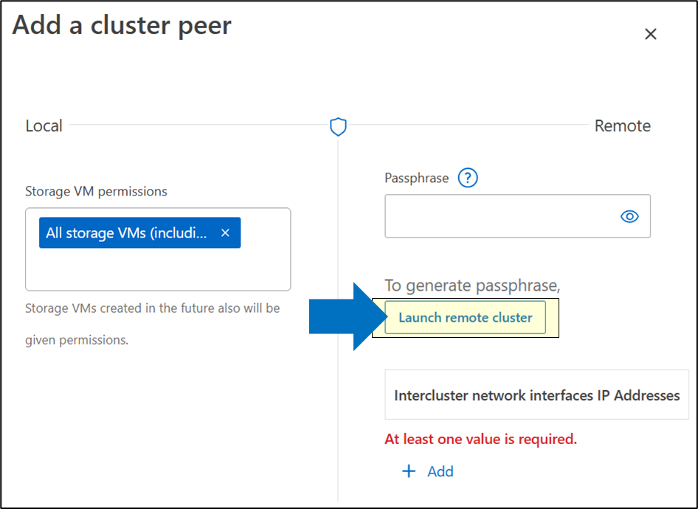
Add the remote cluster management IP address and click “Launch.”
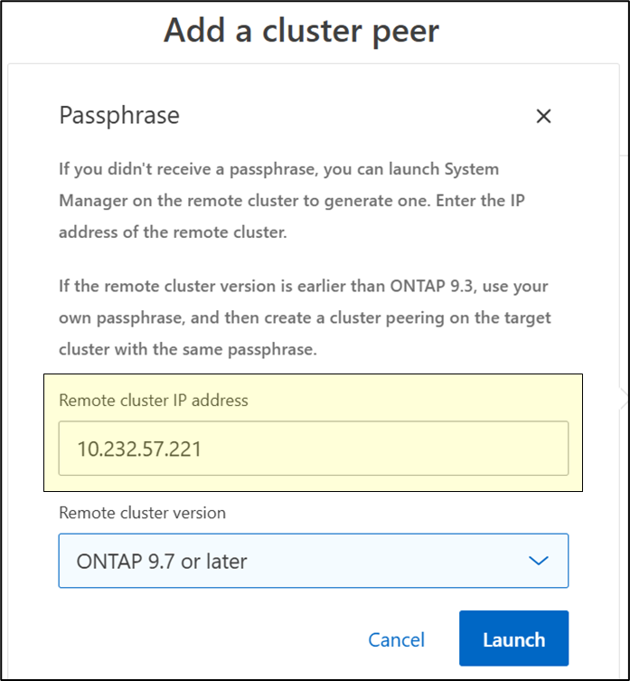
Generate passphrase
This will open a new window to the NetApp AFX cluster to generate a new passphrase for cluster peer authentication. From here, copy the passphrase and add it to the unified ONTAP system.
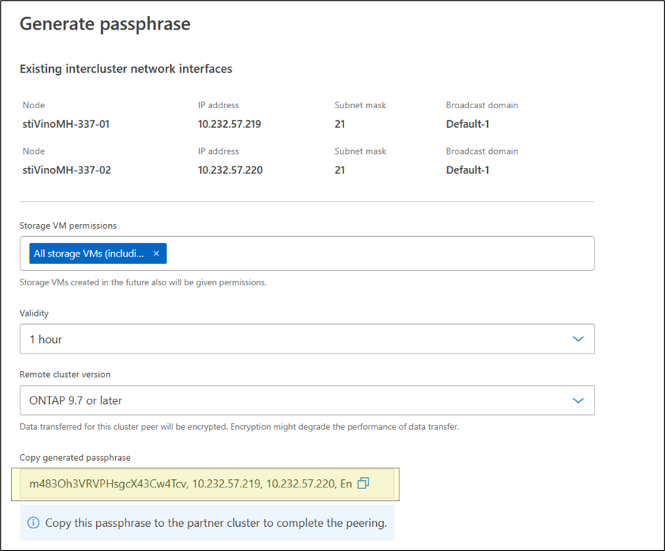
Add the passphrase
Verify if the intercluster IP addresses for the NetApp AFX cluster are populated. If everything looks good, click “Initiate cluster peering.”
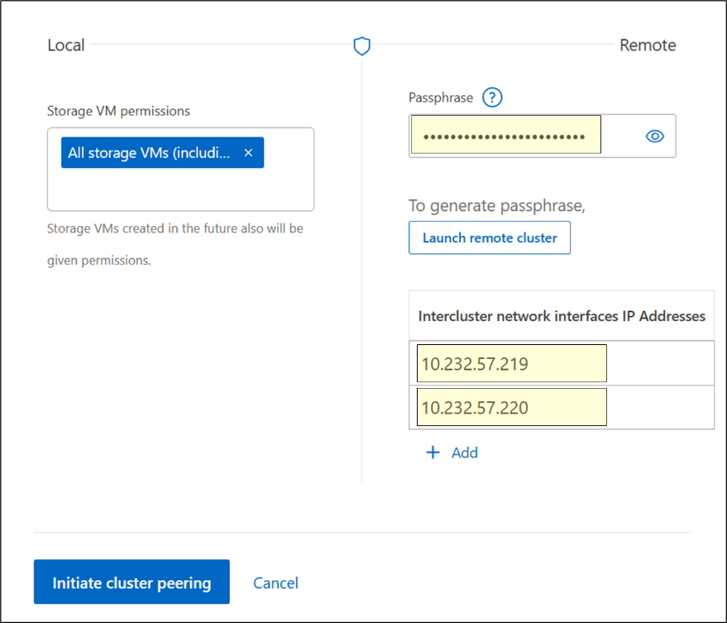
Verify the cluster peer status
If successful, you will see cluster peers listed under Protection -> Overview. Initially, the peer may show as “partial” with a red X next to the name. This can happen when the peer job is finishing. Eventually, the status should show a green check:
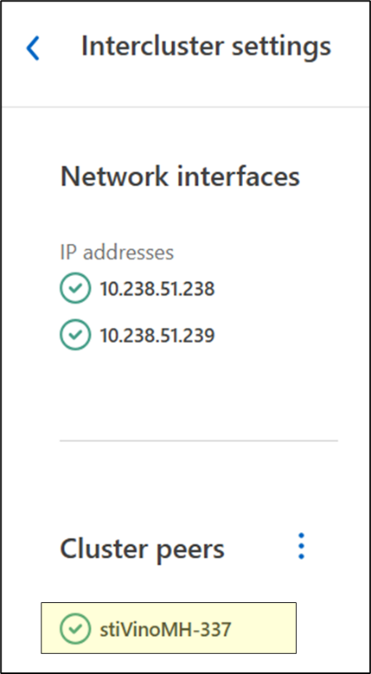
You can also check the cluster peer health from the command line.
AFX::*> cluster peer health show
Node Cluster-Name Node-Name
Ping-Status RDB-Health Cluster-Health Availability
---------- --------------------------- --------- --------------- ------------
AFX-01
unified unified-01
Data: interface_reachable
ICMP: - true true true
unified-02
Data: interface_reachable
ICMP: - true true true
AFX-02
unified unified-01
Data: interface_reachable
ICMP: - true true true
unified-02
Data: interface_reachable
ICMP: - true true true
4 entries were displayed.

- Establish SnapMirror from unified ONTAP to AFX.
Use source volume with production datasets on unified ONTAP cluster to the NetApp AFX cluster.
Navigate to the volume using the left menu. (Storage -> Volumes).
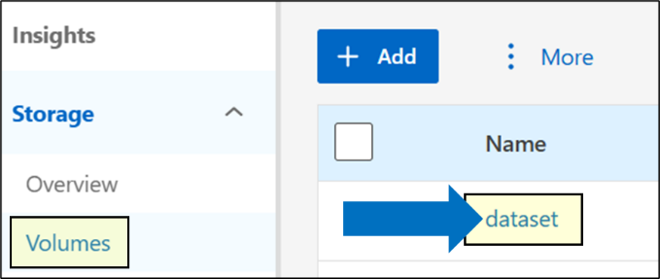
Hover over the volume name and click the to expand the menu.
Select “Protect”.
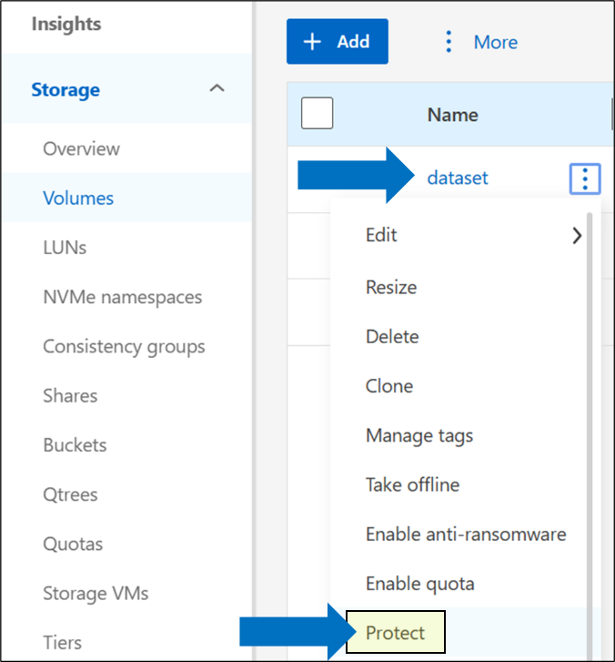
Configure the SnapMirror settings and click “Protect”
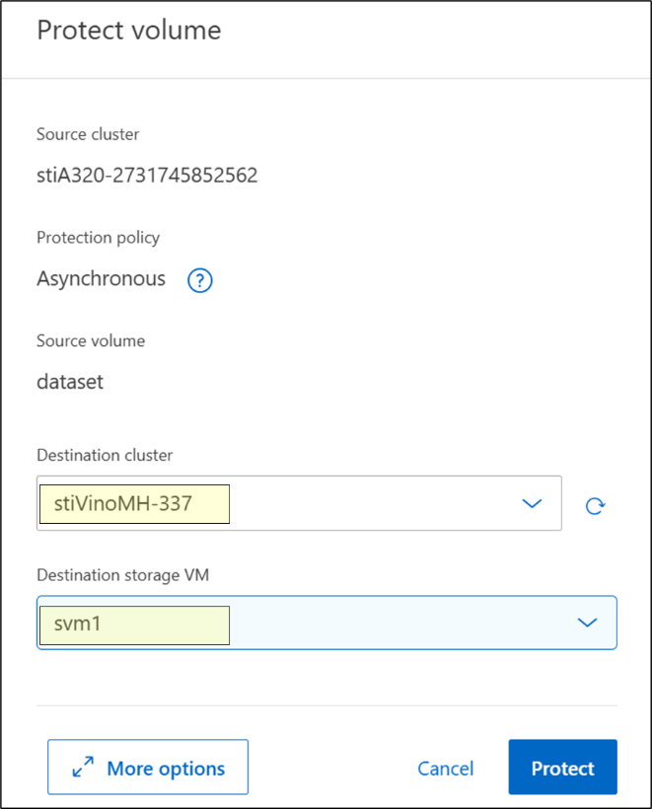
If the above steps fail, you can attempt to create the relationship via the CLI.

CLI Steps
Check the constituent count on the source volume’s FlexGroup volume.
SnapMirror of FlexGroup volumes will require identical constituent counts on source and destination.
AFX::> set advanced; volume show -vserver vs0 -volume dataset -fields constituent-count

Create a FlexGroup on the AFX cluster
The volume will need the same number of constituent volumes + equal/greater size with a type of “DP.”
AFX::> set advanced; vol create -volume dataset_dst -state online -size 2T -type DP -number-of-constituents [number from previous step]

Create the SnapMirror relationship
AFX::> snapmirror create -source-path vs0:dataset -destination-path svm1:dataset_dst -vserver svm1 -throttle unlimited

Initialize the SnapMirror
AFX::> snapmirror initialize -destination-path svm1:dataset_dst

- Verify replication is progressing and eventually completed. Optional: Leverage EMS to send email notification when SnapMirror job is completed.

GUI steps
Navigate to Protection -> Replication
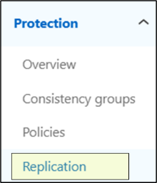
Click on the SnapMirror relationship
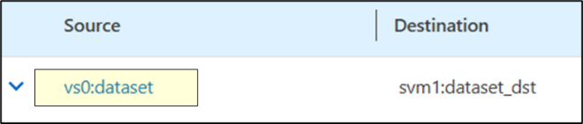
Verify the status
Is it healthy? What state is it in? What was the last transfer status?
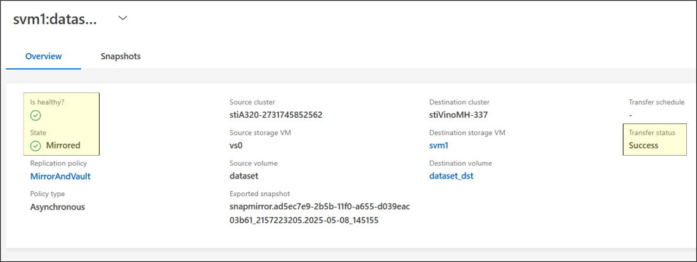
CLI Steps
AFX::*> snapmirror show
Progress
Source Destination Mirror Relationship Total Last
Path Type Path State Status Progress Healthy Updated
----------- ---- ------------ ------- -------------- --------- ------- --------
vs0:dataset XDP svm1:dataset_dst
Snapmirrored
Idle - true -

- Compare source and destination datasets.
Source and destination datasets can be compared via the CLI to see if the file counts are identical. This is an inexact science, but is useful for a start.

unified::*> vol show -vserver vs0 -volume dataset -fields files-used
vserver volume files-used
------- ------- ----------
vs0 dataset 78001
AFX::*> vol show -vserver svm1 -volume dataset_dst -fields files-used
vserver volume files-used
------- ----------- ----------
svm1 dataset_dst 78001

Compare contents/checksums
For a more accurate comparison, you will need to compare the actual contents of the volumes. For NFS, you can do that by mounting both volumes and running a diff command on the NFS client.
For the source volume, the last common snapshot should be used as the path.

# mount /unifiedONTAPvol
# mount /AFXONTAPvol
# diff -r unifiedONTAPvol/.snapshot/lastcommonsnap/ AFXONTAPvol/
The command can take considerable time (depending on file count and size), as it will read the entirety of the files. But if both volumes are identical, you should see no differences in the listings. If you wish to avoid this potentially lengthy step, use the files used count comparisons from the vol show command.

- Break the SnapMirror relationship and test ability to access and write to destination volume on NetApp AFX.
From the NetApp AFX System Manager GUI, navigate to Protection -> Replication.
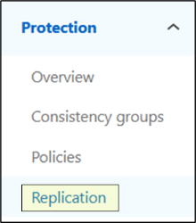
Hover over the relationship and use the to expand the menu. Select “Break.”
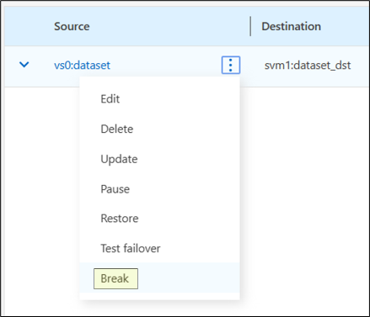
Confirm the details and click “Break.”
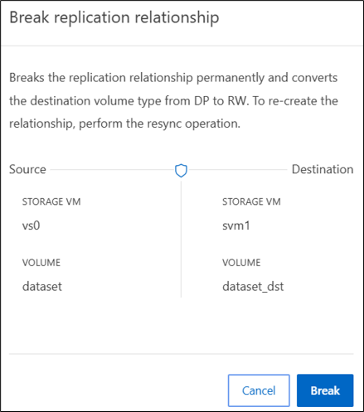
- Establish a SnapMirror from NetApp AFX to unified ONTAP with DR/backup as a goal.
There are two ways to achieve this goal. One way is to create a separate, brand new SnapMirror to a new destination volume. The other way is to initiate a “reverse resync,” which will re-use the original source volume. The below covers both steps. You can perform both or you can choose one.

Destination ONTAP cluster will need to be on 9.16.1 or later to allow Advanced Capacity Balancing to be enabled. If it’s not possible to use a destination unified ONTAP cluster, use the NetApp AFX cluster as the destination instead.
New SnapMirror steps
Navigate to Storage -> Volumes

Hover over the volume name and click the to expand the menu.
Select “Protect”.

Review the options and click “Protect.”
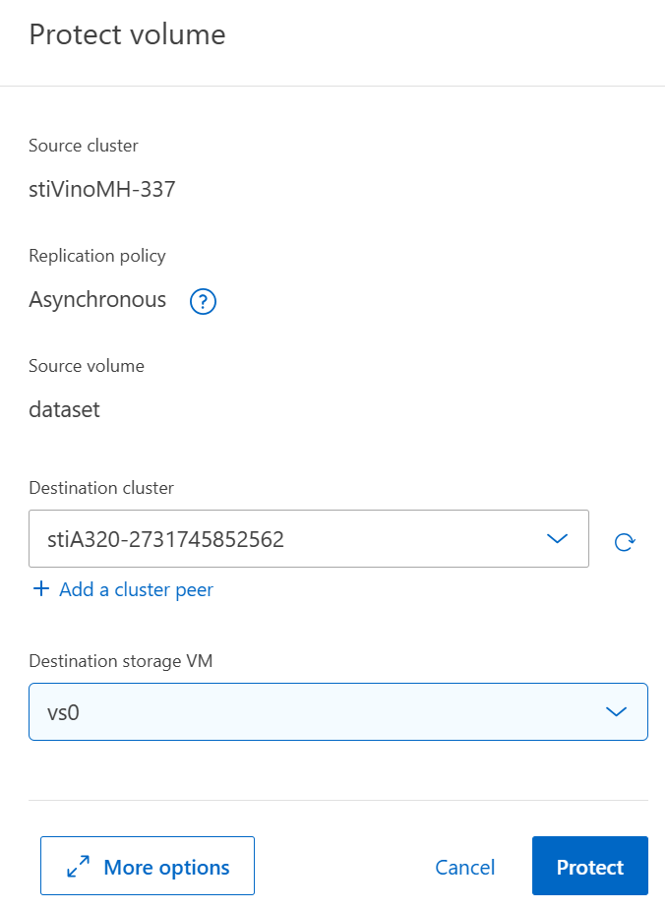
Reverse Resync steps:
Navigate to Protection -> Replication.

Hover over the relationship and use the to expand the menu. Select “Reverse Resync.”
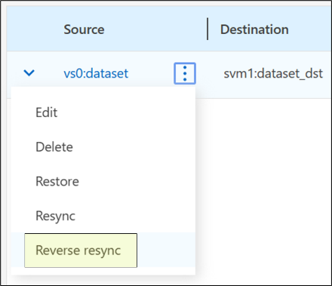
Verify in the unified ONTAP destination cluster that the relationship appears when navigating to Protection -> Relationships.
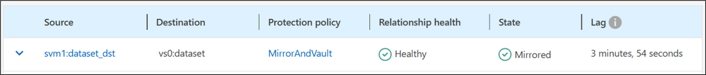
Expected outcome(s):
- A data protection relationship from unified ONTAP to NetApp AFX is established, and data migration is completed.
- Source and destination volume datasets are compared to verify successful migration.
- SnapMirror relationship is broken; destination volume is verified as writeable and ready for workload testing.
- OPTIONAL: Replicate from NetApp AFX to unified ONTAP
Test results:
Test summary:
Comments:
- Volume management
NetApp AFX makes some changes to how volumes are created and managed. This test aims to display some of those changes, show scale, and how volumes move automatically.
Test 5) Volume management.
Section | Details
Error! Reference source not found. | Tester: |  | Date:
Test requirements: | No specific requirements.
Test procedure:
- Use the script found in the appendix to create a large number of volumes on the cluster.
- Review the location of the constituent volumes of the FlexGroup volumes. Note the balance of volume counts per node. Volume counts should be relatively evenly distributed (+/- 2).
AFX::> vol show -volume name* -is-constituent true -fields size -node [node-name]
Example:
AFX::*> vol show -node AFX-01
…
98 entries were displayed. << SVM root is the +1
AFX::*> vol show -node AFX-02
…
97 entries were displayed.

- Create a new volume FlexGroup on a dedicated aggregate in admin privilege. Note the error.
AFX::*> set admin

AFX::> volume create -volume fg1 -aggr-list dataFA[tab] -aggr-list-multiplier 20

Error: command failed: Aggregate "dataFA_2_p0_i1" cannot be used to create a volume on this platform.

- Create a new FlexGroup volume on a specific node’s virtual aggregate using the -aggr-list-multiplier flag in diag priv. Use tab completion to suggest one of the virtual data aggregates.
AFX::> set diag
AFX::*> volume create -volume fg1 -aggr-list dataFA[tab] -aggr-list-multiplier 20
While NetApp AFX no longer leverages aggregates as a physical construct, there are still virtualized aggregates that “own” volumes. These provide a location for NVRAM commits to occur, since we still write the same way as unified ONTAP. By default, all volumes are created in the Storage Availability Zone and ONTAP handles the volume placement.
- View the volume count for each data aggregate after creating the FlexGroup volume. Note that the volumes counts are imbalanced.
AFX::*> aggr show -aggregate data* -fields volcount
aggregate volcount
-------------- --------
dataFA_2_p0_i1 31
dataFA_4_p0_i1 10

- Create a new FlexGroup volume without specifying the aggregate name and check the volume count again. Note how ONTAP is attempting to balance the placement across by placing new volumes evenly across nodes, but the imbalance is still present on the manually placed volumes.
AFX::*> volume create -volume fg2 -auto-provision-as flexgroup

rtp-afx1k-c01::*> aggr show -aggregate data* -fields volcount
aggregate volcount
-------------- --------
dataFA_2_p0_i1 41
dataFA_4_p0_i1 20

- The imbalance is present because when you manually override ONTAP volume placement, it disables the rebalance functionality (-atm-state). Check that in diag priv.
rtp-afx1k-c01::*> vol show -vserver svm1 -volume fg1,fg2 -fields atm-state
vserver volume atm-state
------- ------ ---------
svm1 fg1 disabled
svm1 fg2 enabled

- That can be re-enabled. Use the following command.
rtp-afx1k-c01::*> set diag; vol modify -volume fg1 -atm-state enabled

- After ~5 minutes, ONTAP runs a job that periodically rebalances the volume counts to even things out. You can either wait for that duration or manually start this process.

After ~5 minutes, we see this:
rtp-afx1k-c01::*> aggr show -aggregate data* -fields volcount,node
aggregate node volcount
-------------- ---------------- --------
dataFA_2_p0_i1 rtp-afx1k-c01-01 31
dataFA_4_p0_i1 rtp-afx1k-c01-02 30
To manually start the rebalance, a diag level command is used (and is not recommended to use on production workloads unless guided by NetApp support).
AFX::> set diag
AFX::*> debug smdb table atm_kick run

HA failover testing in a later part of this test plan will cover volume rebalancing there as well.
If you need to delete volumes/clean up volumes, you can leverage the volume delete script in the Scripts section.

Expected outcome(s):
- Volume counts will be balanced across nodes.
- Volume counts will rebalance when uneven.
Test results:
Test summary:
Comments:
- API testing/seamless support for customer automation
NetApp AFX is intended to provide a seamless ONTAP experience. Included in that is API parity between unified and NetApp AFX so that legacy automation suites using REST API calls to ONTAP will be plug-and-play into NetApp AFX.
If no current API-based automation suites are in use, then some basic REST API calls are provided to test functionality. See the appendix for examples.
Test 6) API testing/seamless support for customer automation
Section | Details
Test 6 | Tester: |  | Date:
Test requirements: | No specific requirements.
Test procedure:
- Test your REST API calls against unified ONTAP.

If you are not already using standard automation REST calls against unified ONTAP, then leverage the example calls in the appendix of this document.

- Test your REST API calls against NetApp AFX.
If you are not already using standard automation REST calls against NetApp AFX, then leverage the example calls in the appendix of this document.
Expected outcome(s):
- REST API calls used with unified ONTAP are tested.
- The same REST API calls are tested against NetApp AFX and are successful, with the exception of SAN-related and aggregate-related calls.
Test results:
Test summary:
Comments:
- Performance testing configuration
Performance testing is generally intended to find the edges of what a system can achieve in specific workload scenarios. Most of the time, the ONTAP default settings do not need to be adjusted to see good performance for most workloads, but in some cases, you may want to adjust some configurations to optimize the system. This section covers some genera considerations and configuration guidelines rather than serving as an actual test.

NFS export policy configuration
Export policies in ONTAP are how access to NFS exports are controlled. Every volume requires an export policy to be set, with rules configured in the policy. If no rules are configured in a policy, that will be considered as “no access.”
For performance benchmarking, we are likely less concerned with permissions to the clients being used for testing and instead would like to avoid any permission-related errors.
As a result, it is recommended to ensure that any export policy rule is set to wide-open access for the data volume, but only to the clients being used to access datasets. In addition, the vsroot policy *must* allow read access in the policy for path traversal.
vsroot policy (uses “default” policy)
export-policy rule create -policyname default -clientmatch 0/0 -rorule any -rwrule never
data volume policy
export-policy create -policyname [name] -vserver [SVM]
export-policy rule create -policyname [name] -clientmatch [client1],[client2],..[clientN] -rorule any -rwrule any -superuser any -anon 0 -chown-mode unrestricted -ntfs-unix-security-ops ignore

NFS server configuration
The following shows what NFS configuration settings were applied in the internal performance benchmark testing we have done at NetApp with AFX. It is recommended to use these and only stray from configurations here when given guidance to do so to get predictable results. One exception is the RDMA setting, which is not needed if RDMA will not be used in testing here. For details on RDMA configuration, see: https://docs.netapp.com/us-en/ontap/nfs-rdma/index.html
RDMA reduces latency and increases throughput for most workloads – roughly 10-30%.
set advanced; nfs modify -vserver [SVM] -v3 enabled -v4.1 enabled -v4.0 disabled -v4-id-domain [yourdomain.com] -v4.1-pnfs enabled -v4.1-trunking enabled -v4-64bit-identifiers enabled -v3-64bit-identifiers enabled -chown-mode unrestricted -tcp-max-xfer-size 262144 -mount-rootonly disabled -nfs-rootonly disabled -v3-hide-snapshot enabled -rdma [enabled optional]

Volume configuration
The following section covers volume creation/configuration considerations and shows what options should be used during the initial creation.
Volume type | FlexGroup
Creation method | CLI  set diag; vol create -vserver [SVM] -volume [name] -size [size] -junction-path [/path] -unix-permissions 777 -files-set-maximum true -maxdir-size 4G -is-large-size-enabled true -snapshot-policy none -autosize-mode grow_shrink -policy [data policy] -snapdir-access false
Defaults changed | - Snapshot policy disabled  - Maxfiles increased  - Maxdirsize increased  - Large size enabled  - Autosize enabled  - UNIX permissions 777  - File System Analytics disabled  - Snapdir access false

Special considerations – FlexGroup volumes
If the workload creates many large files (>1GB) in a single folder, modify the volume’s workflow to data:
AFX::> set advanced; vol modify -vserver [SVM] -volume [FlexGroup name] -workflow data
If the workload is VMware datastores hosted on a FlexGroup volume, disable the -gdd option:
AFX::> set diag; vol modify -vserver [SVM] -volume [FlexGroup name] -granular-data disabled

Why snapshots are disabled
In general, snapshots in ONTAP are not detrimental to overall system performance. However, in benchmarking, we would disable snapshots for two reasons:
- Granular control over the environment – We can create snapshots when we want to create them to better control the scenarios when snapshots are created and make it easier to measure their impact.
- Data churn – Many benchmark tests will create a lot of data and then subsequently delete that data, which will rapidly grow the size of any existing snapshots on the volume. To avoid space allocation issues, we disable snapshots.
Snapdir access is also disabled to prevent unwanted filesystem crawls across snapshots.

Mount options
Mount options, in general, are variable depending on use cases. This section attempts to show a general use case mount option list that was used in our internal performance testing. If the NFS server is configured properly (see above) then you won’t need to specify NFS versions or wsize/rsize options.
Base options (applies to all clients/scenaros):
-o tcp,hard,intr

Session trunking (OS-specific)
RHEL: trunkdiscovery
Ubuntu (depends on version): trunkdiscovery (newer releases)
max_connect=4 (older releases)
RDMA specific options
rdma,write=eager
Other mount options
Some workloads might benefit from special mount options during benchmark tests. The following table shows some of those options and what use cases might see performance improvements.
Table 3) Alternate NFS mount options and their use cases
NFS mount option | Description | Use case
nocto | Disables "close-to-open" cache consistency. The client will not revalidate cached file attributes when a file is opened, relying instead on cached data even if it may be stale. | Read-heavy, single-client workloads where files rarely change (e.g., static web content, software libraries, read-only media archives). Not suitable for multi-client writes.
cto | Enables close-to-open cache consistency (default). When a file is opened, the client checks with the server to ensure its cached copy is still valid. Guarantees that a file closed on one client is seen as up-to-date when opened on another. | Multi-client shared access workloads where data consistency matters (e.g., shared home directories, collaborative development environments).
actimeo | Sets all attribute cache timeouts (acregmin, acregmax, acdirmin, acdirmax) to a single value in seconds. Controls how long the client trusts cached file/directory metadata before revalidating with the server. | Simplifying tuning when you want a uniform caching policy. High values benefit read-heavy/static workloads; low values (e.g., actimeo=0) suit rapidly changing data needing near-real-time consistency.
acregmin | Sets the minimum time (seconds) the client caches attributes for a regular file before revalidating. Default is typically 3s. | Workloads with frequently updated small files where you want to fine-tune freshness vs. performance (e.g., log ingestion, config file polling).
acregmax | Sets the maximum time (seconds) the client caches attributes for a regular file. Default is typically 60s. | Mostly-static file workloads where extending the max reduces metadata chatter (e.g., large read-only datasets, package repositories).
acdirmin | Sets the minimum time (seconds) the client caches attributes for a directory before revalidating. Default is typically 30s. | Workloads with frequent directory listing or creation (e.g., build systems, mail spools with Maildir format) where directory freshness matters.
acdirmax | Sets the maximum time (seconds) the client caches attributes for a directory. Default is typically 60s. | Stable directory structures that rarely change — raising this reduces GETATTR calls (e.g., large static directory trees, archival storage).
clientaddr | Specifies the client IP address to advertise to the NFS server for callback communication (NFSv4/v4.1+). The server uses this address to send delegation recalls and other callbacks. | Multi-homed clients or environments with complex networking (e.g., clients with multiple NICs, VPN/overlay networks, or NAT) where the auto-detected address may be incorrect.
nconnect | Creates multiple TCP connections (up to the specified count) to the NFS server for a single mount, allowing parallel I/O over separate connections. | High-throughput, I/O-intensive workloads that are bottlenecked by a single TCP stream (e.g., large file transfers, HPC/scientific computing, video editing, database backups, big data analytics). Particularly beneficial on high-bandwidth networks (10 GbE+).
krb5* | Specifies what Kerberos security flavor to use with the mount. Requires Kerberos configuration to work properly. See TR-4616 NFS Kerberos with Active Directory for details. | Securing NFS mounts; has a negative impact on performance.

Client configuration
The client configuration used for our internal benchmarking is covered in the Clients section at the beginning of this document. The following contains some additional configuration considerations. This list is not considered exhaustive and will be modified over time to accommodate additional use cases/scenarios.

NFS readahead
From: https://learn.microsoft.com/en-us/azure/azure-netapp-files/performance-linux-nfs-read-ahead
NFS read-ahead predictively requests blocks from a file in advance of I/O requests by the application. It's designed to improve client sequential read throughput. Until recently, all modern Linux distributions set the read-ahead value to be equivalent of 15 times the mounted filesystems rsize.
RHEL 8.3 and Ubuntu 18.04 introduced changes that might negatively impact client sequential read performance. Unlike earlier releases, these distributions set read-ahead to a default of 128 KiB regardless of the rsize mount option used. Upgrading from releases with the larger read-ahead value to releases with the 128-KiB default experienced decreases in sequential read performance. However, read-ahead values may be tuned upward both dynamically and persistently. For example, testing with SAS GRID found the 15,360 KiB read value optimal compared to 3,840 KiB, 960 KiB, and 128 KiB. Not enough tests have been run beyond 15,360 KiB to determine positive or negative impact.
For steps on how to view/set NFS readahead values, see: How to show or set read-ahead values

Network configuration
The following section covers some general networking guidance for client and storage networking. These are based on the internal benchmark tests we have done.

Storage network considerations
- At least one data IP address per node, per SVM (more per node is better)
- Maximum of 16 IP addresses per node, per SVM
- All data interfaces routable to all clients
- Bonded/teamed ports per node using LACP
- MTU size of 9000 (end to end)
- Priority flow control (PFC priority 3) enabled when using RDMA
- DNS round robin/load balancing configured to include all data interface IP addresses

Client network considerations
- Dual NICs bonded for RoCE (LACP)
- RX/TX ring buffers set to 8192
- PFC and DSCP configured per NIC (when using RDMA)
- RoCE traffic class set using cma_roce_tos (when using RDMA)
- sunrpc.rdma_slot_table_entries set to 200

ONTAP feature considerations
The following covers specific ONTAP feature configuration modifications that are not covered in the sections above.

Disable storage efficiencies
In general, storage efficiencies are one of the selling points for a production workload, as they can generate large space savings across a variety of workloads. However, in performance benchmarking, they offer less value (as many simulated workloads are either uncompressible or are zero-byte workloads and always deduplicating). As a result, we recommend disabling all storage efficiencies while performing benchmark tests.
vol efficiency off -volume [name] -vserver [SVM]
aggr efficiency modify -aggregate data* -cross-volume-background-dedupe false -cross-volume-inline-dedupe false
aggr efficiency wise-tsse modify -aggregate data* -enable-workload-informed-tsse false

Aggressive readahead
n media streaming workloads, a 4K movie is often split into tens of thousands of files, each typically 50 MB to 250 MB in size. Each file represents a frame, and the application reads an entire frame in a single request. To maintain a smooth, uninterrupted stream with no visible buffering, these frame reads must complete without drops.
ONTAP provides a volume-level option (-aggressive-readahead-mode) to optimize these workloads. Starting in ONTAP 9.19.1, a new cross_file_sequential_read mode for aggressive readahead has been introduced on AFX to accelerate workloads with predictable I/O patterns across similar file types (for example, media rendering and streaming).
cross_file_sequential_read predicts the next file to be read based on its name and begins readahead on those files before the client issues the read call. The prediction logic assumes that all files in a directory follow a naming pattern with a monotonically increasing numeric suffix (eg. file1, file2, file3). All files in the directory must follow this pattern, using either decimal or hexadecimal numbering. Filenames can be up to 255 characters long. The logic is extension agnostic and generates the next set of filenames in the current directory based solely on the current filename. If a filename previously generated using base10 numbering does not exist in the directory, the names are regenerated using hexadecimal numbering. If none of the generated filenames exist, no prefetch is issued for that set. Prefetching resumes when the next client read is issued.
To enable on a per-volume basis:
AFX::> set adv; vol modify -volume [name] -aggressive-readahead-mode cross_file_sequential_read
With this option enabled, frametest performance benchmarks were able to read 30,000 4K frames at 30 frames per second with 30 clients (NFSv3 and SMB3) and 34 clients (NFSv4.1), without a single dropped frame.
While cross-file sequential read is primarily designed for media workloads, other read-heavy workloads with predictable access patterns and file names - such as AI training and inference - can also benefit.

Considerations and caveats
- Shared buffer cache – Aggressive read ahead uses the same buffer cache as other volumes on the node. Enabling it may affect read performance for other volumes on that node.
- Underlying storage performance – If files cannot be read quickly enough (for example, on HDD-based FAS systems), cached data may be evicted before the client read occurs, negating the benefits of read ahead.
- Access pattern requirements – If the workload's read pattern is not sequential, or if files in a directory are not named in an increasing sequential order, the cross_file_sequential_read aggressive read ahead mode will not provide meaningful benefits.

- Customer workload testing – real data
The goal of these workload tests is to show that real data workloads can be ported over to NetApp AFX seamlessly and can potentially provide performance benefits over unified ONTAP – particularly when growing the compute side of the cluster.
For NFS considerations, see the Appendix in this document.
Test 7) Customer workload testing – real workloads, real data
Section | Details
Test 7 | Tester: |  | Date:
Test requirements: | No specific requirements.
Test procedure:
- Mount NetApp AFX volume using NAS protocol of your choice.
Mount using NFS or SMB. For best results, use multiple simultaneous clients rather that testing a single client’s performance.

Find the export path of your data volume in System Manager.
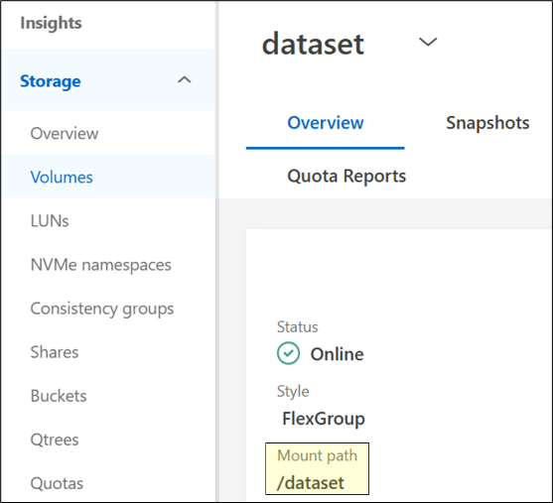
Mount the volume using NFS.
Optionally, include the mount path in /etc/fstab or automounter*
*Recommended NFS versions and mount options are found in the NFS considerations above.
- Run designated workloads against existing datasets that have been migrated over from unified ONTAP. While benchmarks are running, move on to Test 5) Performance Monitoring.
Test real-world data using everyday workloads. As workloads are running, test the limits of NetApp AFX by adding more clients or more jobs to the workload to push the limits of scale.
Expected outcome(s):
- Workloads should not need additional configuration or changes to run properly using NetApp AFX.
- Performance should be as good or better than unified ONTAP.
Test results:
Test summary:
Comments:
- Customer workload testing – Performance benchmarks
In lieu of - or in addition to – testing real data workloads, storage benchmark tests can also be run against the NetApp AFX cluster to display some of the potential performance.
For EDA workloads, we can leverage SPEC SFS 2020 EDA for benchmarking. This benchmark can also be used for general testing of small random IO (including high metadata) and larger sequential IO.
For AI/ML workloads, we will leverage MLcommons, which can also act as a throughput-specific benchmark.
For details on installing, configuring and running SpecSFS or MLcommons, see the Appendix of this document.
Test 8) Customer workload testing - benchmarks
Section | Details
Test 8 | Tester: |  | Date:
Test requirements: | No specific requirements.  Benchmark tests are run using specific parameters stated in this document.
Test procedure:
- Create a FlexGroup volume in the NetApp AFX cluster.

Navigate to the Storage -> Volumes menu in System Manager
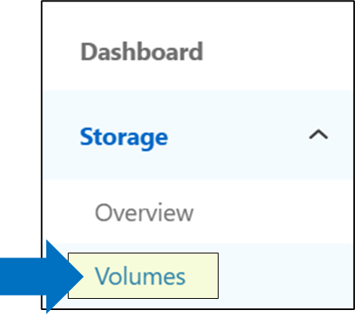
Click + Add
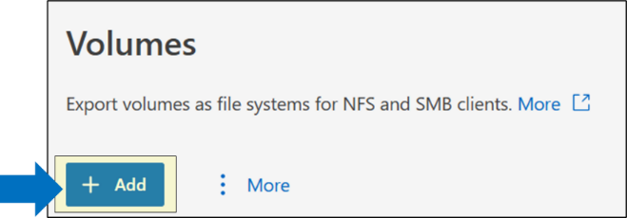
Enter the volume name, capacity and select “High throughput” to create a FlexGroup
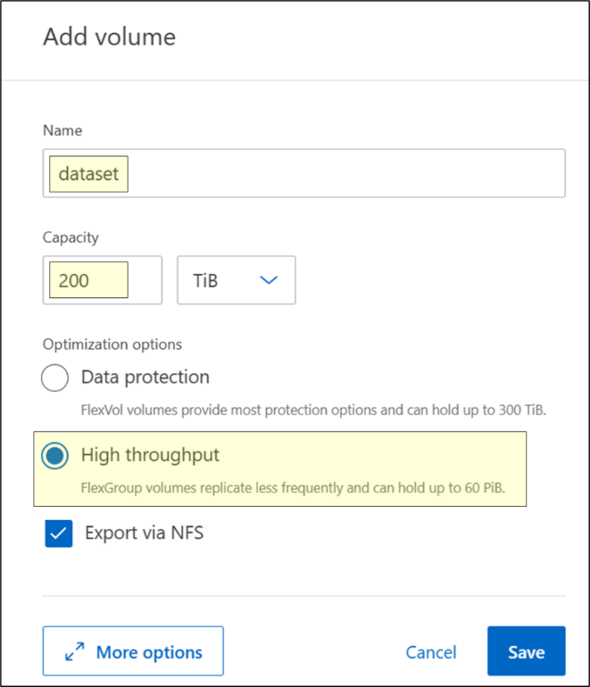
Optionally, click “More options” to disable/enable data protection features and add export policies and rules
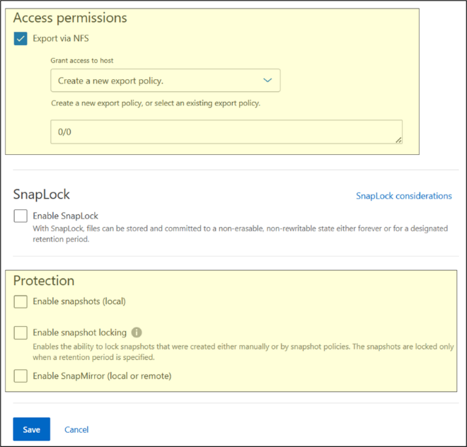
Click save.
- Mount NetApp AFX volume using NAS protocol of your choice.
Mount using NFS or SMB. For best results, use multiple simultaneous clients rather that testing a single client’s performance.

Find the export path of your data volume in System Manager.

Mount the volume using NFS.
Optionally, include the mount path in /etc/fstab or automounter*
*Recommended NFS versions and mount options are found in the NFS considerations in the Appendix of this document..

- Generate datasets.
For detailed steps on how to run the benchmarks, see the appendix of this document.

- Run benchmarks on datasets. While benchmarks are running, move on to the Performance Monitoring test plan.
Expected outcome(s):
- Benchmarks should show the performance capabilities of this system.
Test results:
Test summary:
Comments:
- Performance monitoring
The goal of this test is to illustrate the performance monitoring capabilities of NetApp AFX and how it can integrate into current performance monitoring tools used by unified ONTAP and how understanding ONTAP performance should have little to no learning curve from unified ONTAP.
NetApp System Manager can be used for basic performance monitoring and is covered in the test below.
NetApp Harvest can be used to monitor performance at a more advanced level:
NetApp Harvest - GitHub
Test 9) Performance monitoring
Section | Details
Test 9 | Tester: |  | Date:
Test requirements: | No specific requirements.  Performance testing being run during monitoring,
Test procedure:
- Verify performance tests are running.
Performance tests can be real data or benchmarks.
From the System Manager GUI
Login to System Manager. On the main page, you can see performance graphs on the right. This shows if there is activity in the cluster.
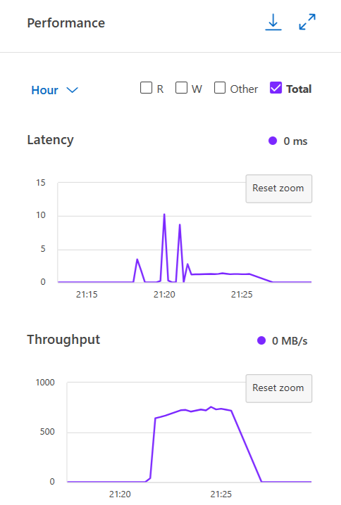
To verify if this activity is happening on the volume you created, you can click on Storage->Volumes and then click on the volume you created.
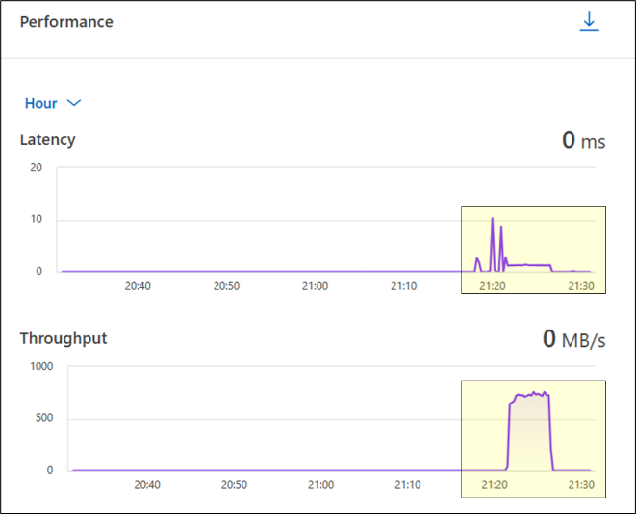
Use CLI statistics to capture performance information.

Cluster statistics can be captured in real time with “statistics show-periodic”
AFX::*> statistics show-periodic
AFX: cluster.cluster: 5/8/2025 01:34:46
cpu cpu total fcache total total data data data cluster cluster cluster disk disk pkts pkts
avg busy ops nfs-ops cifs-ops ops spin-ops recv sent busy recv sent busy recv sent read write recv sent
---- ---- -------- -------- -------- -------- -------- -------- -------- ---- -------- -------- ------- -------- -------- -------- -------- -------- --------
7% 13% 777 777 0 0 678 699MB 2.67MB 2% 698MB 2.37MB 0% 326KB 300KB 8.39MB 31.7KB 482985 36295
7% 13% 907 907 0 0 795 785MB 2.89MB 2% 784MB 2.59MB 0% 334KB 307KB 12.2MB 15.8KB 542564 39790
8% 14% 797 797 0 0 705 707MB 2.75MB 1% 706MB 2.46MB 0% 337KB 304KB 109MB 341MB 488621 37404
cluster: cluster.cluster: 5/8/2025 01:34:52
cpu cpu total fcache total total data data data cluster cluster cluster disk disk pkts pkts
avg busy ops nfs-ops cifs-ops ops spin-ops recv sent busy recv sent busy recv sent read write recv sent
---- ---- -------- -------- -------- -------- -------- -------- -------- ---- -------- -------- ------- -------- -------- -------- -------- -------- --------
Minimums:
7% 13% 777 777 0 0 678 699MB 2.67MB 1% 698MB 2.37MB 0% 326KB 300KB 8.39MB 15.8KB 482985 36295
Averages for 3 samples:
7% 13% 827 827 0 0 726 730MB 2.77MB 1% 730MB 2.47MB 0% 332KB 304KB 43.5MB 113MB 504723 37829
Maximums:
8% 14% 907 907 0 0 795 785MB 2.89MB 2% 784MB 2.59MB 0% 337KB 307KB 109MB 341MB 542564 39790

For volume-level:
AFX::*> qos statistics volume performance show -volume dataset -vserver svm1
Workload ID IOPS Throughput Latency
--------------- ------ -------- ---------------- ----------
-total- - 854 838.93MB/s 1178.00us
-total- - 586 561.70MB/s 1190.00us
-total- - 1005 985.07MB/s 1177.00us
- Collect protocol-level statistics during performance tests.
Performance tests can be real data or benchmarks.
From the command line, you can run “statistics start” to begin a stats collection during a specific job run. For this example, we will collect NFSv4.1 statistics. You can run these statistics at any time, but it is best to run these before starting a benchmark or data workload and then stopping them when the job is complete. These commands can be run in advanced privilege.
AFX::> set advanced -confirmations off

AFX::*> statistics start -object nfsv4_1 -vserver svm1 -sample-id unet3d_datagen
Statistics collection is being started for sample-id: unet3d_datagen

[run test to completion]

AFX::*> statistics stop -sample-id unet3d_datagen
Statistics collection is being started for sample-id: unet3d_datagen

Once the statistics are stopped, you can view all the counter collected with:
AFX::*> statistics show -sample-id unet3d_datagen

To view specific counters, you can use the counter name or wildcards. For instance, to see all GETATTR values:
AFX::*> statistics show -sample-id unet3d_datagen -counter *getattr*

Object: nfsv4_1
Instance: svm1
Start-time: 5/8/2025 01:44:16
End-time: 5/8/2025 01:49:55
Elapsed-time: 339s
Scope: cluster

Counter Value
-------------------------------- --------------------------------
getattr_avg_latency 21us
getattr_latency_hist -
<6us 24
<10us 52
<14us 806
<20us 1131
<40us 960
<60us 30
<200us 8
<400us 17
getattr_success 3028
getattr_total 3028

To see a breakdown of the workload percentages:
AFX::*> statistics show -sample-id unet3d_datagen -counter *percent*

Object: nfsv4_1
Instance: svm1
Start-time: 5/8/2025 01:44:16
End-time: 5/8/2025 01:49:55
Elapsed-time: 339s
Scope: cluster

Counter Value
-------------------------------- --------------------------------
compound_percent 33%
putfh_percent 33%
sequence_percent 33%
write_percent 32%

To see a breakdown of read and write sizes:
cluster::*> statistics show -sample-id unet3d_datagen -counter *size_hist*

Object: nfsv4_1
Instance: svm1
Start-time: 5/8/2025 01:44:16
End-time: 5/8/2025 01:49:55
Elapsed-time: 339s
Scope: cluster

Counter Value
-------------------------------- --------------------------------
nfs41_write_size_histo -
<=512B 7
<=2KB 5
<=4KB 24
<=8KB 6
<=16KB 18
<=32KB 108
<=64KB 138
<=128KB 204
<=256KB 315
<=512KB 471
<=1MB 207785
Expected outcome(s):
- Benchmarks should show the performance capabilities of this system.
- Performance statistic collection should be nearly identical to ONTAP.
Test results:
Test summary:
Comments:
- Capacity management
Viewing and managing capacity in NetApp AFX has been streamlined to improve simplicity and understanding of what capacity you actually have available. Aggregates as a managed construct are removed. Instead, volumes and the new Storage Availability Zone concept are how we view and managed capacity. This test plan shows different ways capacity is managed in NetApp AFX.
Test 10) Capacity management
Section | Details
Test 10 | Tester: |  | Date:
Test requirements: | No specific requirements.  Performance testing being run during live node additions.
Test procedure – GUI:
- View capacity in the dashboard.
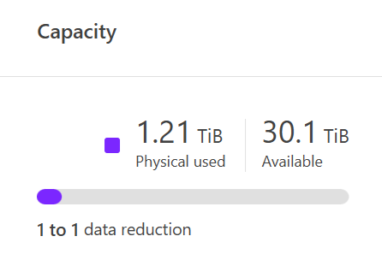

From the CLI
- Display the Storage Availability Zone
AFX::> storage availability-zone show
- Display the cluster space
AFX::> cluster space show
Expected outcome(s):
- Capacity views should be easy to understand.
- Storage availability zones should simplify capacity use.
Test results:
Test summary:
Comments:
- Compute scaling (optional)
One of the main benefits of NetApp AFX is the ability to scale compute and capacity independently. In this test, we will add 2 additional storage nodes to a 2-node NetApp AFX cluster during live workloads to verify that node additions are not only nondisruptive, but also increase performance scale linearly as volumes are rebalanced across nodes. This can also be done with other node count options (ie, starting with 4 nodes and adding 4 more nodes for an 8 node cluster).
Test 11) Node additions during live workloads
Section | Details
Test 11 | Tester: |  | Date:
Test requirements: | No specific requirements.  Performance running during live node additions.
Test procedure:
- Ensure benchmarks or performance workloads are running during these tests. Note the current average throughput and IOPS.
AFX::> set advanced
AFX::*> qos statistics volume performance show -vserver svm1 -volume [volname]

- Check volume location of current nodes. Note the number of volumes per node.
AFX::> set advanced
AFX::*> vol show -fields node,size,constituent-count -is-constituent true -node *

- Log into the service processor of the node(s) you wish to add to the cluster.
- From the prompt, type “system console” to access the node’s console. If the node is not at the LOADER prompt, you can use ctl+d to exit to the BMC/service processor prompt. Type “system reset”, answer y for dirty shutdown, then “system console” to watch the boot process. Hit ctl+c when you see the “interrupt Autoboot” message.
- Once at the LOADER prompt, run the following:
set-defaults
setenv bootarg.init.unjoined true
saveenv
- Then, boot the node to the boot menu prompt.
LOADER> boot_ontap menu

- Select option 4 from the menu.
Please choose one of the following:

(1) Normal Boot.
(2) Boot without /etc/rc.
(3) Change password.
(4) Initialize and configure system.
(5) Maintenance mode boot.
(6) Update flash from backup config.
(7) Install new software first.
(8) Reboot node.
(9) Clean System Configuration.
(10) Set Onboard Key Manager recovery secrets.
(11) Configure node for external key management.
Selection (1-11)? 4

- If prompted, type yes:
WARNING: This node may not have been properly unjoined from an existing cluster, please confirm before using option (4)

WARNING: This node may not have been properly unjoined from an existing cluster. Please confirm before continuing with option 4.
Zero disks, reset config and install a new file system?: yes
If you get sent back to LOADER from here, type boot_ontap at the LOADER prompt

- Use the cluster setup wizard to configure a node management LIF/subnet/gateway. This will be used by System Manager to detect the node for addition into the cluster. Places to input information highlighted in yellow.
Welcome to the cluster setup wizard.

You can enter the following commands at any time:
"help" or "?" - if you want to have a question clarified,
"back" - if you want to change previously answered questions, and
"exit" or "quit" - if you want to quit the cluster setup wizard.
Any changes you made before quitting will be saved.

You can return to cluster setup at any time by typing "cluster setup".
To accept a default or omit a question, do not enter a value.

This system will send event messages and periodic reports to NetApp Technical
Support. To disable this feature, enter
autosupport modify -support disable
within 24 hours.

Enabling AutoSupport can significantly speed problem determination
and resolution, should a problem occur on your system.
For further information on AutoSupport, see:
https://support.netapp.com/autosupport/

Type yes to confirm and continue {yes}: yes
May 16 02:26:09 [localhost:asup.general.optout:notice]: AutoSupport will be enabled 24 hours after system initialization.

Enter the node management interface port [e0M]:
Enter the node management interface IP address: 10.232.12.128
Enter the node management interface netmask: 255.255.254.0
Enter the node management interface default gateway: 10.232.12.1
A node management interface on port e0M with IP address 10.232.12.128 has been created.

- Press CTL+C and enter the cluster CLI to modify the cluster interconnect IP addresses, as they auto create and may not be routable on your network. If you get a login: prompt, use admin. There will be no password here.
This step is only needed if the other cluster interfaces on existing ndoes do not use the 169.254.x.x addresses that ONTAP auto creates. In most cases, you can leave these as defaults.

::> net int show -role cluster
(network interface show)
Logical Status Network Current Current Is
Vserver Interface Admin/Oper Address/Mask Node Port Home
----------- ---------- ---------- ------------------ ------------- ------- ----
Cluster
clus1 up/up 169.254.118.206/16 localhost e7a true
clus2 up/up 169.254.220.172/16 localhost e7b true
2 entries were displayed.
::> net int modify -vserver Cluster -lif clus1 -address 192.168.76.222
(network interface modify)

::> net int modify -vserver Cluster -lif clus2 -address 192.168.76.226
(network interface modify)

- Repeat the above setup steps on the other NetApp AFX node(s).

- From here, access the System Manager window via the cluster management IP. Navigate to Cluster -> Overview and click on the “Nodes” tab.
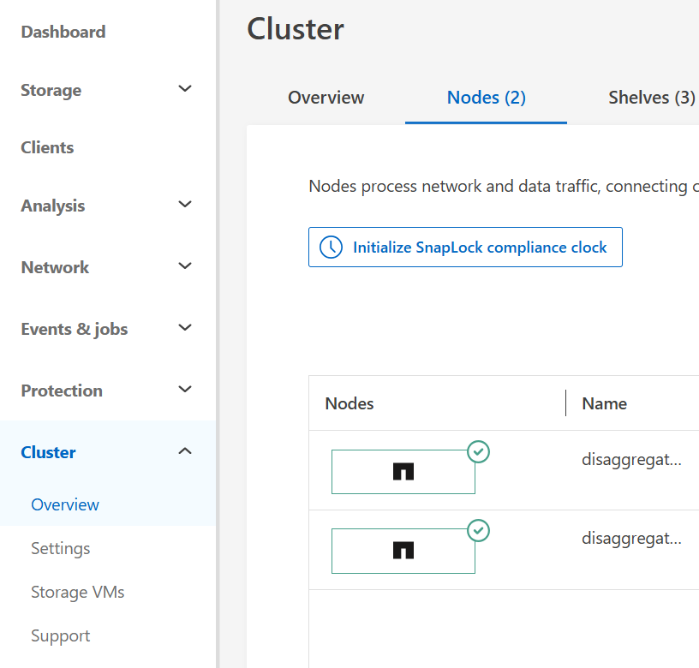

- At the bottom of the page, you should see a section called “Not part of this cluster” and your new nodes below that. Click “+ Add” to add the node to the cluster.
An odd number of nodes cannot be added to a cluster.
If the nodes are discovered before the cluster interconnect IP addresses are changed, then you will need to re-discover the nodes by exiting the window and navigating back.
If the GUI addition does not work, try the CLI command cluster add-node instead If issues persist, utilize contact NetApp support or reach out to [email].
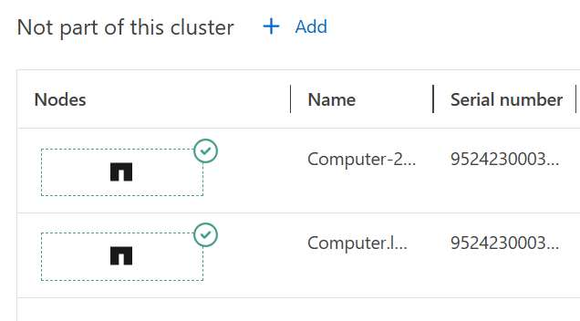

- Use the “Add nodes” screen to fill in your information. Management IP addresses can be added manually or by using a subnet.
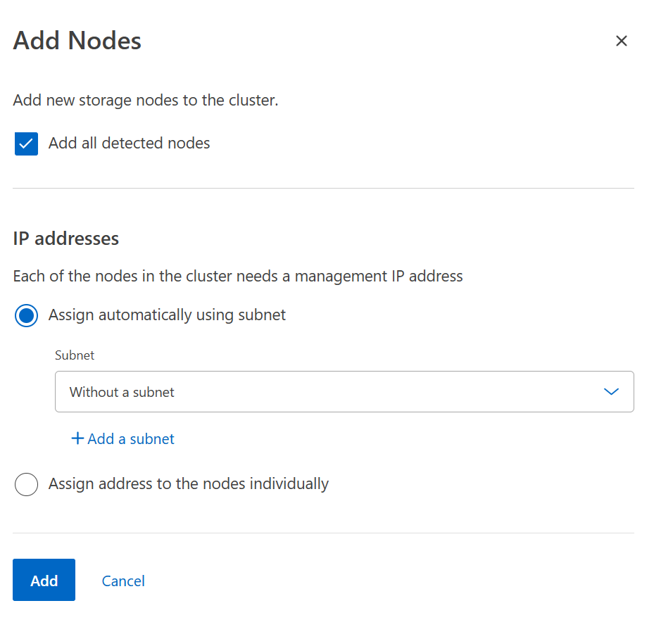

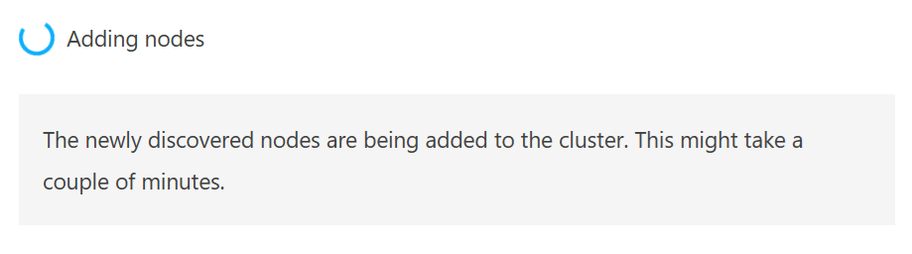

- Log into the cluster CLI. Monitor the node add status.
AFX::*> add-node-status
(cluster add-node-status)

Node Name Cluster IP Status Error Reason
---------------- ------------------- ------------------- --------------------------
AFX-01 192.168.76.221 success
AFX-03 192.168.76.226 node-initialization
AFX-04 192.168.76.220 node-initialization
AFX-02 192.168.76.224 success
4 entries were displayed.

- OPTIONAL: Log into the system console of the nodes being added via the service processor and observe the steps being performed.

- Once the node adds have completed, check the volume placement across all nodes.
AFX::> set advanced
AFX::*> vol show -fields node,size,constituent-count -is-constituent true -node AFX-01
AFX::*> vol show -fields node,size,constituent-count -is-constituent true -node AFX-02
AFX::*> vol show -fields node,size,constituent-count -is-constituent true -node AFX-03
AFX::*> vol show -fields node,size,constituent-count -is-constituent true -node AFX-04

Eventually, volumes should be distributed evenly across all nodes. Check back every 5 minutes or so.
If disks are unavailable to one of the nodes (ie, bad switch config, bad cabling, card issues), then nodes will not add properly.
If the node does not have two healthy cluster LIFs (ie a cluster port is down), the node will not add properly.
Volumes will not move to unhealthy nodes/incomplete node joins.

- Add/configure new network interfaces for your SVM on a per-node basis to add performance to the workload. Add at least one per node for NFSv3 and at least two per node if using NFSv4.x.
AFX::> net int create -vserver [SVM] -lif [name] -address [10.10.10.10] -netmask [255.255.255.0] -home-node [node1] -home-port [port] -rdma-protocols [optional] -broadcast-domain [optional]
..
AFX::> net int create -vserver [SVM] -lif [name] -address [10.10.10.10] -netmask [255.255.255.0] -home-node [node4] -home-port [port] -rdma-protocols [optional] -broadcast-domain [optional]

- If you are using pNFS, you clear the device caches to ensure the new interfaces get picked up.
AFX::> set diag -c off
AFX::*> pnfs lif-mapping-cache flush -node *
AFX::*> pnfs devices cache flush -node * -vserver [SVM1]
AFX::*> pnfs devices invalidate -global-device-table-id *

- Verify if performance has increased for the currently running workload (throughput, CPU utilization, IOPS, etc.)
AFX::> set advanced
AFX::*> qos statistics volume performance show -vserver svm1 -volume [volname]
From System Manager, you can view the performance graph.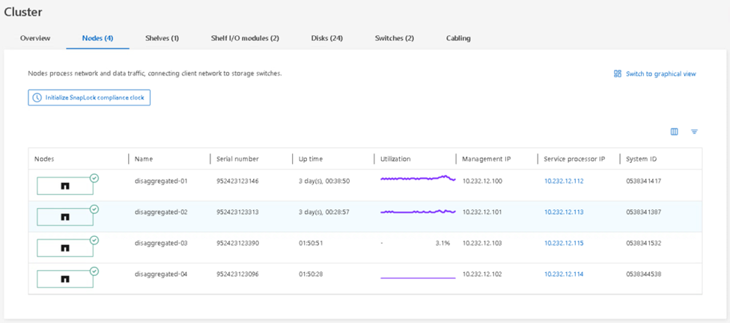
Expected outcome(s):
- Adding new nodes to the cluster should be nondisruptive.
- Volume moves should happen automatically and be nondisruptive.
- Performance should scale up linearly.
Test results:
Test summary:
Comments:
- Node failure behavior
In NetApp AFX, storage failovers and givebacks allow for workloads to operate even through disruptions to nodes. One main difference, however, is that volumes owned by nodes will be automatically moved evenly across surviving nodes after a time period (~17 minutes) where the cluster verifies the node is truly down. In unified ONTAP, volumes would only move to the HA partner.
This test’s goal is to not only show that failovers and givebacks are capable of operating nearly identical to unified ONTAP, but also will show that storage administrators no longer need to factor in volume counts when sizing clusters greater than 4 nodes in size because NetApp AFX will rebalance volumes across all nodes in storage failover scenarios rather than allowing a partner node to be overcommitted.
Failover here will be generated by node panic, which will automatically perform a call home to generate a case (provided ASUP is enabled). We will send a test ASUP prior to that to inform support that the cluster is under maintenance.
Test 12) Node failure behavior
Section | Details
Test 12 | Tester: |  | Date:
Test requirements: | No specific requirements.  Benchmarks or performance workloads are active.
Test procedure:
- Log into the cluster via the cluster management LIF.
- Verify benchmarks or performance workloads are running during these tests.
AFX::> set advanced
AFX::*> statistics show-periodic -counter nfs-ops
AFX: cluster.cluster: 5/15/2025 18:18:17
nfs-ops
--------
3455
5253
If there are NFS ops in progress, then the workload is active.

- Check and note current volume locations across all nodes.
AFX::> set advanced
AFX::*> vol show -fields node,size,constituent-count -is-constituent true -node AFX-01
AFX::*> vol show -fields node,size,constituent-count -is-constituent true -node AFX-02
AFX::*> vol show -fields node,size,constituent-count -is-constituent true -node AFX-03
AFX::*> vol show -fields node,size,constituent-count -is-constituent true -node AFX-04

- Send an Autosupport to show the node will be under maintenance/testing.
AFX::> autosupport invoke -node * -type test -message "POC maintenance"

- Panic node4
AFX::> node run -node AFX-04
Type 'exit' or 'Ctrl-D' to return to the CLI
AFX-04> priv set diag
Warning: These diagnostic commands are for use by NetApp
personnel only.
AFX-04*> panic
This process can take a long time due to the size of the core files. Booting back up immediately may not be possible.

- While the nodes are in takeover, check the network interfaces and if they have been migrated.
AFX::*> net int show -vserver SVM1 -fields is-home,is-home,home-node,home-port,curr-node,curr-port
“is-home false” means the interface has been migrated from its home node.

- Check the volume locations for each node. Note and compare to before takeover.
Volume moves after failover can take roughly 17-22 minutes as ONTAP waits to verify the node is actually down. But once they are enacted, they will complete quickly.
AFX::> set advanced
AFX::*> vol show -fields node,size,constituent-count -is-constituent true -node AFX-01
AFX::*> vol show -fields node,size,constituent-count -is-constituent true -node AFX-02
AFX::*> vol show -fields node,size,constituent-count -is-constituent true -node AFX-03
AFX::*> vol show -fields node,size,constituent-count -is-constituent true -node AFX-04

- View the volume move status.
AFX::*> vol move show -vserver svm1 -instance

- Check the EMS messages to see if the volumes have moved.
AFX::> event log show

- Verify if performance has changed for currently running workload (throughput, CPU utilization, IOPS, etc.) and if operations have experienced noticeable disruption.
Use the performance monitoring steps in the Performance monitoring test plan above.

- Boot the node by logging into the service processor and access the system console.
SP-CLI> system console
LOADER> boot_ontap

- Verify that the node has come back up. After a period of time, it will automatically give back. Check to see if it has performed an automatic giveback. This should take roughly 10 minutes after the nodes boots.
AFX::system*> storage failover show
Takeover
of
Node Partner Possible State Description
-------------- -------------- -------- ---------------------------------------
AFX-01
AFX-04 true Connected to AFX-04,
Partial giveback
AFX-02
AFX-03 true Connected to AFX-03

AFX-03
AFX-02 true Connected to AFX-02

AFX-04
AFX-01 true Connected to AFX-01.
Waiting for cluster applications to
come online on the local node.

- If in “Partial Giveback” wait another 5 minutes and rerun the “show” command.
AFX::system*> storage failover show
Takeover
of
Node Partner Possible State Description
-------------- -------------- -------- ---------------------------------------
AFX-01
AFX-04 true Connected to AFX-04

AFX-02
AFX-03 true Connected to AFX-03

AFX-03
AFX-02 true Connected to AFX-02

AFX-04
AFX-01 true Connected to AFX-01

4 entries were displayed.

- During giveback, verify if performance has changed for currently running workload (throughput, CPU utilization, IOPS, etc.) and if operations have experienced noticeable disruption. Operations using stateful NAS (such as SMB and NFSv4.x) will experience some disruption due to locking exchange.
Use the steps in the performance monitoring test plan.

- Check the home status of the network interfaces.
AFX::> net int show -is-home false

If the interfaces are not at home, revert them.
AFX::> net int revert *

- After giveback is complete, verify the volume locations.
AFX::> set advanced
AFX::*> vol show -fields node,size,constituent-count -is-constituent true -node AFX-01
AFX::*> vol show -fields node,size,constituent-count -is-constituent true -node AFX-02
AFX::*> vol show -fields node,size,constituent-count -is-constituent true -node AFX-03
AFX::*> vol show -fields node,size,constituent-count -is-constituent true -node AFX-04

- View the volume move status.
AFX::*> vol move show -vserver svm1 -instance
Expected outcome(s):
- The selected node will panic.
- Cluster will send AutoSupport to NetApp support.
- Cluster will perform give back to normal operations.
- Storage failover should not interrupt operations.
- Volumes should move across nodes to balance performance in between 17-22 minutes after failover.
- Performance should not see a noticeable decrease once volumes are moved.
- Givebacks should rebalance volumes and performance back to the initial state.
- Volumes will not necessarily return back to the same nodes they originated on.
Test results:
Test summary:
Comments:
- OPTIONAL: FlexCache volume functionality
NetApp FlexCache volumes provide a way to localize reads on remote datasets by populating only the data in use in cache to conserve capacity utilization while maximizing read performance. The goal of this test is to illustrate that NetApp AFX can be used to connect to unified ONTAP to provide a small capacity footprint for read scaling without needing to copy an entire dataset, while adding compute nodes asymmetrically in NetApp AFX.
Test 13) OPTIONAL: Use FlexCache between unified and NetApp AFX
Section | Details
Test 13 | Tester: |  | Date:
Test requirements: | No specific requirements.
Test procedure:
- Navigate to the NetApp AFX System Manager and login

- Peer the clusters (if necessary)
This step may not be necessary if you’ve already peered the clusters for SnapMirror.
Follow the steps in the Data Migration test plan above to peer clusters.

- Create a SVM peer for the FlexCache volume
You may need to re-peer the clusters in some cases.

Navigate to “Cluster -> settings”
Scroll down to Storage VM peers and click the and select “Add a storage VM peer”
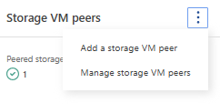
Select the peered cluster and the desired SVM to peer.
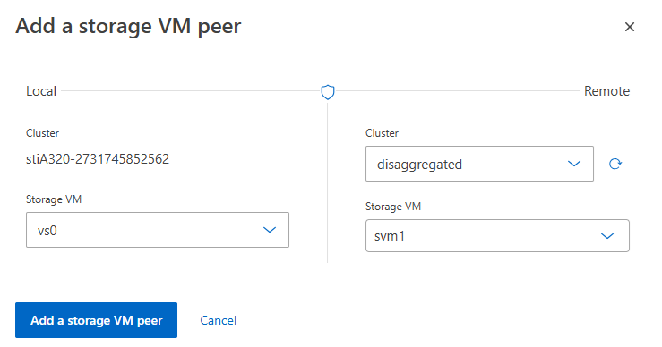
Specify FlexCache as the application to use.

- Create the FlexCache volume
Click on Storage -> Volumes and click “Add”
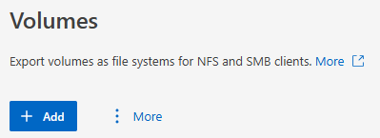
In the Add volume window, click “More options”
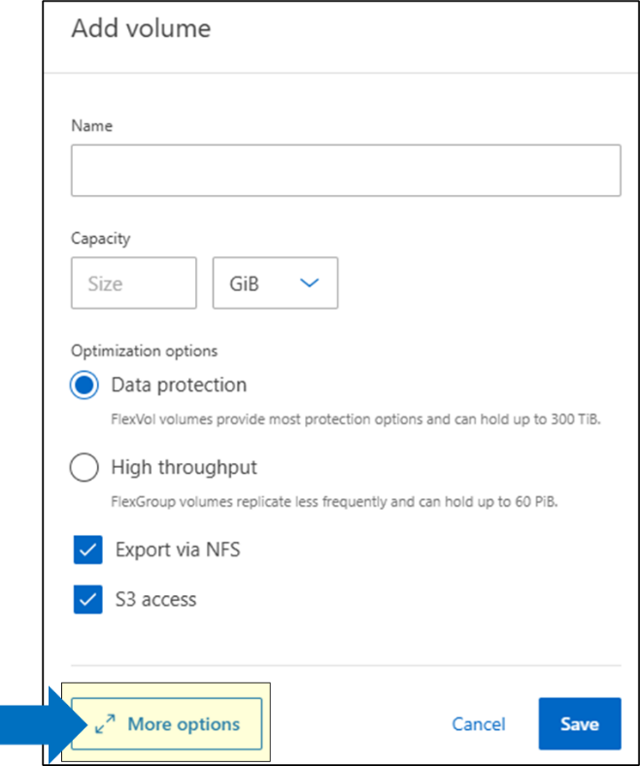
- Give the cache a name and select “Add as a cache for remote volume” below the name and select the cluster, SVM and volume to connect to as a cache.
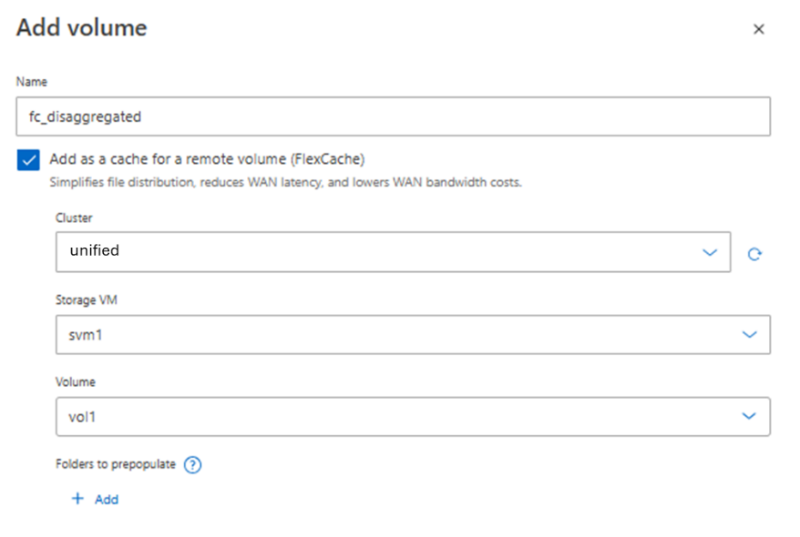
- Give the cache a size – it doesn’t have to be the same size as the origin volume – and configure the access permissions.
FlexCache writeback is not currently supported for FlexGroup volumes in NetApp AFX.
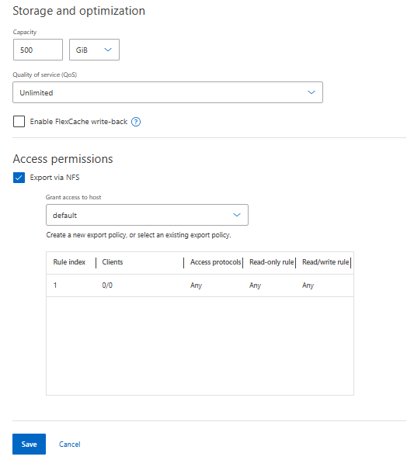
- Click save. The FlexCache will be created.
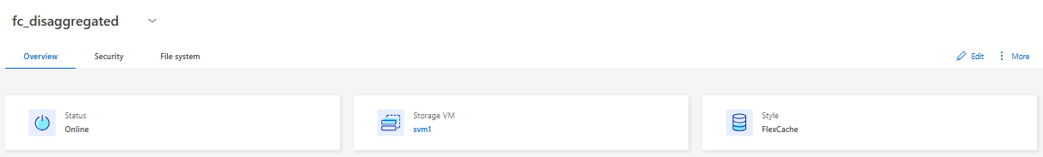
- Mount information is found on the volume detail page.
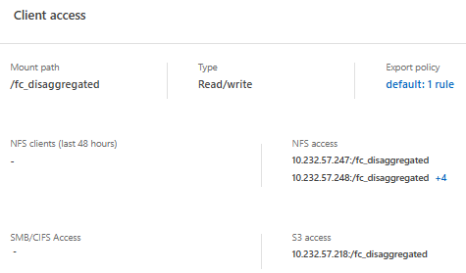
- When you mount the FlexCache on the client, the directory structure will match what is on the origin, but data will only populate on access.
# ls -la /origin
total 20
drwxrwxrwx 4 root root 4096 May 18 02:06 .
drwxr-xr-x 22 root root 4096 May 19 21:33 ..
drwxr-xr-x 2 root root 4096 May 18 02:17 host-configs
drwxrwxrwx 3 root root 4096 May 16 17:06 .snapshot
drwxr-xr-x 9 root root 4096 May 18 02:05 storage
# mount 10.193.67.203:/fc_AFX /cache/
# mount | grep cache
10.193.67.203:/fc_AFX on /cache type nfs4 (rw,relatime,vers=4.1,rsize=262144,wsize=262144,namlen=255,hard,proto=tcp,timeo=600,retrans=2,sec=sys,clientaddr=10.193.67.223,local_lock=none,addr=10.193.67.203)

# ls -la /cache
total 16
drwxrwxrwx 4 root root 4096 May 18 02:06 .
drwxrwxrwx 9 root root 4096 May 23 23:54 ..
drwxr-xr-x 2 root root 4096 May 18 02:17 host-configs
drwxr-xr-x 9 root root 4096 May 18 02:05 storage

- FlexCache volumes can also be pre-populated if you know what data you need cached to reduce the initial latency hit on first read.
In System Manager, on the FlexCache volume, click and select “Prepopulate folders”
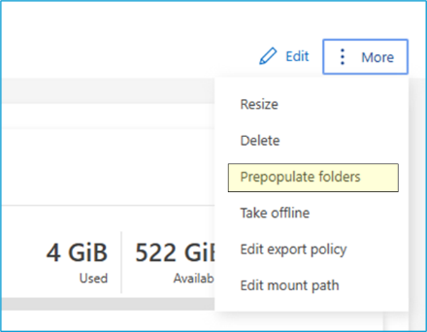
Then, click “+Add” in the window to select the folder to populate. For instance, if you want to run a training job on Resnet50 data, specify the folder path with that data in it and click save.
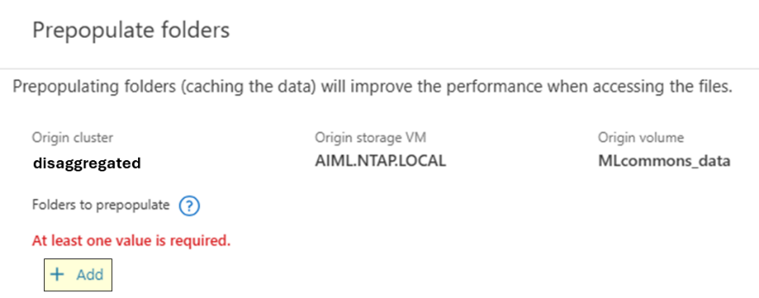
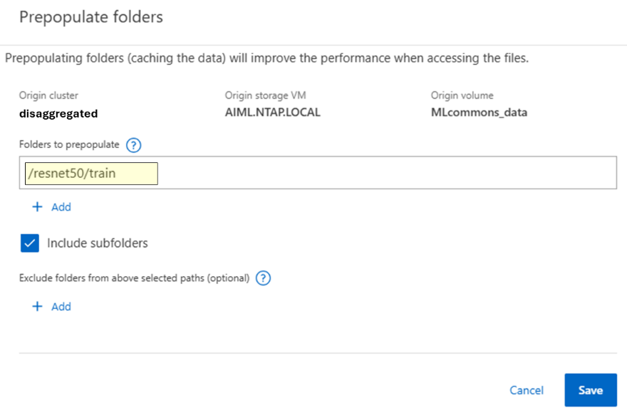
As this happens, you will see the “Cache miss” graph get activity and the Capacity increase in real time in the System Manager view for the cache volume.

The Resnet50 training folder in this test is ~320GB in size. The view in System Manager shows that capacity used after the pre-populate.
Pre-populate can take some time to complete. The ~320GB test below took around 25 minutes to pre-populate data.
Your data path will vary based on the data you have populated.
# du -h /aiml/dataset/resnet50/train
321G /aiml/dataset/resnet50/train
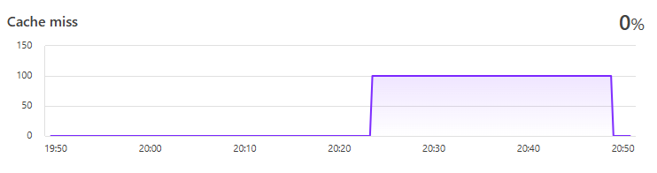
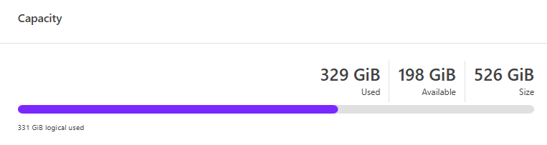
- Run a performance test against the origin volume in unified ONTAP. Then, run it again on the pre-warmed FlexCache volume on the same dataset.
- Run a 2nd performance test against a different folder in unified ONTAP. Then, re-run it on a FlexCache that has not been pre-warmed to see the performance hit on a cache that needs to populate data.
Expected outcome(s):
- FlexCache peering and creation should be identical to how unified ONTAP creates FlexCache volumes.
- FlexCache in NetApp AFX should be able to leverage a unified ONTAP origin.
- FlexCache pre-populate should allow for pre-warming of cache data.
- FlexCache should improve read performance for local reads over remote reads.
Test results:
Test summary:
Comments:
- OPTIONAL: S3 in ONTAP
ONTAP provides S3 as a protocol for data access, as well as the ability to present datasets as both NAS and S3 in the same volume. This functionality is valuable to use cases looking to move to object for their applications, but still have legacy file shares in their environment. Providing a way to present data to any protocol in the same volume removes the requirement to copy large amounts of data to new locations.
This optional test plan covers configuration of S3 for use with the datasets created for performance benchmarking above.
Test 14) OPTIONAL: S3 in ONTAP
Section | Details
Test 14 | Tester: |  | Date:
Test requirements: | No specific requirements.
Test procedure:
- Enable S3 on the SVM

Navigate to Cluster -> Storage VMs
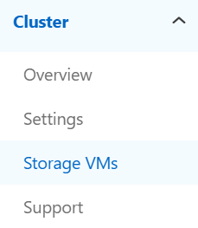

Click on the desired SVM and look for the “Protocols” section. That shows if S3 is enabled.
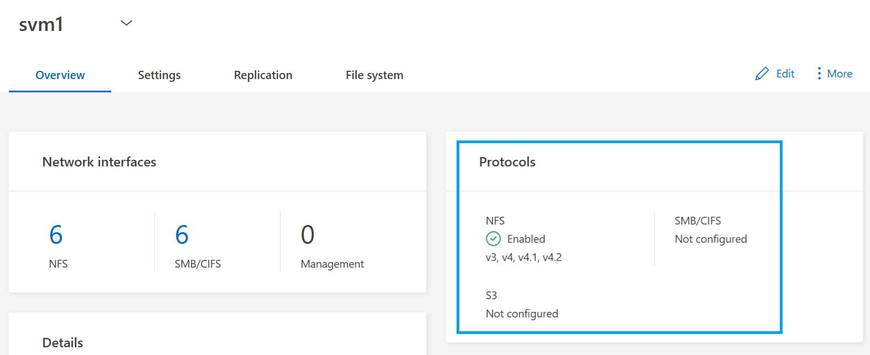

Click on the “Settings” tab and then the  on the S3 section.
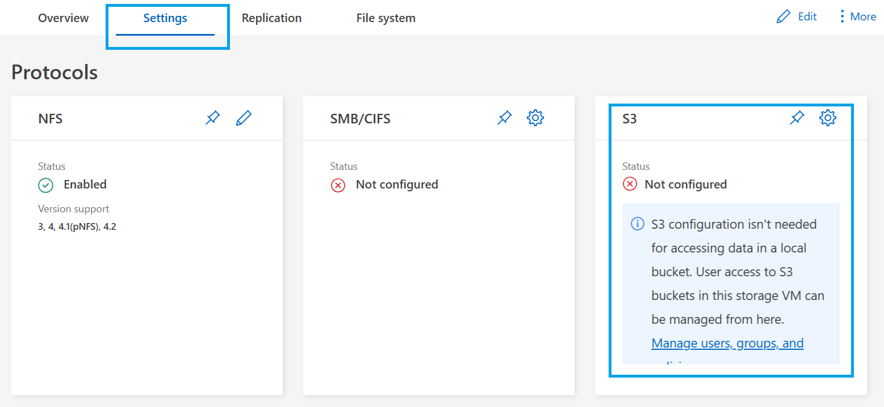

Give the S3 server a name and configuration. This name should be a FQDN that is resolvable in DNS.
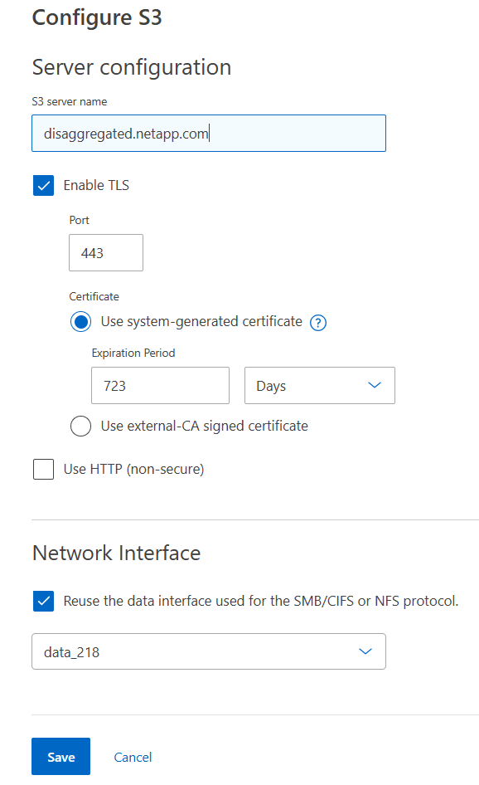
If desired for this test plan, use HTTP to avoid requiring certificates.

Click save. ONTAP will perform configurations behind the scenes, such as user creation, certificates, etc.

Once it’s finished, a screen will pop up with information about the S3 server needed for authentication to the buckets. Download these or copy and save for future use.
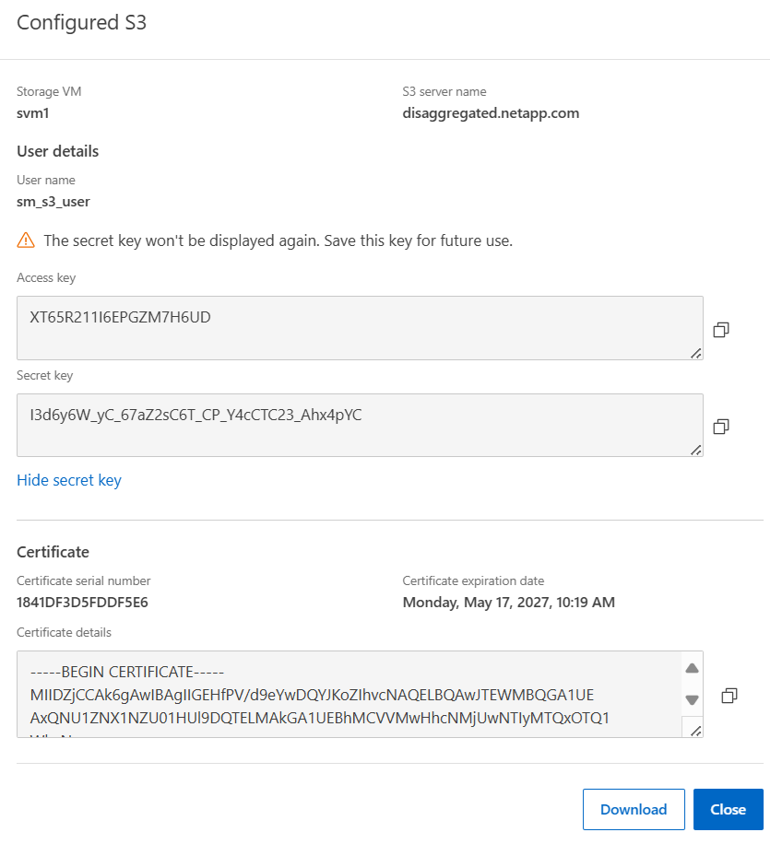

To add a unique user, click on the once S3 has been enabled.
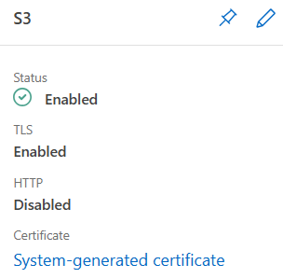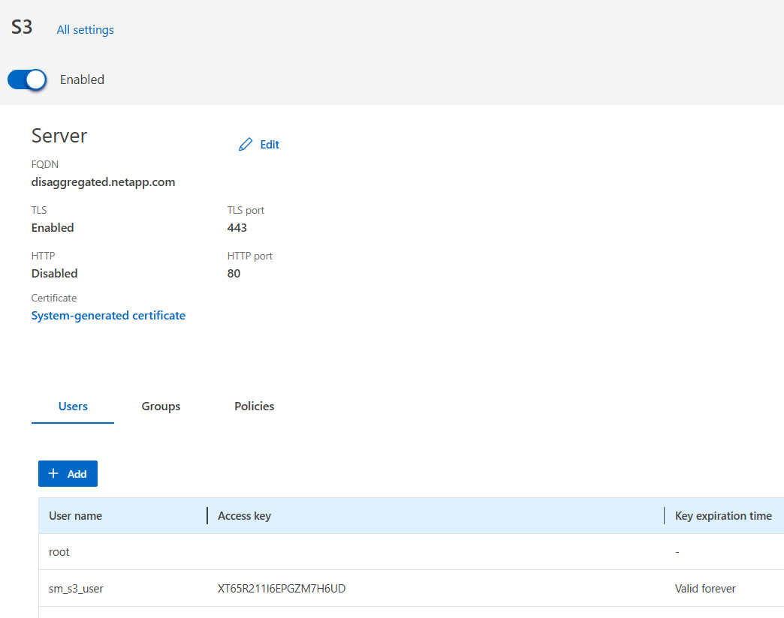

An S3 user needs to map to a corresponding NAS user. If you want to use the root user, you need to generate a passkey for root.
For root user, click the and “Regenerate key” and then save the information.
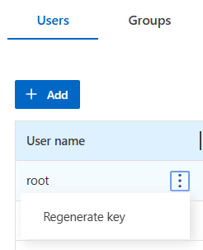

To add a user, click “Add” and type the name and set the desired key validity. Remember, the user must map to a NAS user if you intend on leveraging NAS/Object protocol duality.
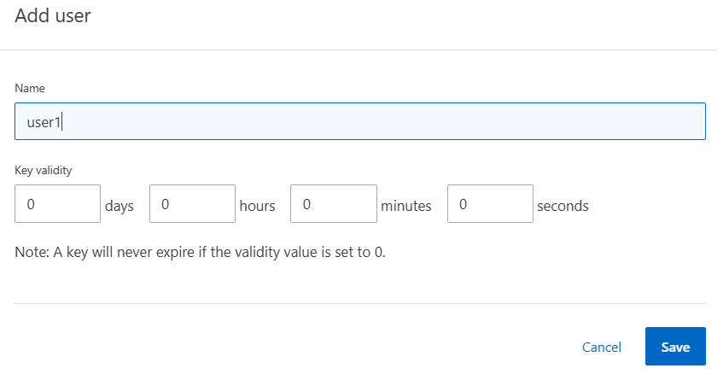

This will create your access/secret keys. Save for later use.
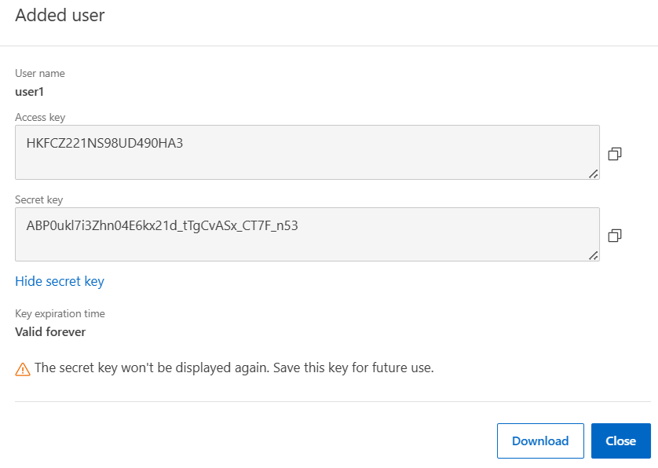

- Create an S3 bucket that can connect to the NAS volume for file/object duality.
Navigate to Storage -> Buckets and then click “Add” and “More options” and add your name, SVM and map the bucket to a folder with the NAS data.
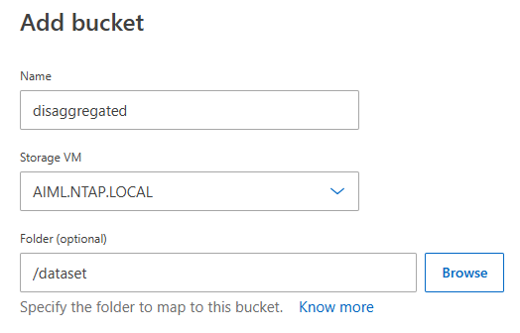
If only one Storage VM is present, you will not need to select the Storage VM.

Optionally, modify bucket permissions, users who have access, etc. Then click “Save.”
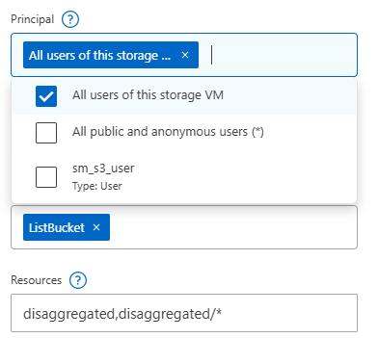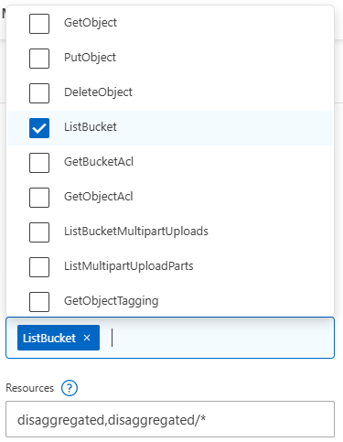

Your bucket will be listed. Clicking on it allows you to manage it further and view the URL.
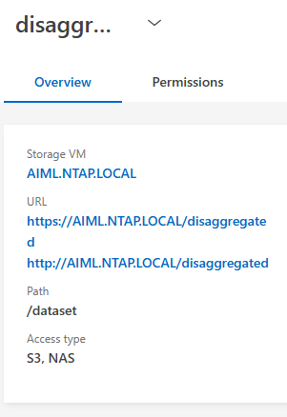

- Connect to a bucket from the client.
- The client should have an S3-capable client (such as s3fs for Linux).
- The client should have authentication configured for the client and user (ie, secret keys, certs, etc).
- The S3 server FQDN should be resolvable in DNS from client and server.
- The bucket mount command will attempt to use http(s)://bucket.url.domain.com during its connection. Add an A/AAAA DNS record or a local host entry to the client and use nslookup to test if the client can find the entry.

On the client, this is an example command can be used to mount the S3 bucket that points to the NAS volume. Ubuntu 22.04 is used here.
# mkdir /mnt/s3_bucket
# s3fs AFX /mnt/s3_bucket/ -o passwd_file=${HOME}/.passwd-s3fs -o url=http://aiml.ntap.local

To debug issues with bucket connections, use the following options:
# s3fs AFX /mnt/s3_bucket/ -o passwd_file=${HOME}/.passwd-s3fs -o url=http://aiml.ntap.local -o dbglevel=info -f -o curldbg

This is an example of a bucket connection issue where the bucket name cannot be resolved.
025-05-22T19:33:42.849Z [CRT] s3fs_logger.cpp:LowSetLogLevel(240): change debug level from [CRT] to [INF]
2025-05-22T19:33:42.849Z [INF] s3fs.cpp:set_mountpoint_attribute(4093): PROC(uid=0, gid=0) - MountPoint(uid=0, gid=0, mode=40755)
2025-05-22T19:33:42.852Z [INF] curl.cpp:InitMimeType(434): Loaded mime information from /etc/mime.types
2025-05-22T19:33:42.852Z [INF] fdcache_stat.cpp:CheckCacheFileStatTopDir(79): The path to cache top dir is empty, thus not need to check permission.
2025-05-22T19:33:42.853Z [INF] s3fs.cpp:s3fs_init(3382): init v1.90(commit:unknown) with GnuTLS(gcrypt)
2025-05-22T19:33:42.853Z [INF] s3fs.cpp:s3fs_check_service(3516): check services.
2025-05-22T19:33:42.853Z [INF] curl.cpp:CheckBucket(3388): check a bucket.
2025-05-22T19:33:42.853Z [INF] curl_util.cpp:prepare_url(254): URL is http://aiml.ntap.local/AFX/
2025-05-22T19:33:42.853Z [INF] curl_util.cpp:prepare_url(287): URL changed is http://AFX.aiml.ntap.local/
2025-05-22T19:33:42.853Z [INF] curl.cpp:insertV4Headers(2680): computing signature [GET] [/] [] []
2025-05-22T19:33:42.853Z [INF] curl_util.cpp:url_to_host(331): url is http://aiml.ntap.local
2025-05-22T19:33:42.858Z [CURL DBG] * Could not resolve host: AFX.aiml.ntap.local

This is an example of a successful connection:
2025-05-22T19:41:52.736Z [INF] s3fs version 1.90(unknown) : s3fs -o passwd_file=/root/.passwd-s3fs -o url=http://aiml.ntap.local -o dbglevel=info -f -o curldbg AFX /mnt/s3_bucket/
2025-05-22T19:41:52.736Z [CRT] s3fs_logger.cpp:LowSetLogLevel(240): change debug level from [CRT] to [INF]
2025-05-22T19:41:52.736Z [INF] s3fs.cpp:set_mountpoint_attribute(4093): PROC(uid=0, gid=0) - MountPoint(uid=0, gid=0, mode=40755)
2025-05-22T19:41:52.740Z [INF] curl.cpp:InitMimeType(434): Loaded mime information from /etc/mime.types
2025-05-22T19:41:52.740Z [INF] fdcache_stat.cpp:CheckCacheFileStatTopDir(79): The path to cache top dir is empty, thus not need to check permission.
2025-05-22T19:41:52.742Z [INF] s3fs.cpp:s3fs_init(3382): init v1.90(commit:unknown) with GnuTLS(gcrypt)
2025-05-22T19:41:52.742Z [INF] s3fs.cpp:s3fs_check_service(3516): check services.
2025-05-22T19:41:52.742Z [INF] curl.cpp:CheckBucket(3388): check a bucket.
2025-05-22T19:41:52.742Z [INF] curl_util.cpp:prepare_url(254): URL is http://aiml.ntap.local/AFX/
2025-05-22T19:41:52.742Z [INF] curl_util.cpp:prepare_url(287): URL changed is http://AFX.aiml.ntap.local/
2025-05-22T19:41:52.742Z [INF] curl.cpp:insertV4Headers(2680): computing signature [GET] [/] [] []
2025-05-22T19:41:52.743Z [INF] curl_util.cpp:url_to_host(331): url is http://aiml.ntap.local
2025-05-22T19:41:52.744Z [CURL DBG] * Trying 10.192.160.180:80...
2025-05-22T19:41:52.744Z [CURL DBG] * Connected to AFX.aiml.ntap.local (10.192.160.180) port 80 (#0)
2025-05-22T19:41:52.745Z [CURL DBG] > GET / HTTP/1.1
2025-05-22T19:41:52.745Z [CURL DBG] > Host: AFX.aiml.ntap.local
2025-05-22T19:41:52.745Z [CURL DBG] > User-Agent: s3fs/1.90 (commit hash unknown; GnuTLS(gcrypt))
2025-05-22T19:41:52.745Z [CURL DBG] > Accept: */*
2025-05-22T19:41:52.745Z [CURL DBG] > Authorization: AWS4-HMAC-SHA256 Credential=PHRPD501WA9RLX7VRS6T/20250522/us-east-1/s3/aws4_request, SignedHeaders=host;x-amz-content-sha256;x-amz-date, Signature=ec6cdc2aec82efd31320ed34cf7d0ff4710ccf3dc5294cf93e5d257ab5fd64e4
2025-05-22T19:41:52.745Z [CURL DBG] > x-amz-content-sha256: e3b0c44298fc1c149afbf4c8996fb92427ae41e4649b934ca495991b7852b855
2025-05-22T19:41:52.745Z [CURL DBG] > x-amz-date: 20250522T194152Z
2025-05-22T19:41:52.745Z [CURL DBG] >
2025-05-22T19:41:55.097Z [CURL DBG] * Mark bundle as not supporting multiuse
2025-05-22T19:41:55.097Z [CURL DBG] < HTTP/1.1 200 OK
2025-05-22T19:41:55.097Z [CURL DBG] < Server: NetApp NAS/9.16.1
2025-05-22T19:41:55.097Z [CURL DBG] < Date: Thu, 22 May 2025 19:43:58 GMT
2025-05-22T19:41:55.097Z [CURL DBG] < x-amz-request-id: 1461343388
2025-05-22T19:41:55.097Z [CURL DBG] < Content-Length: 170639
2025-05-22T19:41:55.097Z [CURL DBG] < Content-Type: application/xml
2025-05-22T19:41:55.097Z [CURL DBG] < Accept-Ranges: bytes
Once a bucket has been connected, you should be able to navigate the mount point to the files and folders within it. Compare the listings with the NFS mount.
Empty folders in an S3 bucket will show errors.
# ls /mnt/s3_bucket/
ls: cannot access '/mnt/s3_bucket/cosmoflow': No such file or directory
cosmoflow mlps-results resnet50 unet3d
# ls /mnt/s3_bucket/resnet50/train/
img_0000_of_2395.tfrecord img_0479_of_2395.tfrecord img_0958_of_2395.tfrecord img_1437_of_2395.tfrecord img_1916_of_2395.tfrecord
img_0001_of_2395.tfrecord img_0480_of_2395.tfrecord img_0959_of_2395.tfrecord img_1438_of_2395.tfrecord img_1917_of_2395.tfrecord
# ls /mnt/nfs/resnet50/train/
img_0000_of_2395.tfrecord img_0479_of_2395.tfrecord img_0958_of_2395.tfrecord img_1437_of_2395.tfrecord img_1916_of_2395.tfrecord
img_0001_of_2395.tfrecord img_0480_of_2395.tfrecord img_0959_of_2395.tfrecord img_1438_of_2395.tfrecord img_1917_of_2395.tfrecord

New files created via NFS will immediately show in the S3 bucket. Permissions will reflect the access settings you created on the bucket.
# touch /mnt/nfs/testfile
# ls -la /mnt/nfs/testfile
-rw-r--r-- 1 root root 0 May 22 2025 /aiml/dataset/testfile

# ls -la /mnt/s3_bucket/testfile
-rw-r----- 1 root root 0 May 22 2025 /mnt/s3_bucket/testfile
Expected outcome(s):
- A volume will be able to be presented to both NAS and object clients.
- The same data is accessible to both NAS and object clients without needing to move.
Test results:
Test summary:
Comments:
- OPTIONAL: Snapshots and SnapMirror impact on performance
Snapshots and SnapMirror are integral to a complete data protection story for ONTAP. Part of their success is tied to their minimal impact on production workloads. The goal of this test is to confirm that snapshots and SnapMirror in operation during performance tests have little to no impact on the system performance.
Test 15) OPTIONAL: Snapshots and SnapMirror during live workloads.
Section | Details
Test 15 | Tester: |  | Date:
Test requirements: | No specific requirements.  Performance testing being run during mirroring and snapshots.
Test procedure:
Snapshot steps
- Verify benchmarks or performance workloads are running during these tests.
In most cases, you won’t be able to see any sort of impact show up on the performance graphs in System Manager, so you would be best served to view the impact from the command line.

From the NetApp AFX cluster CLI, kick off the performance statistics
cluster::> set advanced
cluster::*> statistics show-periodic -counter nfs-ops|data-sent|data-recv -interval 1

From the client, start a long running job.
Once the workload begins, you should start to see performance stats every 1 second
cluster::*> statistics show-periodic -counter nfs-ops|data-sent|data-recv -interval 1
cluster: cluster.cluster: 5/12/2025 12:14:46
data data
nfs-ops recv sent
-------- -------- --------
1985 1.86MB 423MB
2310 1.52MB 352MB
2068 1.69MB 381MB
2116 1.75MB 400MB
2512 1.72MB 398MB
2108 1.76MB 397MB
2739 1.71MB 387MB
2074 1.66MB 373MB

- From the NetApp AFX GUI, take a snapshot while the job is running
Navigate to the volume screen and use themenu to select Snapshot
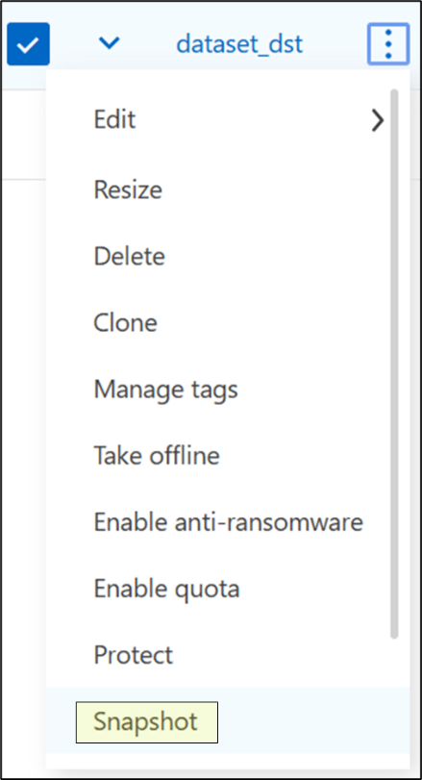
Specify a name and click “Add”
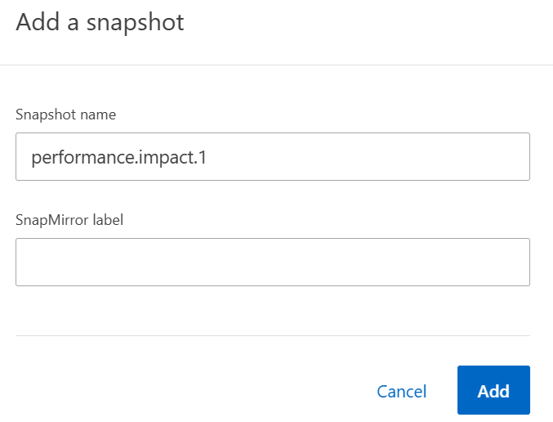
- Verify that little to no performance impact occurred:
Example:
data data
nfs-ops recv sent
-------- -------- --------
2507 1.85MB 423MB
2091 1.75MB 391MB
2575 1.50MB 347MB
1911 1.56MB 396MB << snapshot occurred somewhere in this range
2437 2.13MB 364MB
1887 1.80MB 413MB
2495 1.48MB 349MB
1695 1.59MB 356MB << snapshot occurred somewhere in this range
2221 1.56MB 355MB
2156 1.49MB 344MB
1658 1.55MB 358MB
2062 1.34MB 312MB
2184 1.65MB 387MB

SnapMirror steps
In the “Data Migration” section, you established a SnapMirror from NetApp AFX to unified ONTAP (or, alternately, to the same NetApp AFX cluster) in step 8. This SnapMirror can be used to issue an update to observe the performance impact of the transfer on a production workload.

- Verify benchmarks or performance workloads are running during these tests.
In most cases, you won’t be able to see any sort of impact show up on the performance graphs in System Manager, so you would be best served to view the impact from the command line.

From the NetApp AFX cluster CLI, kick off the performance statistics
cluster::> set advanced
cluster::*> statistics show-periodic -counter nfs-ops|data-sent|data-recv -interval 1

From the client, start a long-running job.
Once the workload begins, you should start to see performance stats every 1 second
cluster::*> statistics show-periodic -counter nfs-ops|data-sent|data-recv -interval 1
cluster: cluster.cluster: 5/12/2025 12:14:46
data data
nfs-ops recv sent
-------- -------- --------
1985 1.86MB 423MB
2310 1.52MB 352MB
2068 1.69MB 381MB
2116 1.75MB 400MB
2512 1.72MB 398MB
2108 1.76MB 397MB
2739 1.71MB 387MB
2074 1.66MB 373MB

- From the NetApp AFX GUI, update the SnapMirror relationship you created in the Data Migration section while the job is running
Navigate to Protection -> Replication on the NetApp AFX GUI
Expected outcome(s):
- Snapshots and SnapMirror should not impact production workload performance in any meaningful way.
Test results:
Test summary:
Comments:
- OPTIONAL: Non-Disruptive ONTAP Upgrade
The upgrade process for NetApp AFX is identical to that of unified ONTAP. This test plan is designed to show some of the differences between how HA failovers and volume rebalancing function in NetApp AFX. The upgrade process can be done via CLI or by using the GUI by navigating to Cluster -> Overview -> Version.
Test 16) OPTIONAL: Non-Disruptive ONTAP Upgrade
Section | Details
Test 16 | Tester: |  | Date:
Test requirements: | No specific requirements.
Test procedure:
- Download the latest ONTAP image from the NetApp website.
- Place the image.tgz file on a webserver. Do not use TinyWeb as it has a 2GB limit.
- Validate the current version of ONTAP
AFX::*> node run -node * -command "version"
4 entries were acted on.

Node: AFX-01
NetApp Release [ONTAP_version_info]: Mon Jun 16 00:59:28 EDT 2025 <1>

Node: AFX-02
NetApp Release [ONTAP_version_info]: Mon Jun 16 00:59:28 EDT 2025 <1>

Node: AFX-03
NetApp Release [ONTAP_version_info]: Mon Jun 16 00:59:28 EDT 2025 <1>

Node: AFX-03
NetApp Release [ONTAP_version_info]: Mon Jun 16 00:59:28 EDT 2025 <1>

- Delete existing ONTAP image.
AFX::*> cluster image package delete -version [version]
Package Delete Operation Completed Successfully

- Execute the upload and upgrade of ONTAP
AFX::> cluster image package get -url http://<webserver>/image.tgz
Package download completed.
Package processing completed.

AFX::> cluster image package show
Package Version Package Build Time
---------------- ------------------
Electricjellyfish__9.17.1
6/22/2025 05:02:29

AFX::> cluster image update -version [version] -nodes *
Starting validation for this update...

It can take several minutes to complete validation...

WARNING: There are additional manual upgrade validation checks that must be performed after these automated validation checks have completed successfully.
Refer to the Upgrade Advisor Plan or the "What should I verify before I upgrade with or without Upgrade Advisor" section in the "Upgrade ONTAP" documentation for the remaining manual validation checks that need to be performed before update.
Upgrade ONTAP documentation available at: https://docs.netapp.com/us-en/ontap/upgrade/index.html
The list of checks are available at: https://docs.netapp.com/us-en/ontap/upgrade/task_what_to_check_before_upgrade.html
Failing to do so can result in an update failure or an I/O disruption.
Please use Interoperability Matrix Tool (IMT http://mysupport.netapp.com/matrix) to verify host system supportability configuration information.

Pre-update Check Status Error-Action
----------------------------------- -------- --------------------------------
NFS mounts Warning Warning: This cluster is
serving NFS clients. If NFS
soft mounts are used, there is
a possibility of frequent NFS
timeouts and race conditions
that can lead to data
corruption during the upgrade.
Action: Use NFS hard mounts, if
possible. To list Vservers
running NFS, run the following
command: vserver nfs show
Nodes to update list Warning Warning: List of nodes to be
upgraded:
"AFX-01,AFX-02,
AFX-03,AFX-04."
Action: To upgrade all selected
nodes, regardless of their
current version, set the
(privilege: advanced)
"-skip-nodes-at-target-version"
parameter to "false".
Overall Status Warning
2 entries were displayed.

Warning: Validation has reported warnings.

Do you want to continue? {y|n}: y

Starting update...
Info: Run the "cluster image show-update-progress" command to check update status.

AFX::> cluster image show-update-progress
Estimated Elapsed
Update Phase Status Duration Duration
-------------------- ----------------- --------------- ---------------
Pre-update checks completed 00:02:00 00:01:50
ONTAP updates in-progress 00:47:00 00:00:11

Details:

Node name Status Status Description
-------------------- ----------------- --------------------------------------
AFX-01 in-progress Installing ONTAP software image.
AFX-02 in-progress Installing ONTAP software image.
AFX-03 in-progress Installing ONTAP software image.
AFX-04 in-progress Installing ONTAP software image.
8 entries were displayed.
- All cluster nodes will reboot
- Validate the new version of ONTAP
AFX::*> node run -node * -command "version"
4 entries was acted on.

Node: AFX-01
NetApp Release [ONTAP_version_info]: Sun Jun 22 01:02:29 EDT 2025 <1>
Node: AFX-02
NetApp Release [ONTAP_version_info]: Sun Jun 22 01:02:29 EDT 2025 <1>
Node: AFX-03
NetApp Release [ONTAP_version_info]: Sun Jun 22 01:02:29 EDT 2025 <1>
Node: AFX-04
NetApp Release [ONTAP_version_info]: Sun Jun 22 01:02:29 EDT 2025 <1>
Expected outcome(s):
- ONTAP Cluster will be updated with new version of ONTAP.
Test results:
Test summary:
Comments:
- OPTIONAL: New feature tests
NetApp AFX includes some new features in the ONTAP 9.19.1 release that can be tested as part of this plan, including:
- Global deduplication
- Dynamic storage efficiency
- Aggressive readahead
- FabricPool (cold data tiering; ONTAP 9.19.1P2 and later)
This section covers configuration details and how to test some of the functionality at a high level.

Global deduplication
Prior to ONTAP 9.19.1, AFX deduplication occurred at the node level, where only data in volumes owned by a specific node was eligible for deduplication. In Unified ONTAP, that deduplication domain was at the aggregate level (via cross-volume deduplication). As a result, if you had files on volumes owned by node1 that were identical in volumes owned by its HA partner (node2), then you did not gain efficiency benefits.
Because NetApp AFX provides a single capacity pool for all nodes, it leverages a single filesystem namespace for volumes. This means that with the new global deduplication feature, all volumes across all nodes can share the same filesystem space and duplicate files and blocks are located in the same deduplication domain.

Operation
Global deduplication is not an inline process, but instead runs post-process across the capacity pool. The jobs are opportunistic and will defer to production workload performance to mitigate the effects of deduplication.

Configuration
Global deduplication is on by default in NetApp AFX.
To show if it is enabled:
AFX::*> global-dedupe show
(storage aggregate efficiency global-dedupe show)
Aggregate State
------------------ ----------
storage_availability_zone_0
Enabled
NetApp AFX doesn’t use the concept of physical aggregates, but the storage efficiency commands do run under the storage aggregate command family for backwards compatibility.
Global deduplication can be disabled with the “stop” command, but it is not recommended to modify it in general. For the purposes of these tests, we will disable global dedupe to illustrate what impact it can have on performance and space savings. However, the current ONTAP release can only re-enable it via diag privilege commands (a bug has been opened to correct that and should be fixed in a future release.
To re-enable global deduplication:
AFX::> set diag
AFX::*> run local flexaggr global_dedup enable -all
This process can take a few minutes to complete.
You can check the current status with:
AFX::> set diag
AFX::*> run local flexaggr global_dedup status
AFX::*> global-dedupe show
The status will show “disabled” or “unknown” for a period but will eventually enter the “Enabled” state.

Test plan – Global deduplication
This test attempts to show the following.
- How global deduplication impacts performance
- The space savings realized with global deduplication vs. traditional node and volume based
- How to view statistics for global deduplication operations
The test plan uses the benchmarking utility called vdbench to generate load and to create a dataset that can be deduplicated. This test plan can be performed in conjunction with the dynamic storage efficiency test plan seen later in this document.
You can access the test plan here:
https://github.com/whyistheinternetbroken/AFXTestPlans/blob/main/vdbench-global-dedupe.adoc

Dynamic storage efficiency
Dynamic storage efficiency is a new ONTAP feature available in NetApp AFX. Dynamic storage efficiency is a feature designed to optimize storage efficiency operations for large-scale, high-performance workloads. By intelligently managing when storage efficiency processes are active, this feature helps maintain high throughput during bursty write operations.
A high-level overview of the feature details:
- Dynamic SE is always on and does not have a cluster command to manually disable it.
- In ONTAP 9.19.1, client write throughput is the primary metric used to determine when to dynamically enable or disable throttling of inline Storage Efficiency (SE).
- Dynamic SE is enabled when a workload throughput exceeds 12GB/s.
- Dynamic SE is disabled when a workload throughput drops below 10GB/s
- Dynamic SE will disable inline storage efficiencies when ONTAP decides to enable it. Post-process efficiencies will take place later on a schedule.

Checking if Dynamic SE is in use
You can collect statistics specific to dynamic SE by running the following command:
AFX::> statistics start -object tsse -counter dse_num_write_ops_ise_throttle | dse_num_write_blks_ise_throttle | dse_num_dynamic_se_throttle_enabled |dse_num_dynamic_se_throttle_disabled | dse_num_tput_already_updated | dse_last_throttle_enable_time_msec | dse_last_throttle_disable_time_msec | dse_num_write_bytes_wrap | dse_num_prev_time_wrap | dse_num_bkg_throttle_enabled | dse_num_bkg_throttle_disabled | dse_num_dynamic_se_ads_throttle -sample-id dynamicSE
Statistics collection is being started for sample-id: dynamics
To show them:
AFX::> rtp-afx1k-c01::*> statistics show -object tsse -counter dse_num_write_ops_ise_throttle | dse_num_write_blks_ise_throttle | dse_num_dynamic_se_throttle_enabled |dse_num_dynamic_se_throttle_disabled | dse_num_tput_already_updated | dse_last_throttle_enable_time_msec | dse_last_throttle_disable_time_msec | dse_num_write_bytes_wrap | dse_num_prev_time_wrap | dse_num_bkg_throttle_enabled | dse_num_bkg_throttle_disabled | dse_num_dynamic_se_ads_throttle -sample-id dynamicSE

Object: tsse
Instance: tsse
Start-time: 7/27/2026 16:16:27
End-time: 7/27/2026 16:16:50
Elapsed-time: 23s
Scope: AFX-01

Counter Value
-------------------------------- --------------------------------
dse_last_throttle_disable_time_ Never
msec
dse_last_throttle_enable_time_ Never
msec
dse_last_throttle_disable_time_ Never
msec
dse_last_throttle_enable_time_ Never
msec
dse_num_tput_already_updated 59
You can also gather additional insights (such as config details, last run, etc.) about dynamic SE with the following advanced privilege command:
AFX::> set advanced
AFX::*> run local wafl stats dynamic_se
Dynamic SE Stats:
Dynamic SE enabled: = Yes
Dynamic SE throttle enable throughput = 12288 MBps
Dynamic SE throttle disable throughput = 10240 MBps
dynamic_se.wdse_num_write_ops_ise_throttle = 0
dynamic_se.wdse_num_write_blks_ise_throttle = 0
dynamic_se.wdse_num_dynamic_se_throttle_enabled = 0
dynamic_se.wdse_num_dynamic_se_throttle_disabled = 0
dynamic_se.wdse_num_tput_already_updated = 0
Time since dynamic SE throttling was last enabled = Never
Time since dynamic SE throttling was last disabled = Never
dynamic_se.wdse_num_write_bytes_wrap = 0
dynamic_se.wdse_num_prev_time_wrap = 0
dynamic_se.wdse_num_bkg_throttle_enabled = 0
dynamic_se.wdse_num_bkg_throttle_disabled = 0
dynamic_se.wdse_num_dynamic_se_ads_throttle = 0
Current sample index = = 0
Delta write throughput 10 samples (in MBps):
0 | 0 | 0 | 0 | 0 | 0 | 0 | 0 | 0 | 0 |

Test plan – Dynamic storage efficiency

Aggressive readahead
In media streaming workloads, a 4K movie is often split into tens of thousands of files, each typically 50 MB to 250 MB in size. Each file represents a frame, and the application reads an entire frame in a single request. To maintain a smooth, uninterrupted stream with no visible buffering, these frame reads must complete without drops.
ONTAP provides a volume-level option (-aggressive-readahead-mode) to optimize these workloads. Starting in ONTAP 9.19.1, a new cross_file_sequential_read mode for aggressive readahead has been introduced on AFX to accelerate workloads with predictable I/O patterns across similar file types (for example, media rendering and streaming).
cross_file_sequential_read predicts the next file to be read based on its name and begins readahead on those files before the client issues the read call. The prediction logic assumes that all files in a directory follow a naming pattern with a monotonically increasing numeric suffix (eg. file1, file2, file3). All files in the directory must follow this pattern, using either decimal or hexadecimal numbering. Filenames can be up to 255 characters long. The logic is extension-agnostic and generates the next set of filenames in the current directory based solely on the current filename. If a filename previously generated using base10 numbering does not exist in the directory, the names are regenerated using hexadecimal numbering. If none of the generated filenames exist, no prefetch is issued for that set. Prefetching resumes when the next client read is issued.
While cross-file sequential read is primarily designed for media workloads, other read-heavy workloads with predictable access patterns and file names - such as AI training and inference - can also benefit.
To see statistics for this feature, use the following advanced privilege command:
AFX::> set advanced
AFX::*> run local wafl stats file_prefetch

FabricPool tiering
NetApp ONTAP provides a way to automatically tier cold data blocks from an active file system to an S3-capable target (such as ONTAP S3, StorageGRID, cloud, etc.) as a way to offer cost-benefits by reducing the amount of capacity being used for inactive data on performance flash tiers.
Starting in ONTAP 9.19.1P2, NetApp AFX adds support for FabricPool tiering. In the initial releases of NetApp AFX, FabricPool was not available as it is based on physical aggregate configurations, while NetApp AFX uses virtualized aggregate concepts. As a result, FabricPool tiering is configured and managed at the volume level.
ONTAP 9.19.1 GA does not officially support FabricPool tiering (and commands are hidden), but the commands to manage it are available to use in a testing scenario such as this one.
The new AFX-specific FabricPool command options are below:
AFX::> cluster object-store config create ?
[-object-store-name] <text> Object Store Configuration Name
[-provider-type] <providerType> Type of the Object Store Provider
[ -auth-type <object_store_auth_type> ] Authentication Used to Access the Object Store
[-server] <Remote InetAddress> Fully Qualified Domain Name of the Object Store Server
[ -is-ssl-enabled {true|false} ] Is SSL/TLS Enabled (default: true)
[ -port <integer> ] Port Number of the Object Store (default: 443)
[-container-name] <text> Data Bucket/Container Name
{ [ -access-key <text> ] Access Key ID for S3 Compatible Provider Types
[ -secret-password <text> ] Secret Access Key for S3 Compatible Provider Types
| [ -azure-account <text> ] Azure Account
[ -ask-azure-private-key {true|false} ] Ask to Enter the Azure Access Key without Echoing
[ -azure-private-key <text> ] Azure Access Key
[ -ipspace <IPspace> ] IPspace to Use in Order to Reach the Object Store (default: Default)
[ -use-http-proxy {true|false} ] Use HTTP Proxy (default: false)
[ -azure-msi-token <text> ] Azure MSI Token for Authentication

Test plan – NetApp AFX FabricPool
An official test plan will be created once FabricPool is officially supported for NetApp AFX in ONTAP 9.19.1P2.

Appendix
The following section covers commands and other information not covered in the above.

About EDA frontend, backend and blended terminology
The EDA terms used in this document for workloads (such as frontend, backend, blended) refer to the workloads documented in SPECSFS 2020.
Specifically, these workloads are defined as follows:
- Frontend – large number of small files, higher metadata
- Backend – lower number of large files, 50/50 read write (sequential)
- Blended – A mix of both frontend and backend workloads

NFS considerations
For NFS workloads, NFSv3 can be used and generally will perform better with high metadata workloads (such as high file count workloads that create many files).
Most EDA workloads make use of NFSv3 – especially EDA frontend workloads, which tend to be more metadata heavy.

Recommended mount options with NFSv3
-o vers=3,tcp,hard,intr,nconnect=8

Recommended mount options for NFSv4.1
For high read/write workloads – such as those found with AI/ML training and inference, NFSv4.1 with parallel NFS and session trunking offer performance benefits that NFSv3 does not, with the following considerations:
- pNFS will require at least one routable network interface per node to function properly.
- With pNFS, avoid including non-routable network interfaces in the SVM configuration.
- NFS session trunking works best when there are routable network interfaces on multiple ports per node to provide added throughput possibilities.
- Session trunking and pNFS are supported only with NFSv4.1 and later.
- Session trunking is provided via a mount option. The method of enabling trunking for an NFS mount will depend on the Linux version in use.
- pNFS requires no special mount options.

Ubuntu 22 and later
AI/ML training and inference workloads with NFSv4.1
-o vers=4.1,tcp,hard,intr,nocto,actimeo=3600,max_connect=8
A mount command will need to be issued for each individual network interface to ensure session trunking is in use with Ubuntu.
Rather than relying on individual mount commands, use the /etc/fstab file to configure the mount commands and then run them all at once with mount -a. See “using fstab” below.

RHEL 9.x and later
AI/ML training and inference workloads with NFSv4.1
-o vers=4.1,tcp,hard,intr,nocto,actimeo=3600,trunkdiscovery
Trunkdiscovery mount option will automatically find the network paths that are a part of the trunking group.

Using fstab
The /etc/fstab file on Linux clients can be used to set NFS mount points in a single file to simplify mount operations. Below is an example of an entry in /etc/fstab for an NFS mount:
SVM:/NFS_export /mnt/NFS_export nfs intr,nfsvers=4.1,max_connect=8,tcp 0 0
When an NFS mount is needed and fstab is populated, the command can be:
# mount -a

Using automounter
The automounter is a service that can be used to configure NFS mount points and have the autofs process manage mounts when a directory is accessed without needing interaction from end users to issue mount commands.
Automounter requires:
- Autofs installed
- /etc/auto.master configured
- /etc/auto.[map] configured (ie, auto.misc)
Below are some examples of auto.master and auto.misc file configurations.
/etc/auto.master
/- /etc/auto.misc

/etc/auto.misc
/mnt/NFS_export -rw,nosuid,hard,tcp,max_connect=8 10.192.160.180:/NFS_export
/mnt/NFS_export -rw,nosuid,hard,tcp,max_connect=8 10.192.160.181:/NFS_export
/mnt/NFS_export -rw,nosuid,hard,tcp,max_connect=8 10.192.160.182:/NFS_export
/mnt/NFS_export -rw,nosuid,hard,tcp,max_connect=8 10.192.160.183:/NFS_export

NFS 64-bit file IDs
FlexGroup volumes allow up to 400 billion files, provided 64-bit file IDs are enabled. While these should be enabled as part of the initial setup and configuration, ensure they are enabled in the environment in the first test plan.
To enable them:
AFX::> set advanced; nfs modify -v3-64bit-identifiers enabled -v4-64bit-identifiers enabled

pNFS and session trunking validation
When using pNFS and/or session trunking, it can be difficult to determine if the protocol features are actively being used. ONTAP provides commands to check these features for activity.
To show pNFS devices
AFX::> set advanced -confirmations off
AFX::*> pnfs devices show -vserver svm1
AFX::*> pnfs devices mappings show -vserver svm1
To show connected NFS clients
AFX::> nfs connected-clients show -vserver svm1
AFX::> network connections active show -service nfs
To verify if pNFS and NFSv4.1 session trunking calls are being issued
To validate if pNFS and/or session trunking are active, use the below to look for incrementing values for pNFS/trunking counters.
For a list of pNFS and session trunking specific counters (and examples) see the Appendix.
AFX::> set diag
AFX::*> nfs show -fields v4.1,v4.1-pnfs,v4.1-trunking
AFX::*> statistics start -object nfsv4_1|nfsv4_1_diag -sample-id AFX
AFX::*> statistics show -object nfsv4_1|nfsv4_1_diag -counter [name1]|[name2]|[name3] -sample-id AFX
To clear pNFS devices (when adding or removing interfaces):
AFX::> set diag -c off
AFX::*> pnfs lif-mapping-cache flush -node *
AFX::*> pnfs devices cache flush -node * -vserver [SVM1]
AFX::*> pnfs devices invalidate -global-device-table-id *

Client tuning considerations
For best results, some client tuning may be useful for improving the overall performance of the workloads you are running. The following sections cover the potential tuning options and why they may improve things.

Wsize and rsize
These mount options set the total window size of the NFS mount for reads and writes. The ONTAP NFS server will set a maximum TCP window size (default of 64K; maximum of 1MB) for NFS connections, but the client can control the window sizes granularly for reads and writes depending on the application workload and behavior.

Small window sizes
If the TCP window size for the mount is set to a smaller value (say, 8K) and a majority of the application IO has a 64K block size, then more packets have to be transmitted across the wire to complete that communication. (64K/8K = 8 packets)
On the storage side, that means a single 64K request from the application becomes 8 IOPS.
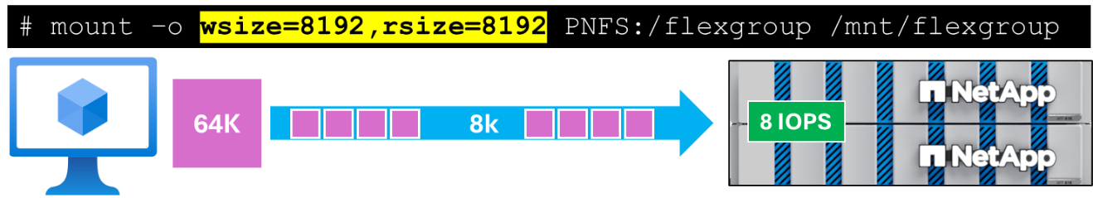
If that same application is mounted using a 64K window size, then each application block can be sent over a single packet, which means a single IOP on storage.
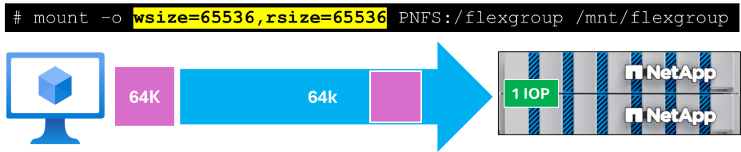
Fewer IOPS mean fewer operations for the CPU to handle. Rather, the CPU will now handle larger operation sizes. The tradeoff will be CPU latency, as smaller operations will take less time to process, while larger operations mean higher CPU wait time. However, the reduction in network operations will mean less impact from network latency to the workload, and in environments with many clients, you may not want millions of IOPS being generated to a single CPU, as that will introduce other problems.

Large window sizes
When a larger window size is specified, smaller block sizes will be able to travel over a single operation and will not be broken up. For instance, 64K over 1MB will generate a single IOP.
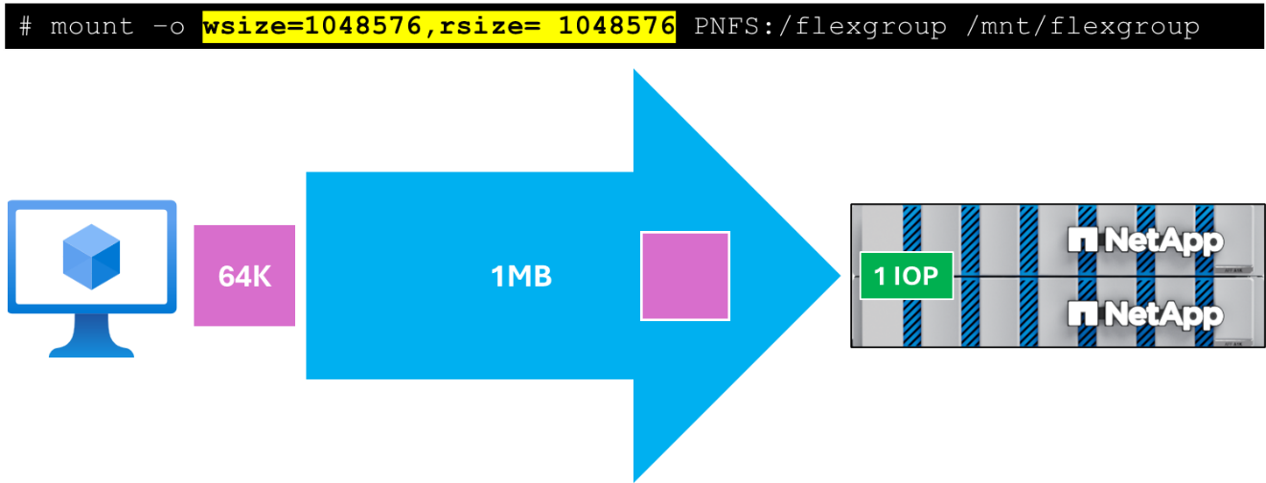
If multiple blocks are sent over a larger window size, then they get sent in a single packet, rather than a packet per operation. However, larger sizes can increase the latency of operations, since the storage can take longer to process the packet and send a response. If latency is critical to your workload, then setting the wsize/rsize to an optimized size might create better overall results. For instance, if your application is latency sensitive and sends 64K application blocks, then the wsize/rsize should be set to 64K.
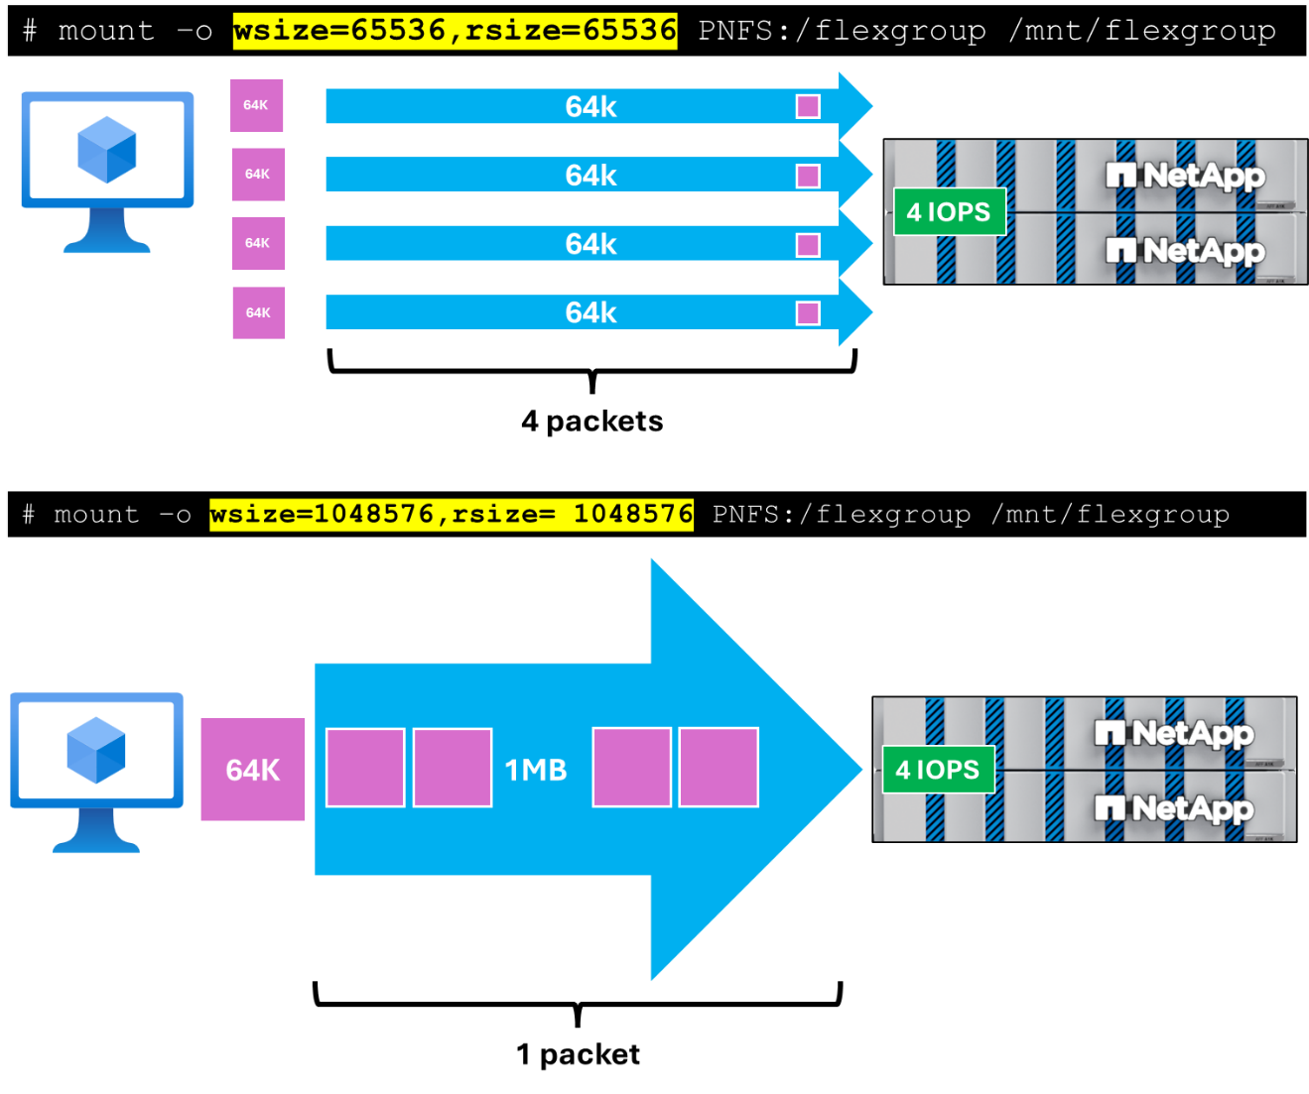
Larger window sizes for mount points offer flexibility across a variety of workloads, regardless of the application block sizes involved.
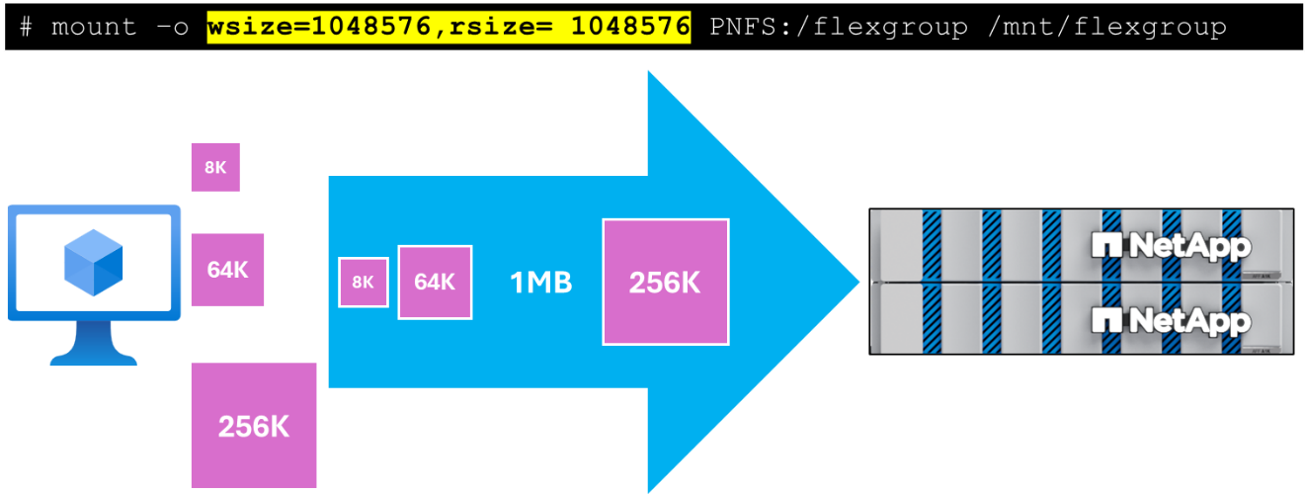

Other considerations
- Random I/O operation sizes are often smaller than the rsize and wsize mount options. As such, they aren't constraints.
- When using the filesystem cache, sequential I/O will occur at the size predicated by the rsize and wsize mount options, unless the file size is smaller than rsize and wsize.
- Operations bypassing the filesystem cache, although still constrained by the rsize and wsize mount options, aren't as large as the maximum specified by rsize or wsize. This consideration is important when you use workload generators that have the directio option.

Recommendation
The recommendation for this test plan is to use a 1MB block size for mount points.

Close-to-open consistency and cache attribute timers
NFS uses a loose consistency model. The consistency is loose because the application doesn't have to go to shared storage and fetch data every time to use it. Such a scenario would have a tremendous impact to application performance. There are two mechanisms that manage this process: cache attribute timers and close-to-open consistency.
If the client has complete ownership of data, that is, it's not shared between multiple nodes or systems, there is guaranteed consistency. If the dataset is rarely changed during the course of a read workload, then consistency can be assumed.
In that case, you can reduce the getattr access operations to storage and speed up the application by turning off close-to-open (cto) consistency (nocto as a mount option) and by turning up the timeouts for the attribute cache management (actimeo=600 as a mount option changes the timer to 10m versus the defaults acregmin=3,acregmax=30,acdirmin=30,acdirmax=60). In some testing, nocto reduces approximately 65-70% of the getattr access calls, and adjusting actimeo reduces these calls another 20-25%. Getattr calls can be costly to overall performance, so if the calls are unnecessary because the data is guaranteed consistent, it is best to reduce those calls as much as possible.

How attribute cache timers work
The attributes acregmin, acregmax, acdirmin, and acdirmax control the coherency of the cache. The former two attributes (acregmin, acregmax)control how long the attributes of files are trusted. The latter two attributes (acdirmin,acdirmax) control how long the attributes of the directory file itself are trusted (directory size, directory ownership, directory permissions). The min and max attributes define minimum and maximum duration over which attributes of a directory, attributes of a file, and cache content of a file are deemed trustworthy, respectively. Between min and max, an algorithm is used to define the amount of time over which a cached entry is trusted.
For example, consider the default values for acregmin (3 seconds) and acregmax (30 seconds). Those attributes are repeatedly evaluated for the files in a directory. After 3 seconds, the NFS service is queried for cache freshness. If the attributes are deemed valid, the client doubles the trusted time to 6 seconds, 12 seconds, 24 seconds, then as the maximum is set to 30, 30 seconds. From that point on, until the cached attributes are deemed out of date (at which point the cycle starts over), trustworthiness is defined as 30 seconds being the value specified by acregmax.
There are cases that can benefit from a similar set of mount options, even when there's no complete ownership by the clients. For example, if the clients use the data as read only and data update is managed through another path, such as AI/ML training and inference workloads or EDA tools and libraries, web content, or texture data.These data sets are typically updated through another client mounting the file systems and periodically pushing content updates.
In these cases, there's a known lag in picking up new content and the application still works with potentially out-of-date data. In these cases, nocto and actimeo can be used to control the period where out-of-date data can be managed. For example, in EDA tools and libraries, actimeo=600 works well because this data is typically updated infrequently. For small web hosting where clients need to see their data updates timely as they're editing their sites, actimeo=10 might be acceptable. For large-scale web sites where there's content pushed to multiple file systems, actimeo=60 might be acceptable.
Using these mount options significantly reduces the workload to storage in these cases. Applications can run significantly faster because they can trust the data in memory. (Memory access time is nanoseconds vs. hundreds of microseconds for getattr/access on a fast network.)

Close-to-open (cto) consistency
Close-to-open consistency (the cto mount option) ensures that no matter the state of the cache, on open the most recent data for a file is always presented to the application. This is the default mount option if not otherwise defined.
- When a directory is crawled (ls, ls -l for example) a certain set of RPCs (remote procedure calls) are issued, depending on the number of files in the directory. The NFS server shares its view of the filesystem. As long as cto is used by all NFS clients accessing a given NFS export, all clients see the same list of files and directories therein. The freshness of the attributes of the files in the directory is controlled by the attribute cache timers (see above). In other words, as long as cto is used, files appear to remote clients as soon as the file is created and the file lands on the storage.
- When a file is opened, the content of the file is guaranteed fresh from the perspective of the NFS server. If there's a race condition where the content hasn't finished flushing from Machine 1 when a file is opened on Machine 2, Machine 2 only receives the data present on the server at the time of the open. In this case, Machine 2 doesn't retrieve more data from the file until the acreg timer is reached, and Machine 2 checks its cache coherency from the server again. This scenario can be observed using a tail -f of a file from Machine 2 when the file is still being written to from Machine 1.

No close-to-open (nocto) consistency
When no close-to-open consistency (nocto) is used, the client trusts the freshness of its current view of the file and directory until the cache attribute timers have been breached.
- When a directory is crawled (ls, ls -l for example) a certain set of RPCs (remote procedure calls) are issued, depending on the number of files in the directory. The client only issues a call to the server for a current listing of files when the acdir cache timer value has been breached. When using the nocto mount option, recently created files and directories don't appear. Recently removed files and directories do appear.
- When a file is opened, as long as the file is still in the cache, its cached content (if any) is returned without validating consistency with the NFS server.

Recommendation
The recommendation for this test plan is to use the actimeo=600 and nocto mount options for EDA workloads that are heavy on reads and to use the defaults for EDA workloads that are a read/write/metadata mix.

Nconnect
Using the nconnect mount option allows you to specify the number of connections (network flows) that should be established between the NFS client and NFS endpoint up to a limit of 16. Traditionally, an NFS client uses a single connection between itself and the endpoint. Increasing the number of network flows can increase the upper limits of I/O and throughput significantly.
nconnect does not operate well with session trunking and pNFS.

Recommendation
- For workloads that utilize NFSv3, use nconnect=8.
- For workloads that leverage NFSv4.1 + pNFS + session trunking, nconnect is not a recommended mount option for AI/ML training workload tests here.

NFS readahead
NFS read-ahead predictively requests blocks from a file in advance of I/O requests by the application. It's designed to improve client sequential read throughput. Until recently, all modern Linux distributions set the read-ahead value to be equivalent of 15 times the mounted filesystems rsize. For details on rsize/wsize, see the section above.
The following table shows the default read-ahead values for each given rsize mount option.
Table 4) Default readahead values – older Linux versions
Rsize value | Blocks read-ahead default
64 KiB | 960 KiB
256 KiB | 3,840 KiB
1,024 KiB | 15,360 KiB
RHEL 8.3 and Ubuntu 18.04 introduced changes that might negatively impact client sequential read performance. Unlike earlier releases, these distributions set read-ahead to a default of 128 KiB regardless of the rsize mount option used. Upgrading from releases with the larger read-ahead value to releases with the 128-KiB default experienced decreases in sequential read performance. However, read-ahead values may be tuned upward both dynamically and persistently. For example, testing found the 15,360 KiB read value optimal compared to 3,840 KiB, 960 KiB, and 128 KiB. Not enough tests have been run beyond 15,360 KiB to determine positive or negative impact.
The following table shows the default read-ahead values for each currently available distribution.
Table 5) Default readahead values – newer releases
Distribution | Release | Blocks read-ahead default
RHEL | 8.3 | 128 KiB
RHEL | 7.X, 8.0, 8.1, 8.2 | 15 X rsize
SLES | 12.X – at least 15SP2 | 15 X rsize
Ubuntu | 18.04 – at least 20.04 | 128 KiB
Ubuntu | 16.04 | 15 X rsize
Debian | Up to at least 10 | 15 x rsize

Managing readahead values on clients
NFS read-ahead is defined at the mount point for an NFS filesystem. The default setting can be viewed and set both dynamically and persistently. For convenience, the following bash script written by Red Hat is provided for viewing or dynamically setting read-ahead for amounted NFS filesystem.
Read-ahead can be defined either dynamically per NFS mount or persistently using udev rules as shown in the sections below.

Viewing readahead values on clients
To display read-ahead for a mounted NFS filesystem, do the following.
Grep the mount path in /proc/self/mountinfo:
# grep /mountpath/ /proc/self/mountinfo | awk '{ print $3 }'
Take the device number and view the current readahead value:
# cat /sys/class/bdi/{devnumber}/read_ahead_kb
Example:
# grep /AFX/ /proc/self/mountinfo | awk '{ print $3 }'
0:30
# cat /sys/class/bdi/0:30/read_ahead_kb
128
If NFS session trunking is in use, there may be multiple devices attached to the same path. In that case, the same command above will show all of those devices.
# grep /AFX/ /proc/self/mountinfo | awk '{ print $3 }'
0:30
0:31
0:33
0:34

Manually setting readahead
Readahead for a mount point can be set dynamically, without needing to remount for the changes to take effect. However, the values will reset once the mount is unmounted/remounted.
To set readahead, echo the value you wish to use into the read_ahead file in the NFS device’s folder.
Example:
# echo 15360 > /sys/class/bdi/0:30/read_ahead_kb
# cat /sys/class/bdi/0:30/read_ahead_kb
15360
When using NFS session trunking (which can utilize multiple mount points to the same NFS export), this process would need to be repeated for each connected device.

Recommendation
For the purposes of this testing, most EDA workloads would benefit from the readahead value being set to 15x the mount’s rsize.

REST API examples for testing.
The following section shows example REST API calls for cluster operations. These can be used alongside or in lieu of current automation suites being used with unified ONTAP. These APIs cover the following standard administration scenarios. A Linux machine is required to use these scripts. Bash, and curl are required to use the scripts.
The examples include:
- Creating and deleting FlexGroup volumes.
- Creating and deleting a network interface.
- Create and initialize a SnapMirror relationship.
- Show NFS server configuration.
- Create an export policy rule.
REST API documentation is available by accessing the System Manager link for the system below:
https://[clus_mgmt_ip]/docs/api
If you prefer to use Ansible playbooks, you can generate sample YAML files in System Manager via the “Save to Ansible playbook” button, found on some System Manager functions (see below).


Generate an AUTH_TOKEN
Auth_tokens authenticate a user to the ONTAP cluster when using the REST API. This token is required to run the scripts below.
One way to create the AUTH_TOK value is to use the command below substituting the password string for the password provided by the account team.
echo -n admin:<password> | base64
Another way if you do not have a Linux system is to retrieve the cluster’s AUTH_TOKEN for the desired user is to use the REST API documentation located at https://[clus_mgmt]/docs/api.
Once on the page, scroll down to find the “Login” button.

Click the button and login with the desired username and password and click “Authorize.”
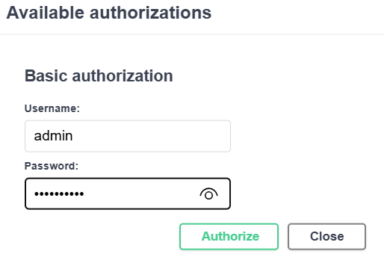
Scroll down to GET cluster. Expand and click “Try it out” and “Execute.”
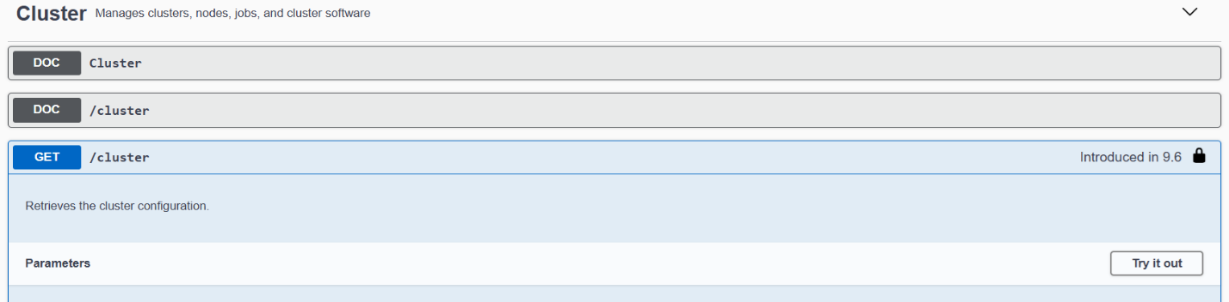
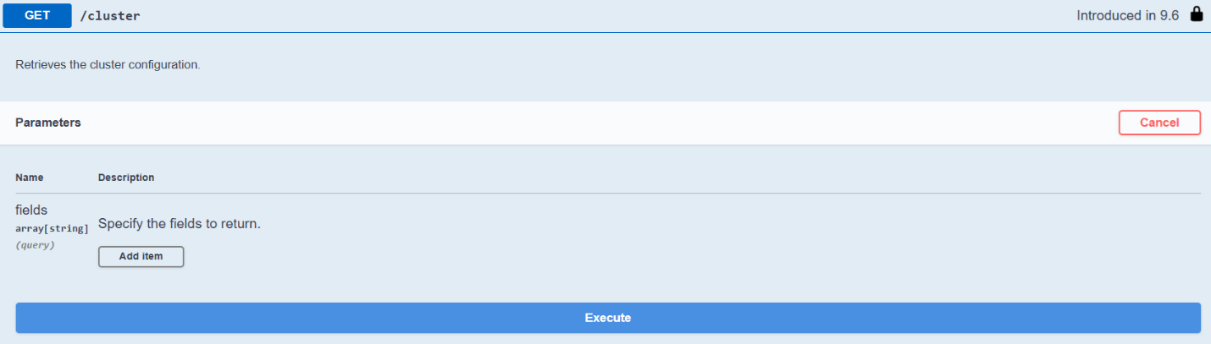
The curl output will contain the AUTH_TOKEN.

Create FlexGroup volume
curl -k -X POST
"https://[CLUS_MGMT_IP]/api/storage/volumes?return_timeout=0&return_records=false" \
-H "accept: application/json" \
-H "authorization: Basic [INSERT AUTH_TOKEN]" \
-H "Content-Type: application/json" \
-d "{ \"constituent_count\": 64, \"guarantee\": { \"type\": \"none\" }, \"name\": \"vol1\", \"nas\": { \"export_policy\": { \"name\": \"default\" }, \"junction_parent\": { \"name\": \"vs1_root\" }, \"path\": \"/vol1\", \"security_style\": \"unix\", \"unix_permissions\": 777 }, \"size\": 500000000000000, \"snapshot_policy\": { \"name\": \"none\" }, \"space\": { \"large_size_enabled\": true }, \"style\": \"flexgroup\", \"svm\": { \"name\": \"svm1\" }, \"type\": \"rw\"}"
For a script to perform this task, see the “Scripts” section of this doc.

Delete volumes
First, retrieve the volume UUID that you want to delete:
curl -k -X GET
"https://[CLUS_MGMT_IP]/api/storage/volumes?is_constituent=false&fields=uuid,&return_records=true&return_timeout=15" \
-H "accept: application/json" \
-H "authorization: Basic [INSERT_AUTH_TOKEN]"
Then, delete the volume (force=true means bypass the recovery queue):
curl -k -X DELETE "https://[CLUS_MGMT_IP]/api/storage/volumes/[UUID here]?force=true&return_timeout=0" \
-H "accept: application/json" \
-H "authorization: Basic [INSERT_AUTH_TOKEN]"

Display the storage availability zone information
curl -k -X GET "https://[CLUS_MGMT_IP]/api/storage/availability-zones? \fields=*&max_records=100&return_records=true&return_timeout=15" \
-H "accept: application/json" \
-H "authorization: Basic [INSERT AUTH_TOKEN]"

Data interfaces
To list all data interfaces:
curl -k -X GET "https://[CLUS_MGMT_IP]/api/network/ip/interfaces?fields=ip.address,location.node.name,location.port.name&service_policy=default-data-files&return_records=true&return_timeout=15" \
-H "accept: application/json" \
-H "authorization: Basic [INSERT_AUTH_TOKEN]"
To create a data interface:
curl -k -X POST
“https://[CLUS_MGMT_IP]/api/network/ip/interfaces?return_timeout=0&return_records=false" \
-H "accept: application/json" \
-H "authorization: Basic [INSERT_AUTH_TOKEN]" \
-H "Content-Type: application/json" \
-d { \"name\": \"{LIF_NAME}\", \"scope\": \"svm\", \"svm\": \"{SVM_NAME}\", \"ip\": { \"address\": \"{IP}\", \"netmask\": \"{NETMASK}\" }, \"location\": { \"home_node\": \"{NODE}\", \"home_port\": \"{PORT}\" }
For a script to create interfaces, see the “Scripts” section of this document.
To delete a data interface (UUID from list required):
curl -k -X DELETE "https://[CLUS_MGMT_IP]/api/network/ip/interfaces/[UUID]" \
-H "accept: application/json" \
-H "authorization: Basic [INSERT_AUTH_TOKEN"

Show NFS server configuration
curl -k -X GET "https://[CLUS_MGMT_IP]/api/protocols/nfs/services?fields=*&max_records=100&return_records=true&return_timeout=15" \
-H "accept: application/json" \
-H "authorization: Basic [INSERT AUTH_TOKEN]"

Storage benchmark testing
The following section covers the specific benchmarking tool we will use for this test plan.

SPEC SFS 2020
We will be using the SPEC SFS 2020 benchmark to simulate EDA frontend, backend and blended workloads. The test profiles use the workload profiles found in the SPEC SFS 2020 user’s guide, as well as details on how to set up and configure the benchmark.

Frontend EDA workload breakdown – SPECSFS 2020
The following table shows the NFS operations involved in the SPECSFS 2020 benchmark.
Table 6) Frontend EDA NFS operations – SPECSFS 2020
NFS operation distribution
Operation type | % | Operation type | %
read | 0 | read file | 7
mmap read | 0 | random read | 8
write | 0 | write file | 10
mmap write | 0 | random write | 15
rmw | 0 | append | 0
mkdir | 1 | rmdir | 0
readdir | 0 | create | 2
unlink | 1 | unlink2 | 1
stat | 39 | access | 15
rename | 0 | copyfile | 0
lock | 0 | chmod | 1
statfs | 0 | pathconf | 0
trunc | 0 | neg_stat | 0
Due to the metadata-heavy nature of frontend EDA workloads, it is recommended to use NFSv3.

Backend EDA workload breakdown
The following table shows the NFS operations involved in the SPECSFS 2020 benchmark.
Table 7) Backend EDA NFS operations – SPECSFS 2020
NFS operation distribution
Operation type | % | Operation type | %
read | 50 | read file | 0
mmap read | 0 | random read | 0
write | 50 | write file | 0
mmap write | 0 | random write | 0
rmw | 0 | append | 0
mkdir | 0 | rmdir | 0
readdir | 0 | create | 0
unlink | 0 | unlink2 | 0
stat | 0 | access | 0
rename | 0 | copyfile | 0
lock | 0 | chmod | 0
statfs | 0 | pathconf | 0
trunc | 0 | neg_stat | 0
Since backend EDA workloads are read/write heavy with very little metadata, it is worth using NFSv4.1 with pNFS and session trunking.

Definition of relevant operations in SPEC SFS 2020
The following section attempts to define the operations mentioned in the frontend and backend workload sections above.
Table 8) NFS operation types in SPEC SFS 2020
Operation type | What it does
read | Sequential reads to an already open file.
read file | Open, read, close file. End-to-end read.
mmap read | Memory map read.
random read | Random read.
write | Sequential write to an already open file.
write file | Open, write, close. End-to-end write.
mmap write | Memory map write.
rmw | Read/modify/write.
append | Add data to end of existing file.
mkdir | Make directory.
rmdir | Remove directory.
readdir | List contents of directory. (Includes readdir+ operations)
create | Create file metadata operation; checks if file exists, allocates a new inode.
unlink | Deletes a file.
unlink2 | 2nd unlink on a different file.
stat | Retrieves the attributes of a file or directory, such as size, permissions, owner, and timestamps. (ie, du and ls)
access | Checks the access permissions for a file or directory to determine if the client has the necessary permissions (read, write, execute).
rename | Rename a file or folder.
copyfile | Copies a file from one to another.
lock | Locks a file.
chmod | Change the permissions of a file or folder.
statfs | Retrieve information about the overall file system. (ie, df)
pathconf | Retrieves configuration information about a file or directory, such as maximum filename length, maximum path length, and other file system limits.
trunc | Truncates a file to a specified length. This can either shorten or extend the file, with the extended portion being filled with zeros.
neg_stat | Refers to a negative status response indicating that a file or directory does not exist or an operation failed. This is not a standard NFS operation but rather a status code.

DLIO/MLcommons
We will be using the MLcommons benchmark leveraging DLIO.
For installation/configuration, see here:
https://github.com/mlcommons/storage
It is recommended to use Ubuntu 22 (latest version), but RHEL 9.x is also a possible version to use for clients.
MLcommons updates fairly regularly. Their updates may outpace what is in this document. Use their site as a single source of truth.

About MLcommons
MLcommons is a nascent benchmark for AI/ML workloads that is currently in version 2.0 (as of May 2025). While it is not yet the standard benchmark for these types of workloads, it is one of the frontrunners to be akin to SPEC SFS benchmarking.
The MLcommons benchmark tool covers several areas of the AI/ML workflow, including:
- VectorDB search
- Checkpointing
- Training/inference
MLcommons attempts to simulate the end-to-end workflow by building in the time it would take to run specific AI/Ml jobs on GPUs, which reduces the overall cost to test AI/ML workloads. GPU times are standardized and offer options such as the NVIDIA A100 and NVIDIA H100 Tensor Core GPUs.
From MLperf’s submission page:
MLPerf Storage emulates accelerators for the training workloads with the tool DLIO developed by Argonne National Labs. DLIO uses the standard AI frameworks (PyTorch, Tensorflow, Numpy, etc) to load data from storage to memory at the same intensity as a given accelerator.
This emulation means that submitters do not need to use hardware accelerators (e.g., GPUs, TPUs, and other ASICs) when running MLPerf Storage - Training.
Instead, our benchmark tool replaces the training on the accelerator for a single batch of data with a sleep() call. The sleep() interval depends on the batch size and accelerator type and has been determined through measurement on a system running the real training workload. The rest of the data ingestion pipeline (data loading, caching, checkpointing) is unchanged and runs in the same way as when the actual training is performed.
There are two main advantages to accelerator emulation. First, MLPerf Storage allows testing different storage systems with different types of accelerators. To change the type of accelerator that the benchmark emulates (e.g., to switch to a system with NVIDIA H100 GPUs instead of A100 GPUs), it is enough to adjust the batch size and sleep() parameter. The second advantage is that MLPerf Storage can put a high load on the storage system simply by increasing the number of emulated accelerators. This allows for testing the behavior of the storage system in large-scale scenarios without purchasing/renting the AI compute infrastructure.

About vectorDB search in MLcommons benchmark
The VectorDB benchmark is designed to measure the performance and efficiency of vector databases, which are specialized systems optimized for storing, indexing, and querying high-dimensional vectors. These vectors are commonly used in machine learning applications such as recommendation systems, image retrieval, and natural language processing (NLP). This type of workload is generally comprised of random reads and writes to storage systems.
MLcommons provides datagen and run-search options to perform this benchmark. The datagen portion will create a simulated dataset, while run-search will perform the vectorDB search benchmark test.
Because of how new vectorDB testing is for this benchmark suite (new as of v2.0), this EAP will not cover vectorDB search benchmarks.

About checkpointing in MLcommons benchmark
Checkpointing in AI/ML workloads is used to reduce the impact of progress lost in the event of a training job failure. Checkpointing workloads have an IO profile of:
- Sequential writes for saving checkpointing information
- Random reads for restoring from checkpoints
- Metadata operations (mostly SETATTR)
Because of how new checkpoint testing is for this benchmark suite (new as of v2.0), this EAP will not cover checkpointing benchmarks

About training in MLcommons benchmark
The training benchmark in MLcommons was the original benchmark released and will be the focus for this EAP. AI/ML training is a heavily sequential read workload on a static dataset and requires high throughput for this type of workload. In MLcommons, the following workload types are used.
- Image segmentation using the U-Net3D model
- Image classification using the Resnet-50 model
- Cosmology parameter prediction using the Cosmoflow model

Generating datasizes
The size of the training dataset is determined with the mlpstorage datasize command and is dependent on the number accelerators defined. Examples below.
U-Net3D
# mlpstorage training datasize -m unet3d --client-host-memory-in-gb 64 --max-accelerators 4 --num-client-hosts 2 --accelerator-type a100
Setting attr from max_accelerators to 4
2025-05-21 13:54:48|STATUS: Benchmark results directory: /tmp/mlperf_storage_results/training/unet3d/datasize/20250521_135448
2025-05-21 13:54:48|STATUS: Instantiated the Training Benchmark...
2025-05-21 13:54:48|RESULT: Minimum file count dictated by 500 step requirement of given accelerator count and batch size.
2025-05-21 13:54:48|RESULT: Number of training files: 14000
2025-05-21 13:54:48|RESULT: Number of training subfolders: 0
2025-05-21 13:54:48|RESULT: Total disk space required for training: 1911.45 GB
Resnet50
# mlpstorage training datasize -m resnet50 --client-host-memory-in-gb 64 --max-accelerators 4 --num-client-hosts 2 --accelerator-type a100
Setting attr from max_accelerators to 4
2025-05-21 14:06:18|STATUS: Benchmark results directory: /tmp/mlperf_storage_results/training/resnet50/datasize/20250521_140618
2025-05-21 14:06:18|STATUS: Instantiated the Training Benchmark...
2025-05-21 14:06:18|RESULT: Minimum file count dictated by dataset size to memory size ratio.
2025-05-21 14:06:18|RESULT: Number of training files: 4790
2025-05-21 14:06:18|RESULT: Number of training subfolders: 0
2025-05-21 14:06:18|RESULT: Total disk space required for training: 639.89 GB
Cosmoflow
# mlpstorage training datasize -m cosmoflow --client-host-memory-in-gb 64 --max-accelerators 4 --num-client-hosts 2 --accelerator-type a100
Setting attr from max_accelerators to 4
2025-05-21 14:09:25|STATUS: Benchmark results directory: /tmp/mlperf_storage_results/training/cosmoflow/datasize/20250521_140925
2025-05-21 14:09:25|STATUS: Instantiated the Training Benchmark...
2025-05-21 14:09:25|RESULT: Minimum file count dictated by dataset size to memory size ratio.
2025-05-21 14:09:25|RESULT: Number of training files: 242954
2025-05-21 14:09:25|RESULT: Number of training subfolders: 0
2025-05-21 14:09:25|RESULT: Total disk space required for training: 640.00 GB

About U-Net3D
The U-Net3D model simulates image segmentation (such as 3D medical imaging). When generating a dataset, the default average file size is 146,600,628 bytes (146MB) and is defined in the unet3d_GPU.yaml file.

About Resnet50
The Resnet50 model is a neural network used in image classification, object detection, semantic segmentation and other computer vision tasks. The default average file size for Resnet50 is 114,660 bytes (~112KB) and is defined in the resnet50_GPU.yaml file.

About Cosmoflow
Cosmoflow is a deep learning model that attempts to model the universe and predict matter and dark energy density and other cosmological applications. The default average file size for Cosmoflow datasets is 2,828,486 bytes (~2.8MB) and is defined in the cosmoflow_GPU.yaml file.

NFS operation breakdown for model runs
The following table shows a breakdown of the NFS operations seen during a training run of each model. The point of this table is to help make decisions about how to best configure storage and clients for these benchmark runs.
These were generated using default NFS mount options and a 1MB rsize.
Table 9) NFS operations percent per model during runs
 | U-Net3D | Resnet50 | Cosmoflow
Number of files trained | 12000 | 2395 | 242954
ACCESS | <1% | <1% | 5%
CLOSE | <1% | <1% | 5%
COMPOUND | 90% | 98% | 31%
CREATE | <1% | <1% | <1%
GETATTR | <1% | <1% | 8%
GETDEVICEINFO (pNFS) | <1% | <1% | <1%
OPEN | <1% | <1% | 5%
PUTFH | 4% | <1% | 25%
READ | 89% | 98% | 17%
SEQUENCE | 4% | <1% | 25%

READ size histogram
The following table shows the incoming block sizes observed for each training workload test on a 1MB mount using default mount options.
Table 10) Block size for READ operations
 | U-Net3D | Resnet50 | Cosmoflow
Number of files trained | 12000 | 2395 | 242954
Average file size | ~140MB | ~136MB | ~2.7MB
<= 512B | 1636
<= 1KB | 1794 | - | 4
<= 2KB | 3478 | - | 12
<= 4KB | 951114 | 147209 | 18581
<= 8KB | 5915 | 8813 | 1889
<= 32KB | 687 | - | -
<= 64KB | 1428 | 13 | -
<= 128KB | 2915 | 6506810 | -
<= 256KB | 7151 | 3259423 | -
<= 512KB | 14997 | - | 20
<= 1MB | 8270819 | - | 3643426

Statistics counters
This section lists relevant statistics counters for some of the sections listed above.

Glossary of NFS operation types found in ONTAP statistics
The following table defines the NFS operation types seen in ONTAP performance statistics and classifies them by metadata or IO.
Table 11) NFS operation glossary
Operation | Use case | Category
ACCESS | Permission checks/verifcation of files/directory. | Metadata
CLOSE | Call to close an open file. Buffered data written, locks are released. | Metadata
COMPOUND | Multiple calls combine into a single call. Can include any of the other operation calls mentioned here. | Metadata
CREATE | Create a new file. | Metadata
GETATTR | Get file attributes, including permissions, atime, size, etc. (find, ls) | Metadata
GETDEVICEINFO | pNFS call to get device information from the NFS server.  (interface to volume relationship) | Metadata
GETFH | Retrieves the file handle for the file or directory. | Metadata
LAYOUTGET | pNFS call to get layout information from NFS server. | Metadata
LOOKUP | Resolve a file or directory name to its file handle. | Metadata
OPEN | Opens the file using the filehandle gathered in LOOKUP | Metadata
PUTFH | Sets filehandle during mount of an NFS export. | Metadata
READ | Reads a file. Can be random or sequential. | IO
READDIR | Reads contents of a directory; lists files and directory names with attributes. | Metadata
READDIRPLUS | Enhanced version of READDIR; used to reduce GETATTR and LOOKUP | Metadata
SEQUENCE | NFSv4.1 and later; manages state of client->server session for proper request ordering and session recovery. | Metadata
SETATTR | Modifies attributes for a file or directory. | Metadata
WRITE | Writes a file. Can be random or sequential. | IO

Network interface counters
AFX::> set advanced -c off
AFX::*> statistics lif show -vserver [SVM1]

pNFS counters – nfsv4_1_diag (diag priv)
Object: nfsv4_1_diag
Counter Description
--------------------------- ----------------------------------------------
cachedio_delete_byttl_pnfs_ds
Number of times the Nfsv41CachedIO pNFS DS
object is deleted due to ttl.
cachedio_fh_pnfs Number of times the Nfsv41CachedIO operation
was invoked on a clustered Data ONTAP
filehandle containing pNFS Device information
but no Qtree export information.
cachedio_fh_pnfs_qtree Number of times the Nfsv41CachedIO operation
was invoked on a clustered Data ONTAP
filehandle containing pNFS Device and Qtree
export information.
cb_layoutrecall_rcv_error The number of NFSv4.1 CB_LAYOUTRECALL
received with error. The CB_LAYOUTRECALL
operation is used by the server to recall
layouts from the client.
cb_layoutrecall_rcv_success The number of NFSv4.1 CB_LAYOUTRECALL
received successfully. The CB_LAYOUTRECALL
operation is used by the server to recall
layouts from the client.
cb_layoutrecall_send_error The number of NFSv4.1 CB_LAYOUTRECALL sent
with error. The CB_LAYOUTRECALL operation is
used by the server to recall layouts from the
client.
cb_layoutrecall_send_success
The number of NFSv4.1 CB_LAYOUTRECALL sent
successfully. The CB_LAYOUTRECALL operation
is used by the server to recall layouts from
the client.
cb_notifydeviceid_rcv_error The number of NFSv4.1 CB_NOTIFY_DEVICEID
received with error. The CB_NOTIFY_DEVICEID
operation is used by the server to send
notifications to clients about changes to
pNFS device IDs.
cb_notifydeviceid_rcv_success
The number of NFSv4.1 CB_NOTIFY_DEVICEID
received successfully. The CB_NOTIFY_DEVICEID
operation is used by the server to send
notifications to clients about changes to
pNFS device IDs.
cb_notifydeviceid_send_error
The number of NFSv4.1 CB_NOTIFY_DEVICEID sent
with error. The CB_NOTIFY_DEVICEID operation
is used by the server to send notifications
to clients about changes to pNFS device IDs.
cb_notifydeviceid_send_success
The number of NFSv4.1 CB_NOTIFY_DEVICEID sent
successfully. The CB_NOTIFY_DEVICEID
operation is used by the server to send
notifications to clients about changes to
pNFS device IDs.
pnfs_accurate_layout Number of accurate layout returned for
layoutget.
pnfs_changed_to_multipart Number of times single part file converted to
multipart.
pnfs_devicecache_flushed Total count of flush done for deviceId.
pnfs_devicecache_lrupurged Number of devices which were purged by LRU
mechanism.
pnfs_devicelist_empty_rsp Number of times deviceId response was empty.
pnfs_ds_local_read Number of local request on data server
pnfs_ds_local_write Number of local request on data server
pnfs_ds_remote_read Number of remote request on data server
pnfs_ds_remote_write Number of remote request on data server
pnfs_dvcid_1_created Number of device id created with version 1.
pnfs_dvcid_2_created Number of device id created with version 2.
pnfs_dvcid_3_created Number of device id created with version 3.
pnfs_dvcid_cache_hit Number of deviceId cache hit.
pnfs_dvcid_cache_miss Number of deviceId cache miss.
pnfs_dvcid_created Number of device id created.
pnfs_dvcid_invalid Number of devices whose state is invalid.
pnfs_dvcid_invalidate_dbladelif_mappings
Number of invalidations of dblade-lif
mappings in deviceid.
pnfs_dvcid_invalidation Number of times deviceId invalidation
occurred.
pnfs_dvcid_negative Number of devices whose state is negative.
pnfs_dvcid_queryagain Number of devices for which query was sent
again to VLDB.
pnfs_dvcid_removed Number of device id removed.
pnfs_dvcid_rpc_error Number of times RPC error was received for
deviceId.
pnfs_dvcid_rpc_request Number of times RPC request was sent for
deviceId information.
pnfs_dvcid_rpc_response Number of times deviceId rpc response was
received.
pnfs_file_layout_not_multipart
Number of times file layout response was
received with not multipart error.
pnfs_file_layout_req_failure
Number of times file layout request was sent.
pnfs_file_layout_req_success
Number of times file layout request was sent.
pnfs_file_layout_rsp_error Number of times file layout response was
received with any other error.
pnfs_file_layout_rsp_success
Number of times file layout response was
received and was success.
pnfs_inaccurate_layout Number of inaccurate layout returned for
layoutget.
pnfs_layout_conversions Number of times the Nfsv41pNFS open states
converted to layout state ids
pnfs_layout_in_hash Number of times deviceId was added in hash.
pnfs_layout_out_hash Number of times deviceId was removed from
hash.
pnfs_layout_recalled Number of times pnfs layout was recalled.
pnfs_lif_mapping_cache_hit Number of times lif mapping cache hit.
pnfs_lif_mapping_cache_miss Number of times lif mapping cache missed.
pnfs_lif_mapping_invalidation
Number of times lif mapping invalidation
occurred.
pnfs_lif_mapping_negative_entry
Number of times lif mapping cache state was
negative.
pnfs_lif_mapping_rpc_error Number of times lif mapping RPC error was
received.
pnfs_lif_mapping_rpc_received
Number of times lif mapping RPC response was
received.
pnfs_lif_mapping_rpc_sent Number of times lif mapping RPC was sent.
pnfs_lifmapping_created Number of lif mapping created.
pnfs_masked_stale_error Number of masked stale error in pNFS IO.
pnfs_mds_local_read Number of local request on meta data server
pnfs_mds_local_write Number of local request on meta data server
pnfs_mds_remote_read Number of remote request on meta data server
pnfs_mds_remote_write Number of remote request on meta data server
pnfs_read_route_to_catalog Number of read requests routed to catalog
inode.
pnfs_real_stale_error Number of stale error in pNFS IO.
pnfs_rpc_noparallel Number of times when parallel request RPC
count reached limit.
pnfs_rpc_nosend_alloc Number of times RPC was not sent due to
allocation failure.
pnfs_stale_error Number of stale error in pNFS IO.
pnfs_write_route_to_catalog Number of write requests routed to catalog
inode.

pNFS counters – nfsv4_1 (advanced priv)
Object: nfsv4_1
Counter Description
--------------------------- ----------------------------------------------
getdeviceinfo_avg_latency Average latency of NFSv4.1 GETDEVICEINFO
operations.
getdeviceinfo_error The number of failed NFSv4.1 GETDEVICEINFO
operations.
getdeviceinfo_percent Percentage of NFSv4.1 GETDEVICEINFO
operations.
getdeviceinfo_success The number of successful NFSv4.1
GETDEVICEINFO operations.
getdeviceinfo_total Total number of NFSv4.1 GETDEVICEINFO
operations.
getdevicelist_avg_latency Average latency of NFSv4.1 GETDEVICELIST
operations.
getdevicelist_error The number of failed NFSv4.1 GETDEVICELIST
operations.
getdevicelist_percent Percentage of NFSv4.1 GETDEVICELIST
operations.
getdevicelist_success The number of successful NFSv4.1
GETDEVICELIST operations.
getdevicelist_total Total number of NFSv4.1 GETDEVICELIST
operations.
layoutcommit_avg_latency Average latency of NFSv4.1 LAYOUTCOMMIT
operations.
layoutcommit_error The number of failed NFSv4.1 LAYOUTCOMMIT
operations.
layoutcommit_percent Percentage of NFSv4.1 LAYOUTCOMMIT operations.
layoutcommit_success The number of successful NFSv4.1 LAYOUTCOMMIT
operations.
layoutcommit_total Total number of NFSv4.1 LAYOUTCOMMIT
operations.
layoutget_avg_latency Average latency of NFSv4.1 LAYOUTGET
operations.
layoutget_error The number of failed NFSv4.1 LAYOUTGET
operations.
layoutget_percent Percentage of NFSv4.1 LAYOUTGET operations.
layoutget_success The number of successful NFSv4.1 LAYOUTGET
operations.
layoutget_total Total number of NFSv4.1 LAYOUTGET operations.
layoutreturn_avg_latency Average latency of NFSv4.1 LAYOUTRETURN
operations.
layoutreturn_error The number of failed NFSv4.1 LAYOUTRETURN
operations.
layoutreturn_percent Percentage of NFSv4.1 LAYOUTRETURN operations.
layoutreturn_success The number of successful NFSv4.1 LAYOUTRETURN
operations.
layoutreturn_total Total number of NFSv4.1 LAYOUTRETURN
operations.

pNFS statistics example
When you see “layoutget_total” incrementing, that means pNFS is sending and receiving device layouts to connected clients.
rtp-a70-c01::*> set advanced -confirmations off; statistics show -object nfsv4_1 -counter *layout* -sample-id sample_1393185

Object: nfsv4_1
Instance: AIML
Start-time: 5/15/2025 16:11:23
End-time: 5/15/2025 18:03:06
Elapsed-time: 6702s
Scope: rtp-a70-c01
Number of Constituents: 2 (complete_aggregation)
Counter Value
-------------------------------- --------------------------------
layoutget_avg_latency 8us
layoutget_success 216
layoutget_total 216

NFSv4.1 session trunking counters – nfsv4_1_diag (diag priv)
Object: nfsv4_1_diag
Counter Description
--------------------------- ----------------------------------------------
nfsv4_1_clients_using_clientid_trunking
Number of Nfsv4.1 clients using client ID trunking
nfsv4_1_clients_using_session_trunking
Number of Nfsv4.1 clients using session trunking

NFSv4.1 session trunking statistics example
When you see “nfsv4_1_clients_using_session_trunking” values, that tells you how many clients are leveraging session trunks.
AFX::*> set advanced -confirmations off; statistics show -object nfsv4_1_diag -counter *session*

Object: nfsv4_1_diag
Instance: nfs4_1_diag
Start-time: 5/15/2025 16:11:23
End-time: 5/15/2025 16:12:15
Elapsed-time: 52s
Scope: AFX-01

Counter Value
-------------------------------- --------------------------------
destroy_session_deletion 1
nfsv4_1_clients_using_session_ 12
trunking
sessions_created 1
sessions_deleted 1

Object: nfsv4_1_diag
Instance: nfs4_1_diag
Start-time: 5/15/2025 16:11:23
End-time: 5/15/2025 16:12:15
Elapsed-time: 52s
Scope: AFX-02

Counter Value
-------------------------------- --------------------------------
destroy_session_deletion 1
nfsv4_1_clients_using_session_ 8
trunking
sessions_deleted

Scripts
The following section contains scripts that can be used with these test plans.

Volume creation and deletion scripts
The following scripts can be used to create/delete data volumes.
https://github.com/whyistheinternetbroken/Benchmarking/tree/main/ONTAP/volumes

LIF creation and cleanup scripts
The following scripts can be used to create/delete network interfaces.
https://github.com/whyistheinternetbroken/Benchmarking/tree/main/ONTAP/networking

NetApp AFX reinitialization script
If you need to re-initialize a cluster during this test plan, the following script can help with that.
https://github.com/whyistheinternetbroken/AFX
Be sure to review the README file. Reach out to parisi@netapp.com for any questions or improvements.

Maximum files monitor
This script can be run as a scheduled job and will monitor a volume for its inode usage.
https://github.com/whyistheinternetbroken/maxfile-increase

Appendix B: Blank test template
Use this template for any performance tests outside of the scenarios described above.
Test 17) Blank test template
Section | Details
<Insert cross reference> | Tester: |  | Date:
Test requirements:
Test procedure:

Expected outcome(s):

Test results:
Test summary:
Comments:

Additional references
- NetApp AFX Overview Technical Reportv
- SPEC SFS 2020 user guide
- NFS Best practice guide for ONTAP
- TR-4616 NFS Kerberos with Active Directory
- TR-4835 How to Configure LDAP in ONTAP
- EDA Best practice guide for ONTAP
- FlexGroup volume best practices
- ONTAP S3 best practice guide
- NetApp AFF A90 Storage System Reference Design Guide - NVIDIA HGX
- MLcommons
- Flexible IO Tester docs

Refer to the Interoperability Matrix Tool (IMT) on the NetApp Support site to validate that the exact product and feature versions described in this document are supported for your specific environment. The NetApp IMT defines the product components and versions that can be used to construct configurations that are supported by NetApp. Specific results depend on each customer’s installation in accordance with published specifications.
Copyright information
Copyright © 2025 NetApp, Inc. All rights reserved. Printed in the U.S. No part of this document covered by copyright may be reproduced in any form or by any means—graphic, electronic, or mechanical, including photocopying, recording, taping, or storage in an electronic retrieval system—without prior written permission of the copyright owner.
Software derived from copyrighted NetApp material is subject to the following license and disclaimer:
THIS SOFTWARE IS PROVIDED BY NETAPP “AS IS” AND WITHOUT ANY EXPRESS OR IMPLIED WARRANTIES, INCLUDING, BUT NOT LIMITED TO, THE IMPLIED WARRANTIES OF MERCHANTABILITY AND FITNESS FOR A PARTICULAR PURPOSE, WHICH ARE HEREBY DISCLAIMED. IN NO EVENT SHALL NETAPP BE LIABLE FOR ANY DIRECT, INDIRECT, INCIDENTAL, SPECIAL, EXEMPLARY, OR CONSEQUENTIAL DAMAGES (INCLUDING, BUT NOT LIMITED TO, PROCUREMENT OF SUBSTITUTE GOODS OR SERVICES; LOSS OF USE, DATA, OR PROFITS; OR BUSINESS INTERRUPTION) HOWEVER CAUSED AND ON ANY THEORY OF LIABILITY, WHETHER IN CONTRACT, STRICT LIABILITY, OR TORT (INCLUDING NEGLIGENCE OR OTHERWISE) ARISING IN ANY WAY OUT OF THE USE OF THIS SOFTWARE, EVEN IF ADVISED OF THE POSSIBILITY OF SUCH DAMAGE.
NetApp reserves the right to change any products described herein at any time, and without notice. NetApp assumes no responsibility or liability arising from the use of products described herein, except as expressly agreed to in writing by NetApp. The use or purchase of this product does not convey a license under any patent rights, trademark rights, or any other intellectual property rights of NetApp.
The product described in this manual may be protected by one or more U.S. patents, foreign patents, or pending applications.
LIMITED RIGHTS LEGEND: Use, duplication, or disclosure by the government is subject to restrictions as set forth in subparagraph (b)(3) of the Rights in Technical Data—Noncommercial Items at DFARS 252.227-7013 (FEB 2014) and FAR 52.227-19 (DEC 2007).
Data contained herein pertains to a commercial product and/or commercial service (as defined in FAR 2.101) and is proprietary to NetApp, Inc. All NetApp technical data and computer software provided under this Agreement is commercial in nature and developed solely at private expense. The U.S. Government has a non-exclusive, non-transferrable, non-sublicensable, worldwide, limited irrevocable license to use the Data only in connection with and in support of the U.S. Government contract under which the Data was delivered. Except as provided herein, the Data may not be used, disclosed, reproduced, modified, performed, or displayed without the prior written approval of NetApp, Inc. United States Government license rights for the Department of Defense are limited to those rights identified in DFARS clause 252.227-7015(b) (FEB 2014).
Trademark information
NETAPP, the NETAPP logo, and the marks listed at http://www.netapp.com/TM are trademarks of NetApp, Inc. Other company and product names may be trademarks of their respective owners.

